Update Grant Agreement Contacts

Grant Recipient Portal Task Card

______________________________________________________________________________

**Portal Access required**: Administrator or Editor

The Grant Recipient Portal (Portal) enables grant recipients to update their Grant Agreement Contacts.

This task card describes the process of viewing, adding and removing Grant Agreement Contacts.

There are two pathways for a user to add and remove a contact for a Grant Agreement in the Portal, either through the **Organisation Profile** or through the **Grant Agreement** link/tile on the Home screen.

## Navigating to Grant Agreement Contacts through the Organisation Profile

### Step 1

From the Home screen, select the **Organisation Profile** tile. Alternatively, select the **Organisation Profile** link from the Navigation menu.

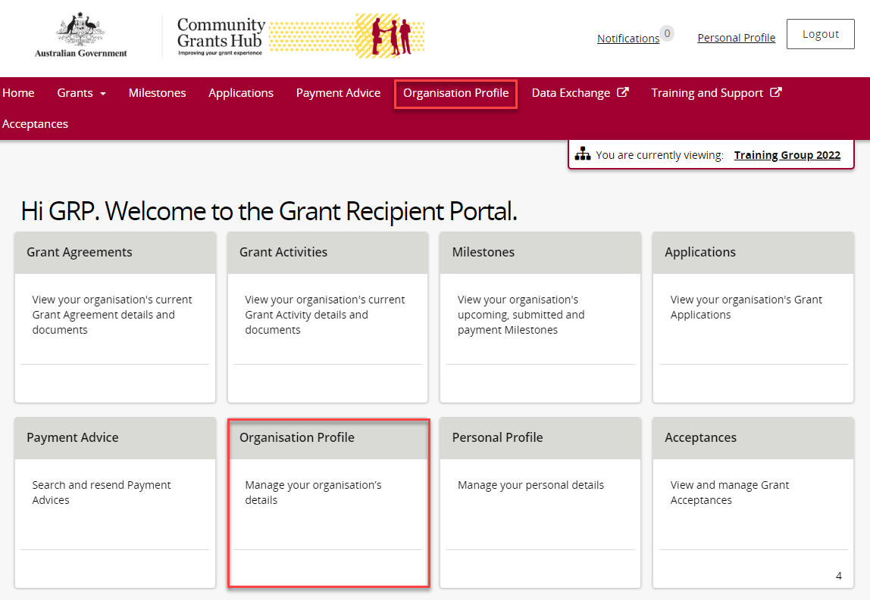

### Step 2

The Organisation Profile screen will display. Select **Staff** from the Organisation profile menu to display the Organisation’s Staff screen.

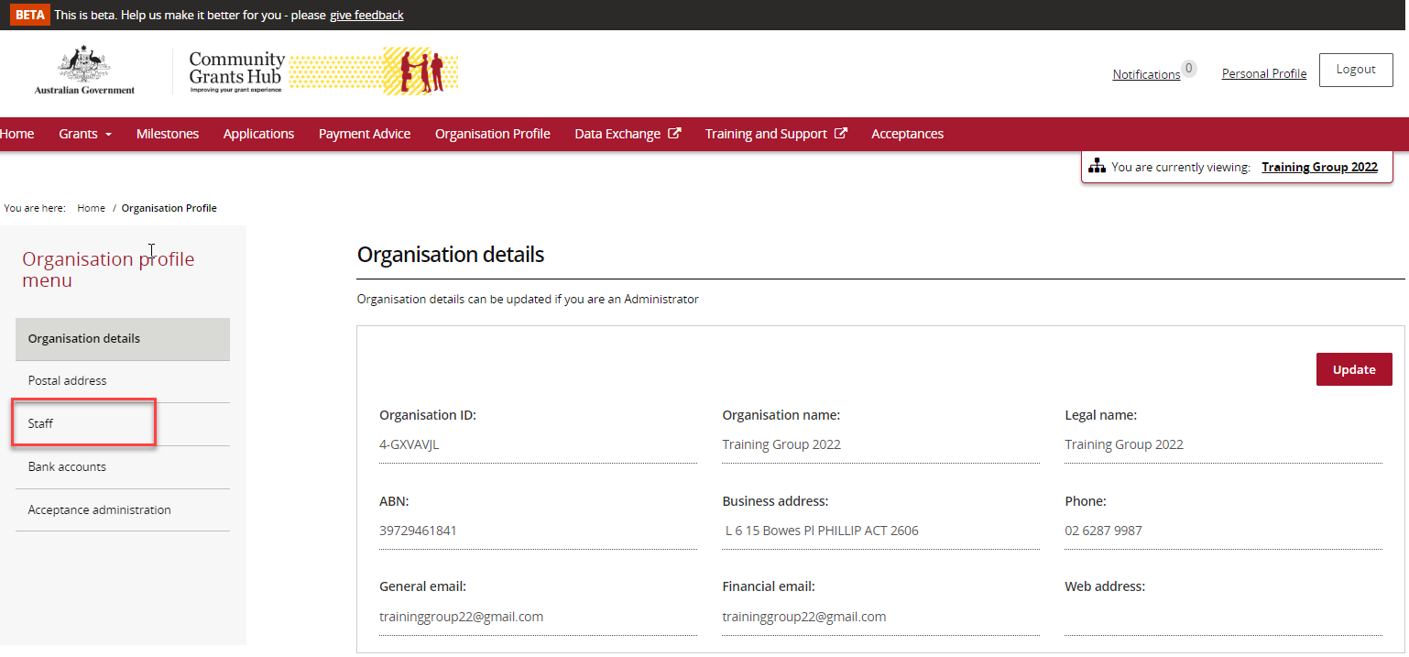

### Step 3

The Organisation’s Staff screen will display. This screen displays Active Staff for the organisation by default. The Staff list can be filtered using the **drop down** menutochoose one of the following:

1. Active Staff
2. Inactive Staff
3. All Staff

Select **View** to display additional information about a particular contact.

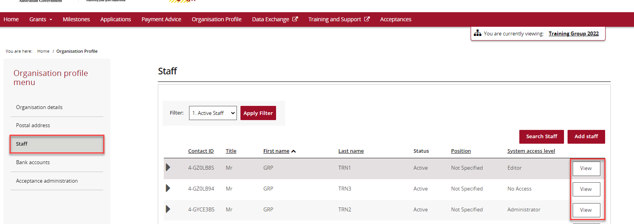

### Step 4

The Staff details screen will display. This screen has four sections:

* Staff details
* System access
* Contact for Grant Agreements
* Contact for Grant Activities

Grant Agreement Contacts are listed under the **Contact for Grant Agreements** section.

To add a contact through the Organisation Profile, proceed to step 5.

To remove a contact through the Organisation Profile, proceed to step 11.

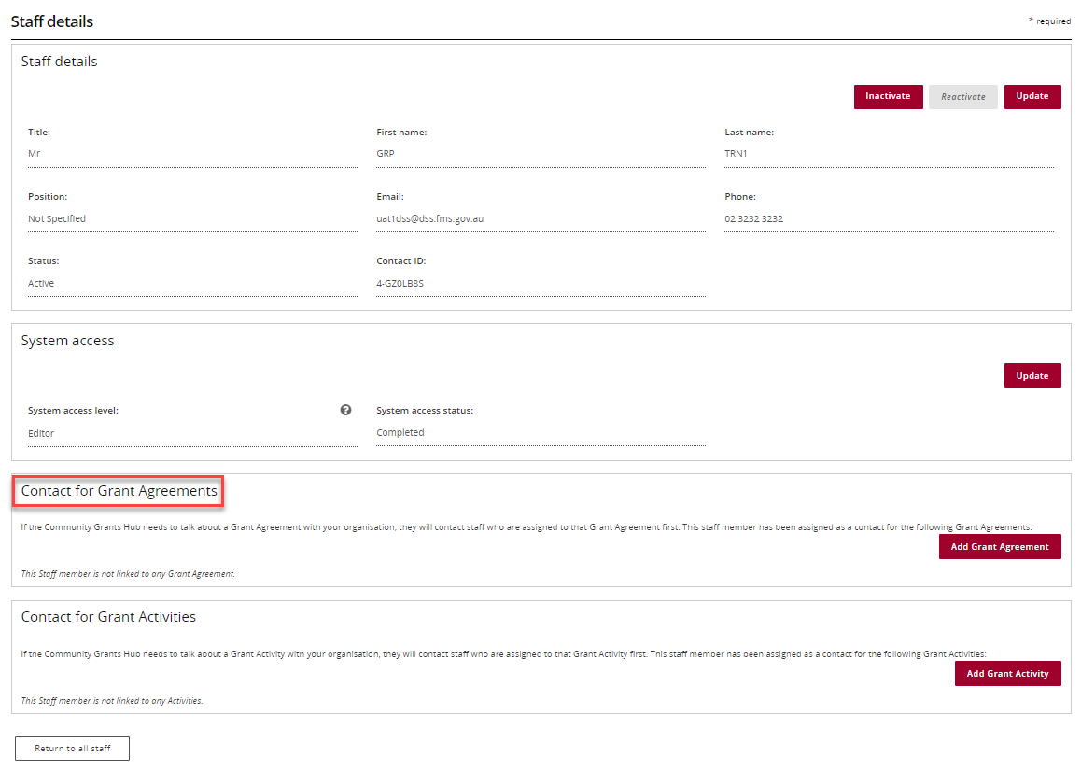

## Adding a Grant Agreement Contact through the Organisation Profile

### Step 5

To add a contact to a Grant Agreement, select **Staff** from the Organisation profile menu. Click **View** next to the staff member you want to add as a Grant Agreement Contact.



### Step 6

The Staff details page will display. Select **Add** **Grant Agreement**.

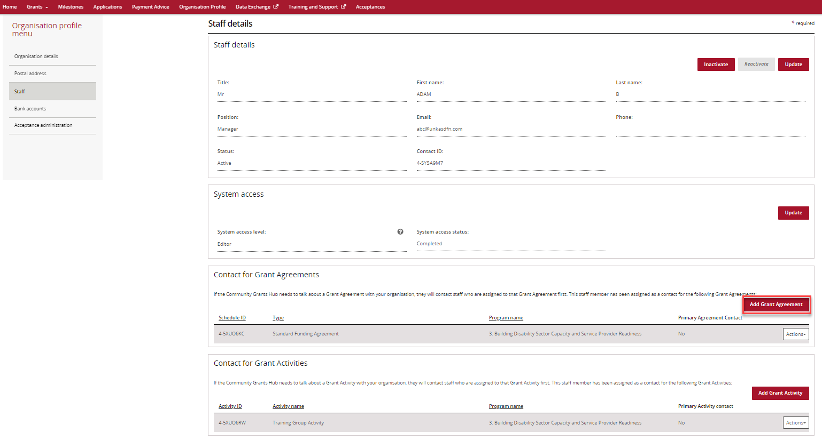

### Step 7

The list of Grant Agreements will display which you can assign the contact to. Select the **Actions** button next to the Grant Agreement you want to add the contact to. The Actions button provides you with three options:

1. Assign as a contact

2. Assign as the primary contact

3. View all contacts for this Agreement.

Select **Assign as a contact** if you want to assign the contact to the Grant Agreement (but not as the primary contact).

Select **Assign as the primary contact** if you want to assign the contact to the Grant Agreement as the primary contact.

**Note:** If you want to see all contacts assigned to the Grant Agreement, select **View all contacts for this Agreement**.

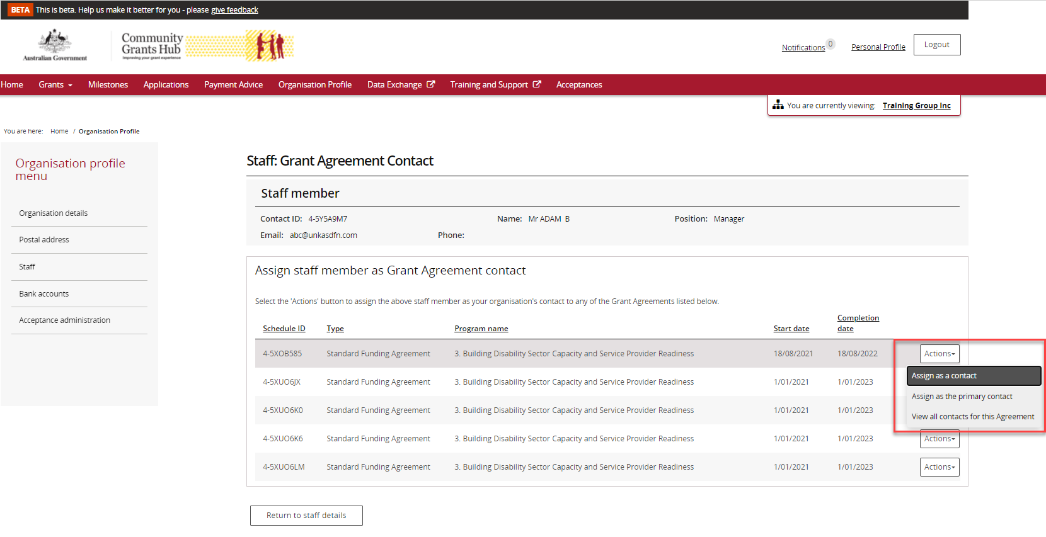

### Step 8

To assign as a contact, select **Assign as a contact.**

If the change is successful, a message will temporarily display on screen confirming the change was successful and the Grant Agreement will be listed on the Staff details screen under **Contact for Grant Agreements** with a **No** for **Primary Agreement Contact**.

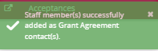

Your contact has now been added to the Grant Agreement.

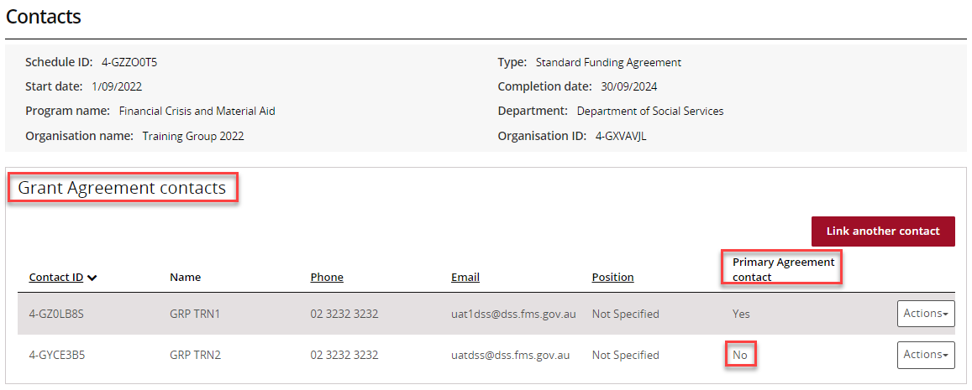

### Step 9

To assign as the primary contact, select **Assign as the primary contact.**

A confirmation message will display asking you to confirm the change by selecting **Continue**.

Select **Continue** to confirm the change of primary contact.

**Note:** you can select **Discard changes and return** to cancel the change.

Screenshot of popup asking to confirm change of primary contact

The popup says Please confirm the change of primary contact.

It includes the Schedule Id, current primary contact and new primary contact details. The user has two options available to them 1. Discard changes and return or                2. Continue.  

### Step 10

A message will temporarily display on screen confirming the change was successful and the Grant Agreement will be listed on the Staff details screen under **Contact for Grant Agreements** with a **Yes** for **Primary Agreement Contact**.

*Successful message - changing primary contact*



Your contact has now been added to the Grant Agreement as the primary contact.

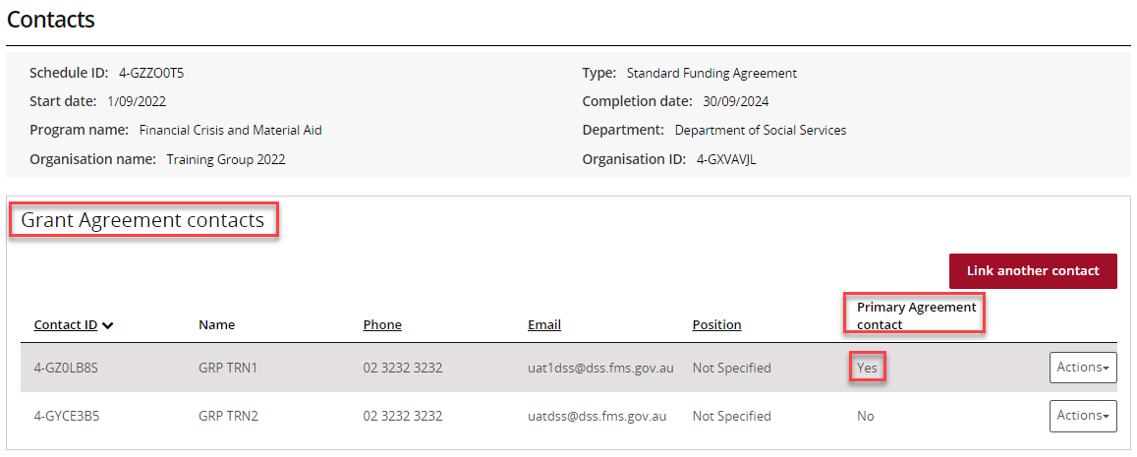

## Removing a Grant Agreement Contact through the Organisation Profile

### Step 11

To remove a contact from a Grant Agreement, select **Staff** from the Organisation profile menu. Click **View** next to the staff member you want to remove as a Grant Agreement Contact.



### Step 12

The Staff details page will display. To remove a staff member as a contact for a Grant Agreement, go to the **Contact for Grant Agreements** section. Click on the **Actions** button next to the Grant Agreement you want to remove the contact from and select **Remove contact from Agreement**.

**Note:** you are unable to remove a contact from a Grant Agreement if they are listed as the primary contact. You will need to assign a new primary contact before removing the existing primary contact.

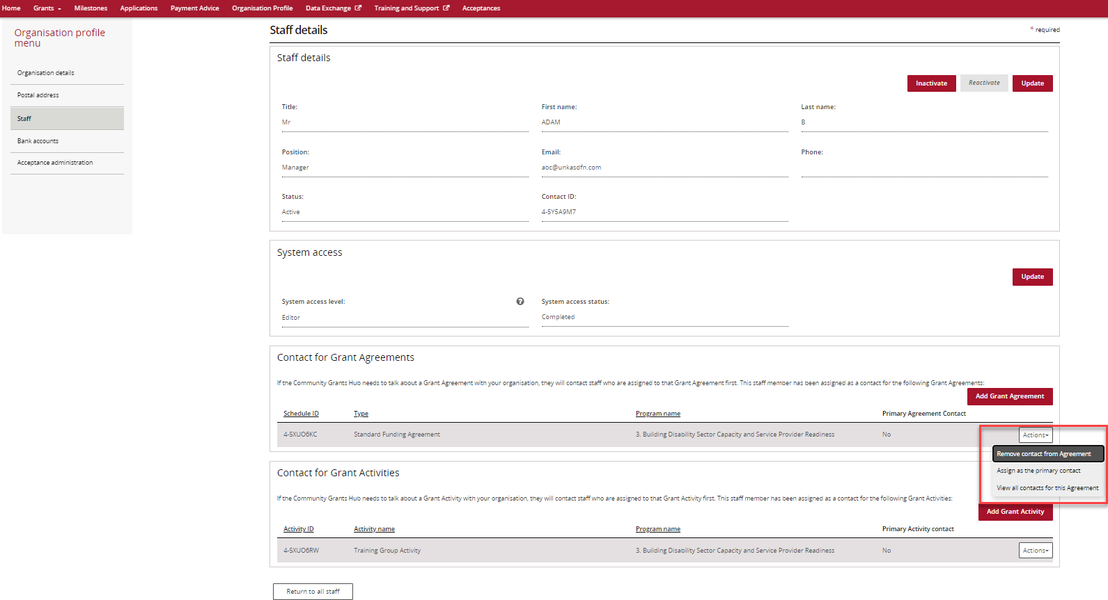

### Step 13

If the change is successful, a message will temporarily display on screen confirming the change was successful and the Grant Agreement will be removed from the Staff details screen under **Contact for Grant Agreements.**

*Successful message - removing contact*

Screenshot of the successful message displayed to grant recipient when the change is successful. The popup says Staff member successfully removed as  a contact.

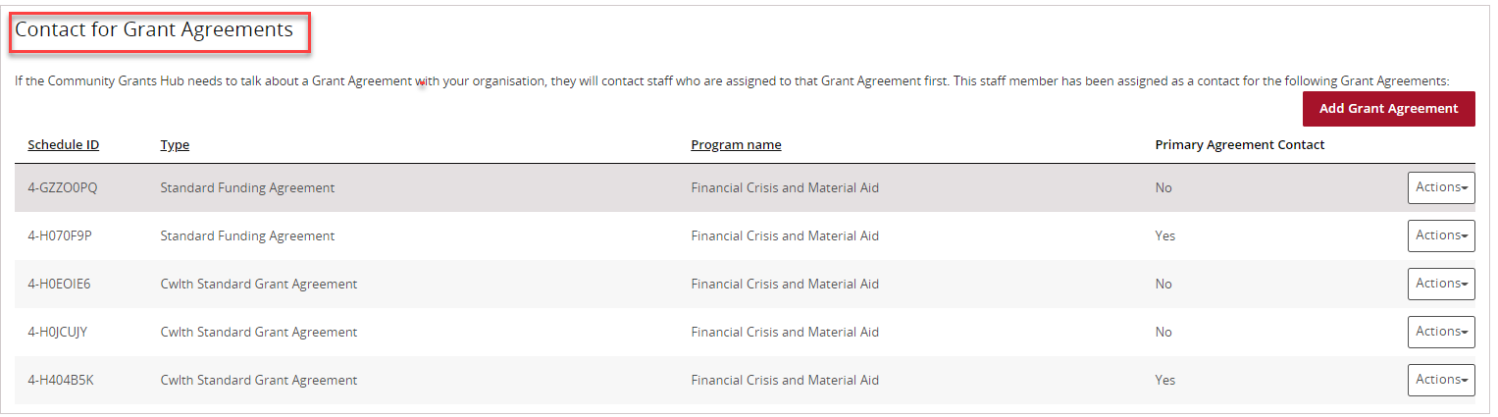

The following error message will appear on the top of the page if the contact is a primary contact for the Grant Agreement. You will need to assign a new primary contact to the Grant Agreement before removing the existing primary contact. The system will not allow the removal of the primary contact without a replacement.

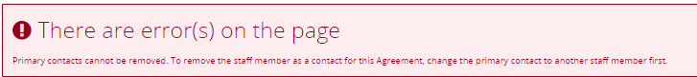

## Navigating to Grant Agreement Contacts through the Grant Agreements link/tile

### Step 14

From the Home screen, select the **Grant Agreements** tile. Alternatively, select **Grants** in the Navigation menu and select **Grant Agreements** from the drop down menu.

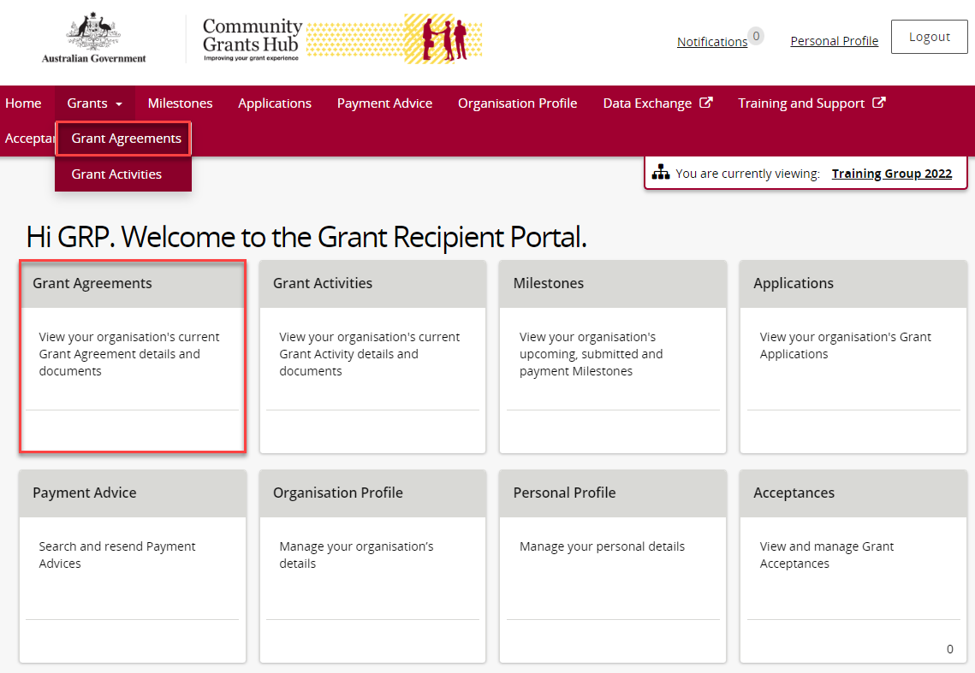

### Step 15

The Grant Agreements screen will display a list of your organisation’s Grant Agreements.

To view a particular Grant Agreement, select the Grant Agreement’s **View** button.

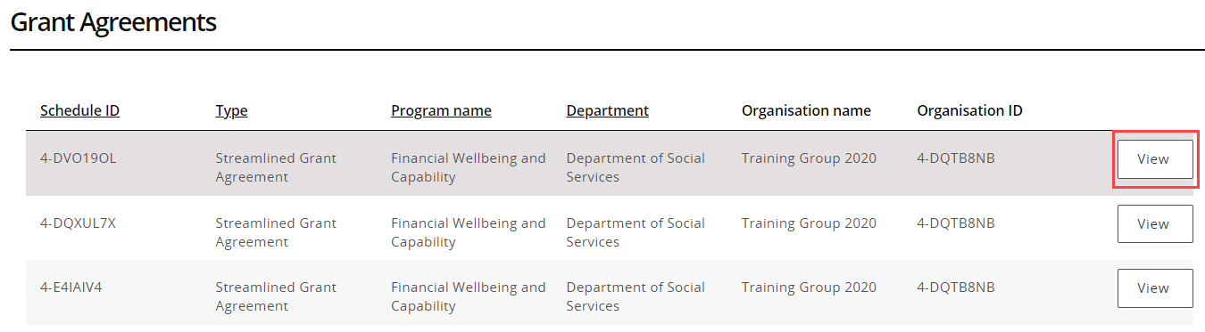

### Step 16

The Agreement detailsscreenwilldisplay an overview of the Agreement by default. The below information related to the Grant Agreement can be viewed:

* Schedule ID
* Agreement Type
* Start date
* Completion date
* Program name
* Department
* Organisation name
* Organisation ID

A list of Grant Activities associated with the Grant Agreement are displayed below.

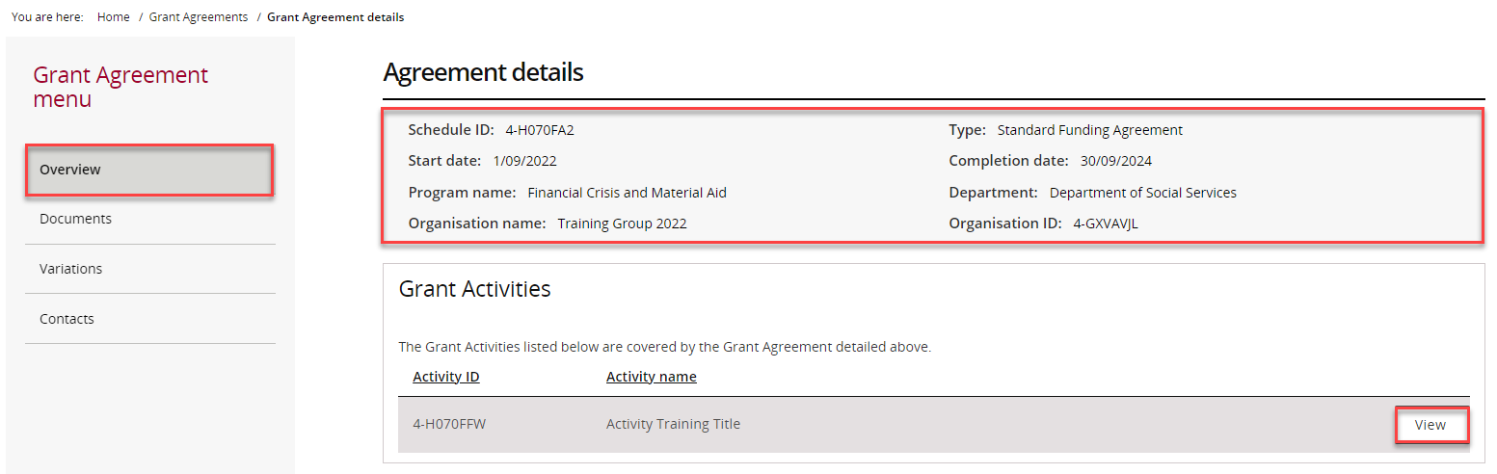

### Step 17

From the Grant Agreement menu, select **Contacts**.

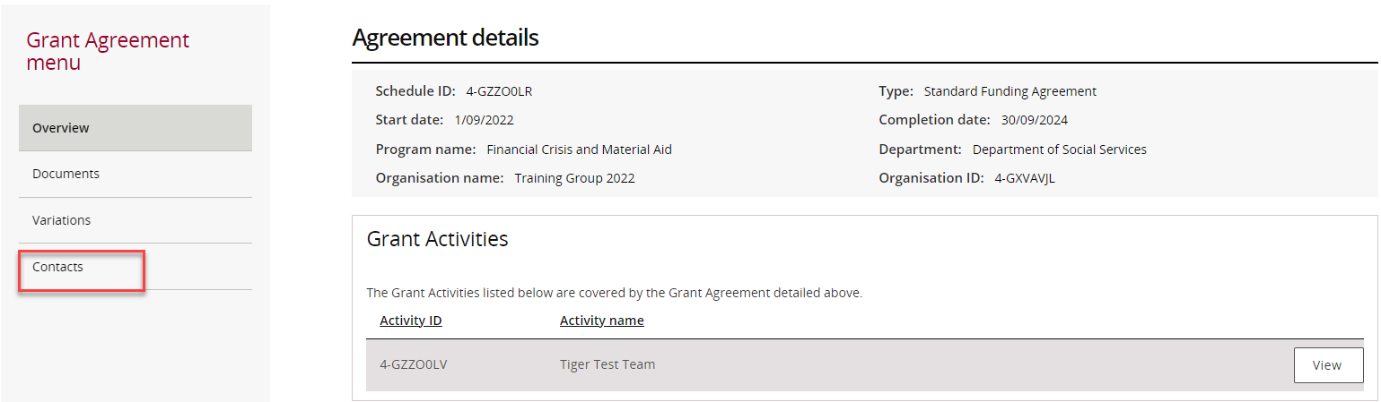

### Step 18

The Contacts screen will display. This screen displays all contacts linked to the Grant Agreement.

To add a contact through the Grant Agreements link/tile, proceed to step 19.

To remove a contact through the Grant Agreements link/tile, proceed to step 25.

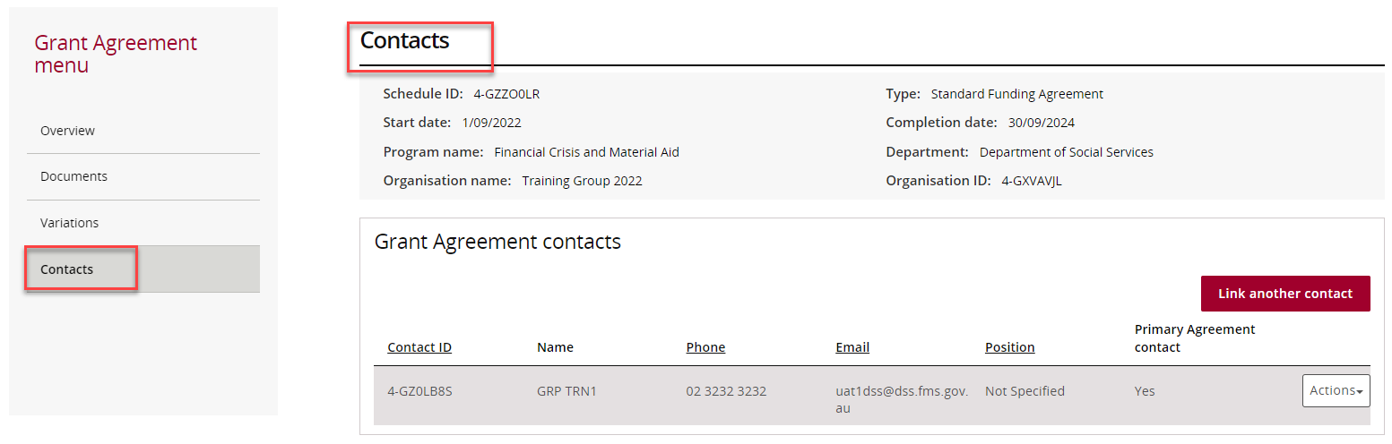

## Adding a Grant Agreement Contact through the Grant Agreements link/tile

### Step 19

To add a contact to a Grant Agreement, select **Contacts** from the Grant Agreement menu, then click on **Link another contact**.

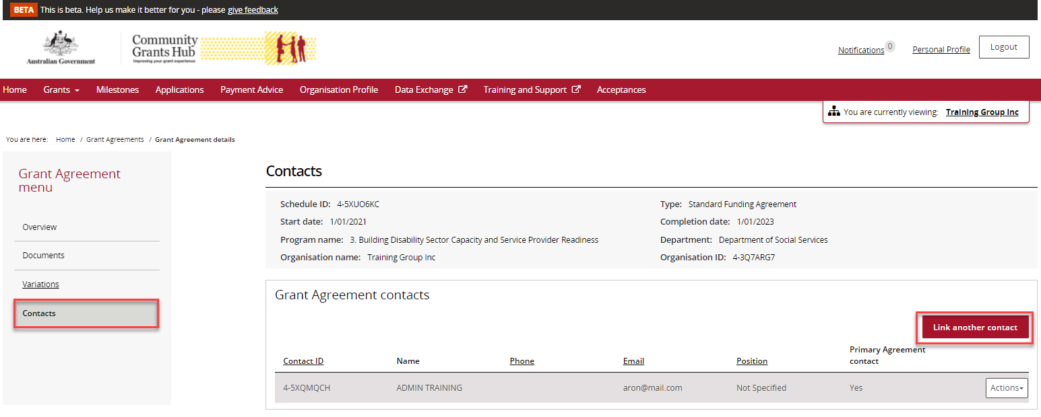

### Step 20

A list of contacts for the organisation will display. Click on the **box** next to the staff member(s) you want to add as a contact for the Grant Agreement and then click on the **Confirm selection** button.

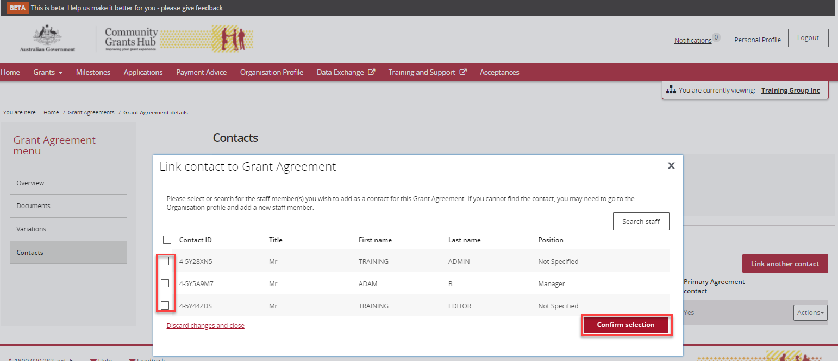

### Step 21

If the change is successful, a message will temporarily display on screen confirming the change was successful and the contact will be listed on the Contacts screen under **Grant Agreement contacts.**

*Successful message – adding contact to Grant Agreement*



Your contact has now been added to the Grant Agreement.

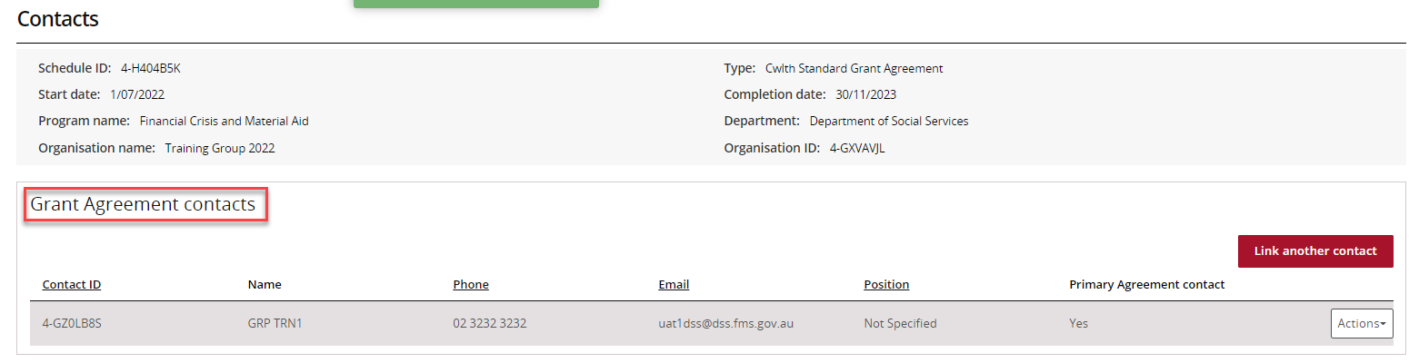

### Step 22

To update the contact as the primary contact, select **Actions** and thenselect **Assign as the primary contact**.

**Note:** There will be a **Yes** under the **Primary Agreement contact** column for the contact who is listed as the primary contact.

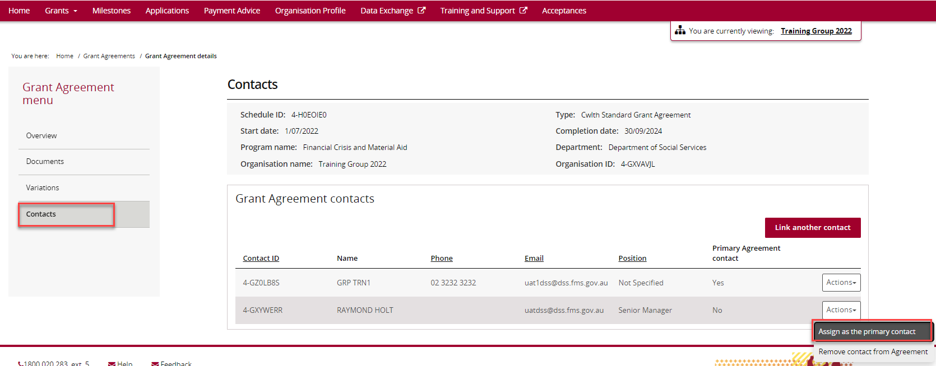

### Step 23

When you select **Assign as the primary contact,** a confirmation message will display asking you to confirm the change of the primary contact by selecting **Continue**.

Select **Continue** to confirm the change of primary contact.

**Note:** you can select **Discard changes and return** to cancel the change.

Screenshot of the Confirm change of primary contact popup. This popup says By clicking 'Continue' below you declare rgar you as an authorised indivdual are changing the contact person for this grant agreement, and that this will constitute a change to the grantee's representative for this agreement.

The user has the option to Discard changes and return or                Continue. 

### Step 24

If the change is successful, a message will temporarily display on screen confirming the change was successful and the contact will be listed on the Contacts screen under **Grant Agreement contacts** with a **Yes** for **Primary Agreement Contact.**

A message will temporarily display on screen confirming the change was successful.

*Successful message - changing primary contact*

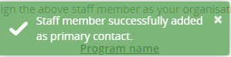

Your contact has now been updated as the primary contact.

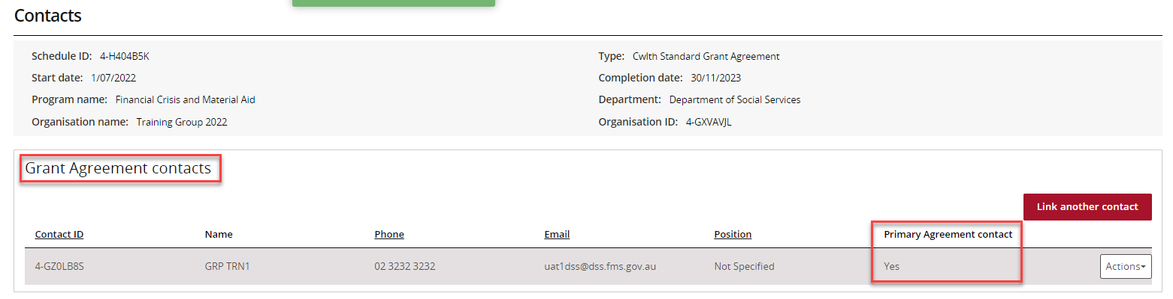

## Removing a Grant Agreement Contact through the Grant Agreements link/tile

### Step 25

To remove a contact from a Grant Agreement, select **Contacts** from the Grant Agreement menu, then select the **Actions** button next to the contact and select **Remove contact from Agreement**.

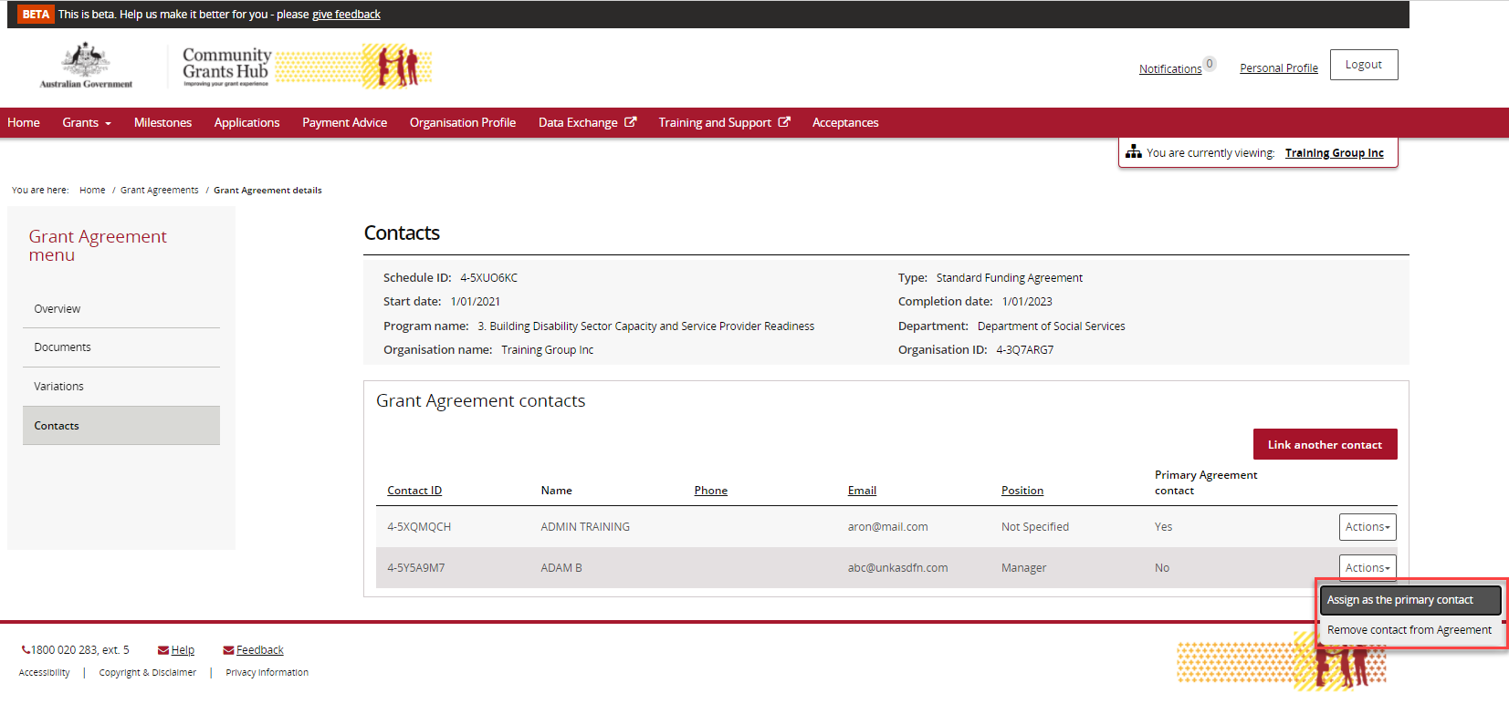

### Step 26

The message box below will display asking for confirmation to remove the contact from the Grant Agreement. Click on **Yes remove as Agreement contact** to remove the contact.

**Note:** you can select **Cancel** to not progress with the change.

Screenshot of the popup message displayed. This popup says Are you sure you would like to remove this staff member as a contact for this Agreement?

The user has the option to Cancel or select Yes remove as Agreement Contact.

### Step 27

If the change is successful, a message will temporarily display on screen confirming the change was successful and the Grant Agreement will be removed from the Contacts screen under **Grant Agreement contacts.**

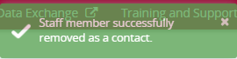

Your contact has now been removed from the Grant Agreement.

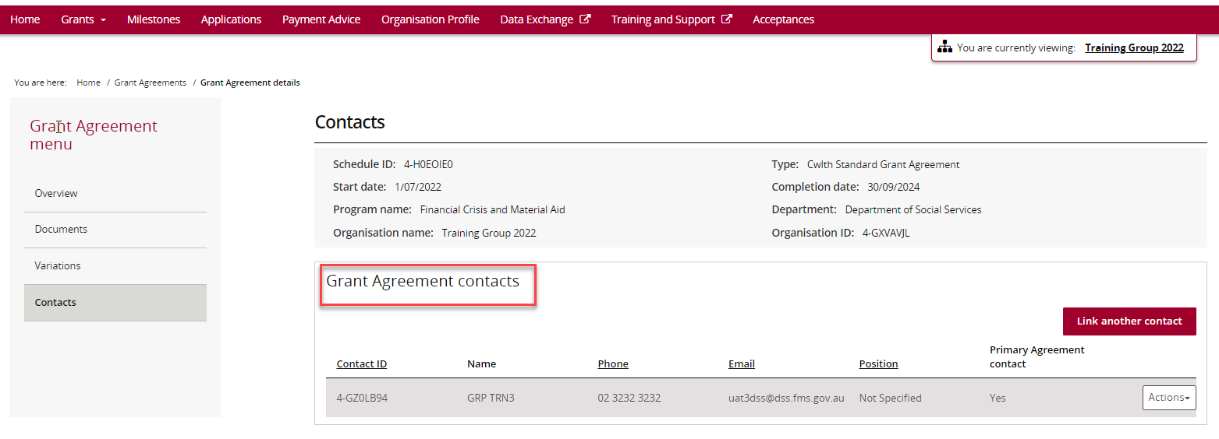

The following error message will appear on the top of the page if the contact is a primary contact for the Grant Agreement. You will need to assign a new primary contact to the Grant Agreement before removing the existing primary contact. The system will not allow the removal of the primary contact without a replacement.

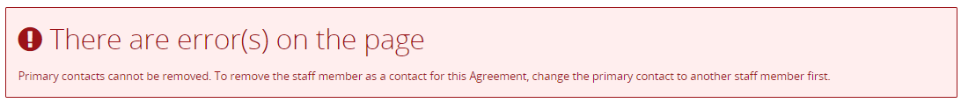

## Need Help?

For further assistance, contact the Grant Recipient Portal Helpdesk:

**Email**: [GRP.Helpdesk@communitygrants.gov.au](mailto:GRP.Helpdesk@communitygrants.gov.au)

**Phone**: 1800 020 283 (Option 5)

**Operating Hours:** Monday to Friday 9:00am – 5:00pm (AEST/AEDT)