Reactivate and Inactivate Organisation Staff

Grant Recipient Portal Task Card

**Portal Access required**: Administrator

The Grant Recipient Portal (Portal) enables grant recipients to reactivate and inactivate their Organisation staff records.

This task card describes the process of reactivating and inactivating Organisation staff records in the Portal.

**Note:** Administrators are not able to inactivate their own staff record.

## What does Active and Inactive Staff mean?

**Active staff** are staff members who are listed as a contact for an Organisation in the Community Grant Hub’s Grant Payment System (GPS) without an end date against the record.

**Inactive staff** are staff members who are listed as a contact for an Organisation in the Hub’s GPS with an end date against their record as they are no longer a contact for the Organisation.

**Note:**

* Grant recipients are unable to see the end date in the Portal
* Contacts without an end date = Active staff (in the Portal)
* Contacts with an end date = Inactive staff (in the Portal).

## Navigating to a Staff Record

### Step 1

From the Home screen, select the **Organisation Profile** tile. Alternatively, select the **Organisation Profile** link from the Navigation menu.

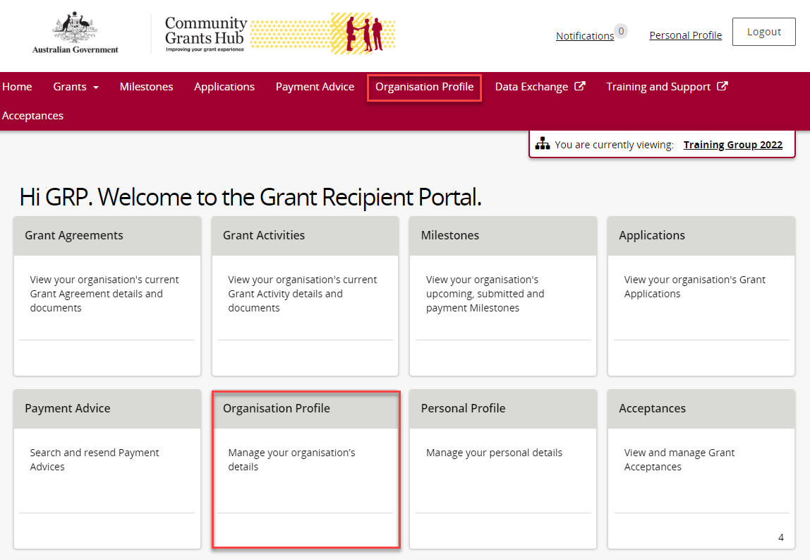

### Step 2

The Organisation Profile screen will display. Select **Staff** from the Organisation profile menu to display the Organisation’s Staff screen.

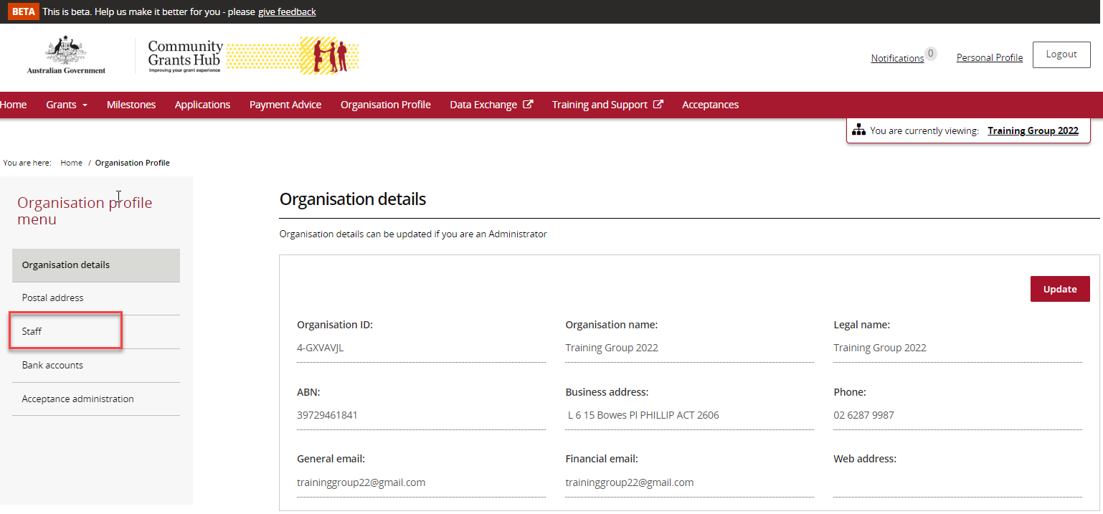

### Step 3

The Organisation’s Staff screen will display. This screen displays Active Staff for the organisation by default. The Staff list can be filtered using the **drop down** menutochoose one of the following:

1. Active Staff
2. Inactive Staff
3. All Staff

**Note:** All staff records display a unique Contact ID. This ID can be very helpful for identification purposes in various screens and assisting with duplicate contacts.

You can view the **Contact ID** from the Staff screen**.**

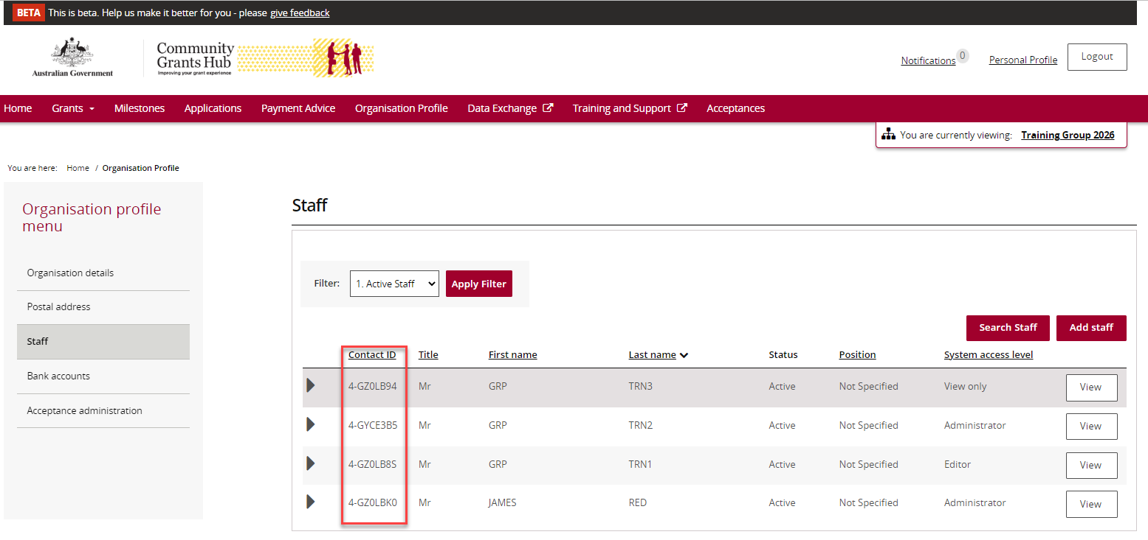

### Step 4

To view additional information about an Organisation staff member select the **View** button next to the staff member.

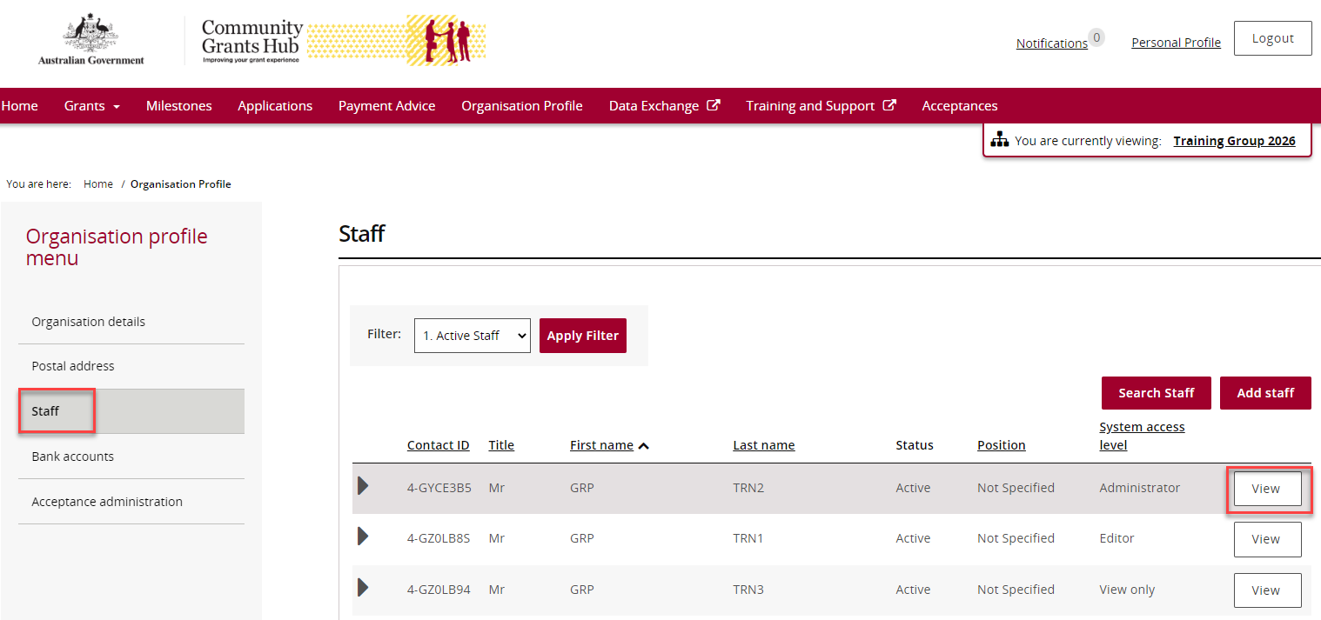

### Step 5

The Staff details screen will display.

This screen has four sections:

* Staff details
* System access
* Contact for Grant Agreements
* Contact for Grant Activities.

This screen is where you will reactivate or inactivate staff records.

For Active Staff records the Inactivate button is enabled.

For Inactive Staff records the Reactivate button is enabled.

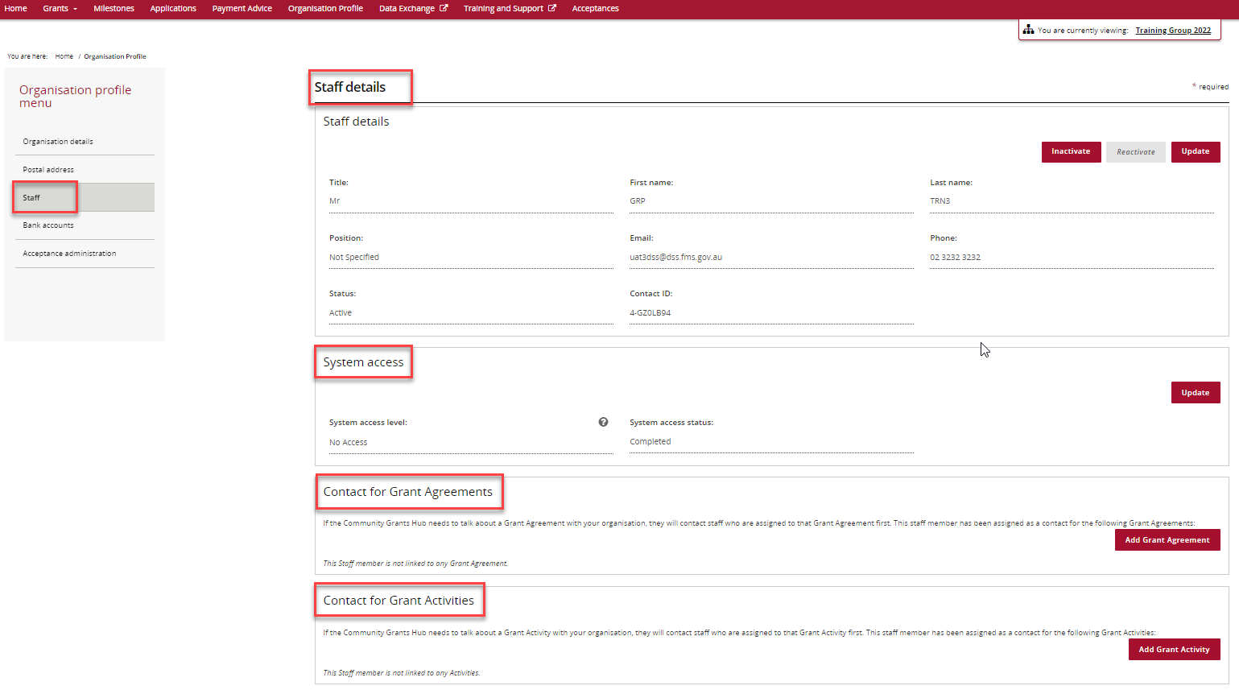

*Example of Active Staff record*

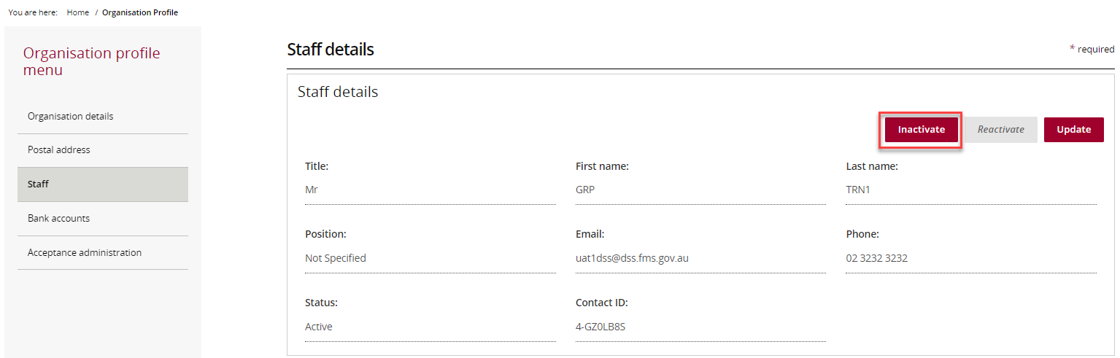

*Example of Inactive Staff record*

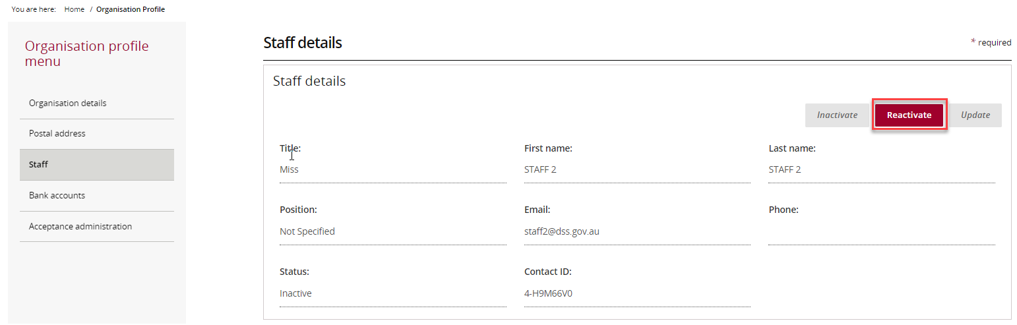

## Reactivating a Staff Record

### Step 6

To reactivate a staff record, from the Staff details screenselect **2. Inactive Staff** from the drop down menu and select **Apply Filter** to view inactive staff for the Organisation.

**Note:** To reactivate a staff record there must be an existing inactive staff record for the Organisation.

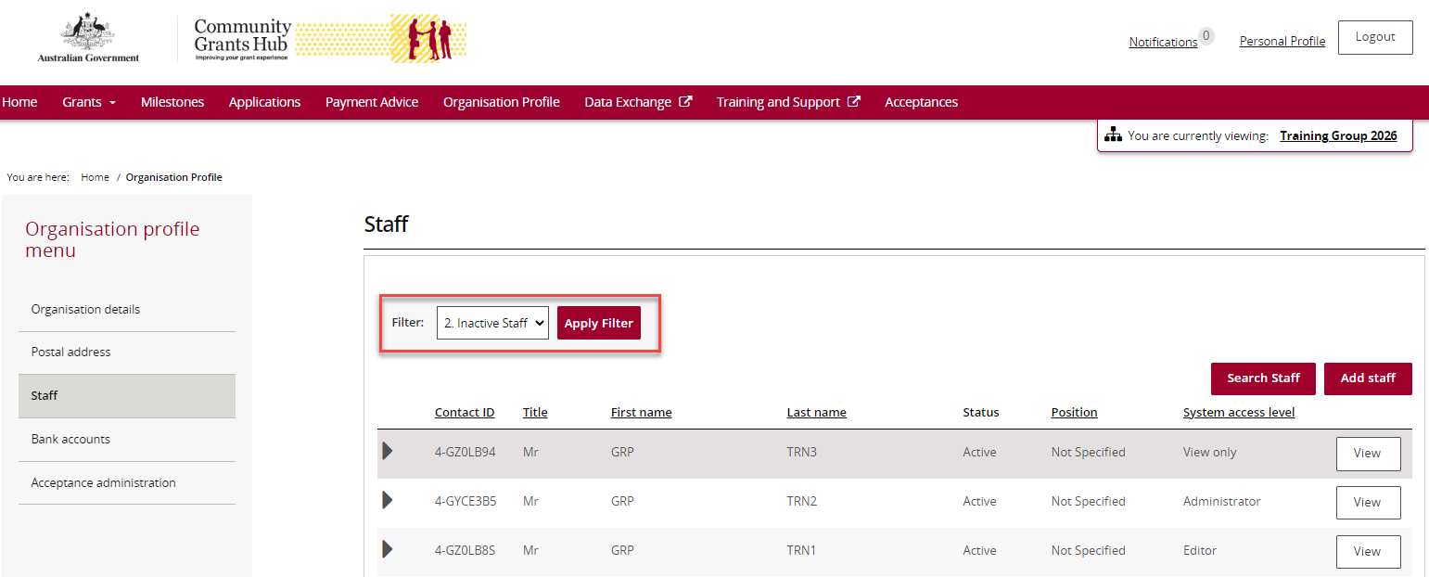

### Step 7

The list of Inactive Staff will display. Select the **View** button next to the staff member you want to reactivate.

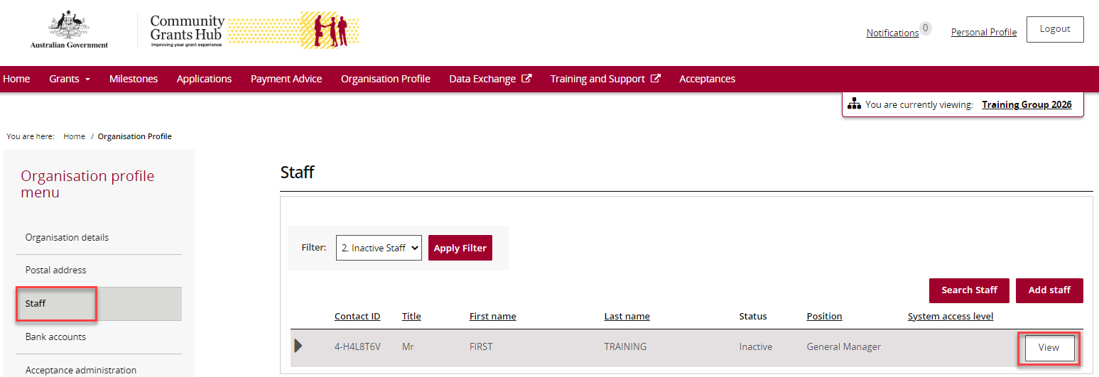

### Step 8

The staff details screen will display.

This screen has four sections:

* Staff details
* System access
* Contact for Grant Agreements
* Contact for Grant Activities

As this contact is inactive, only the **Reactivate** button will be enabled.

Select the **Reactivate** button to update the Staff record as an active contact for the Organisation.

**Note:** Reactivating staff at this level does not re-establish any prior relationships to Agreements or Activities in the Portal. For further details refer to the [Update Grant Agreement Contacts](https://www.communitygrants.gov.au/grant-agreement-contacts) Task Card and [Update Grant Activity Contacts](https://www.communitygrants.gov.au/grant-activity-contacts) Task Card which are available on the [Portal Training and Support](https://www.communitygrants.gov.au/grant-recipient-portal/training-and-support) page of the Hub’s website.

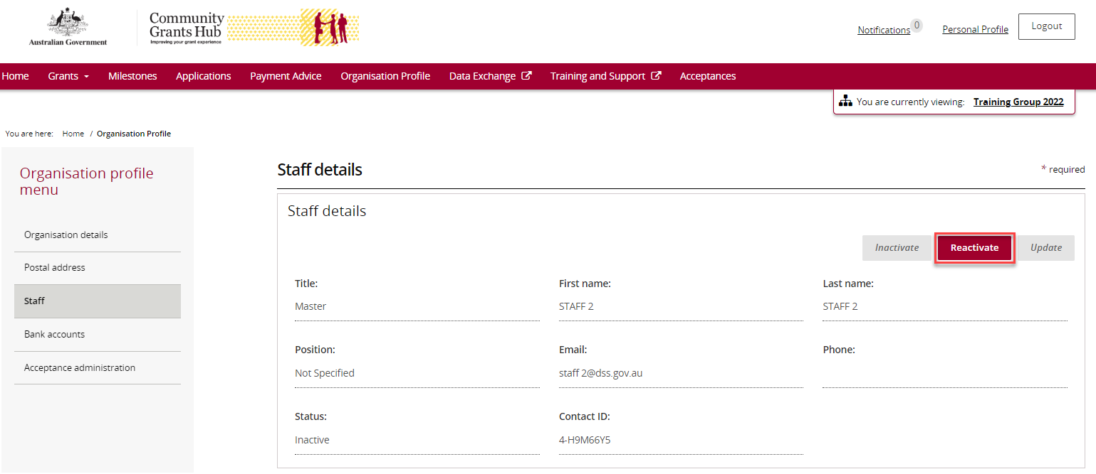

Your contact is now active and listed in the Organisation’s Active Staff list.

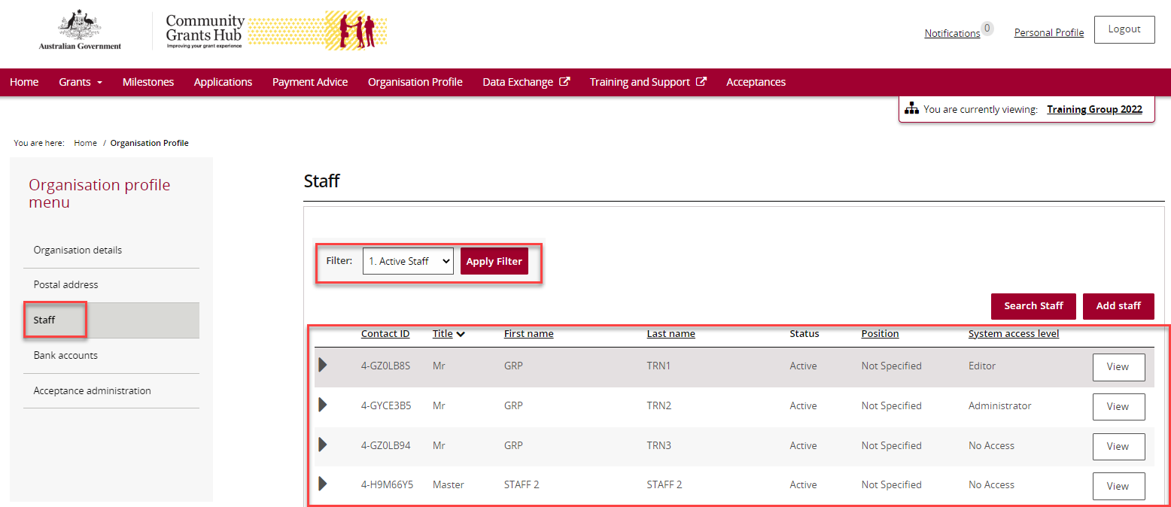

## Inactivating a Staff Record

### Step 9

To inactivate a staff record, from the Staff details screen select **1. Active Staff** from the drop down menu and select **Apply Filter** to view active contacts for the Organisation.

**Note:** To inactivate a staff record there must be an existing active staff record for the Organisation.

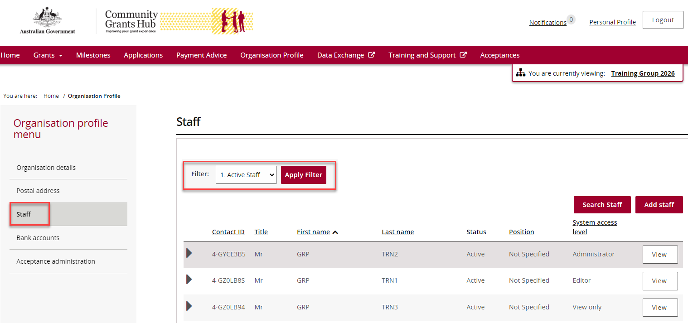

### Step 10

The list of Active Staff will display. Select the **View** button next to the staff member you want to inactivate.



### Step 11

The Staff details screen will display.

This screen has four sections:

* Staff details
* System access
* Contact for Grant Agreements
* Contact for Grant Activities.

As this contact is Active, the **Inactivate** button is enabled.

Select the **Inactivate** button to update the Staff record as an Inactive contact for the Organisation.

**Note:**

* A staff record cannot be inactivated if it is the Primary Contact for a current Agreement, Program Schedule, or Activity until another Primary Contact is assigned.
* If the staff record has a ‘requested’ access status, it also cannot be inactivated and an error message will appear. Please contact the [Portal Helpdesk](mailto:GRP.Helpdesk@communitygrants.gov.au) for assistance with this error.

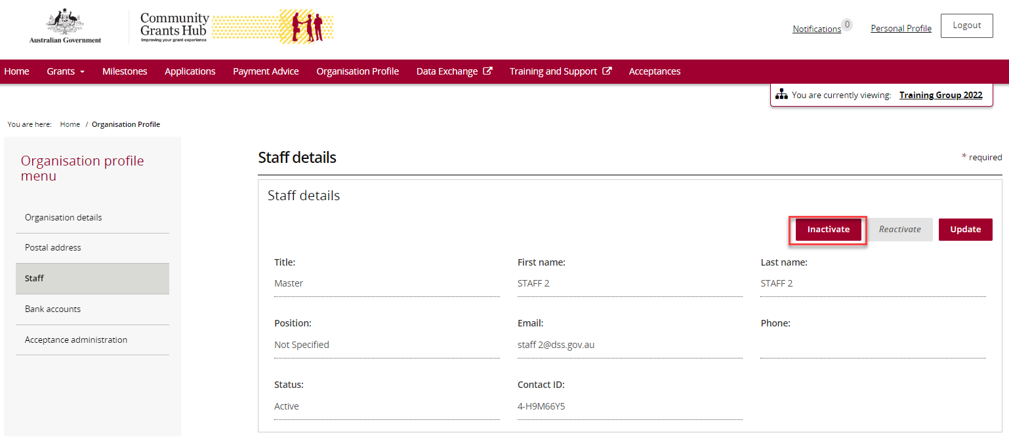

Your contact is now Inactive and listed in the Organisation’s Inactive Staff list.

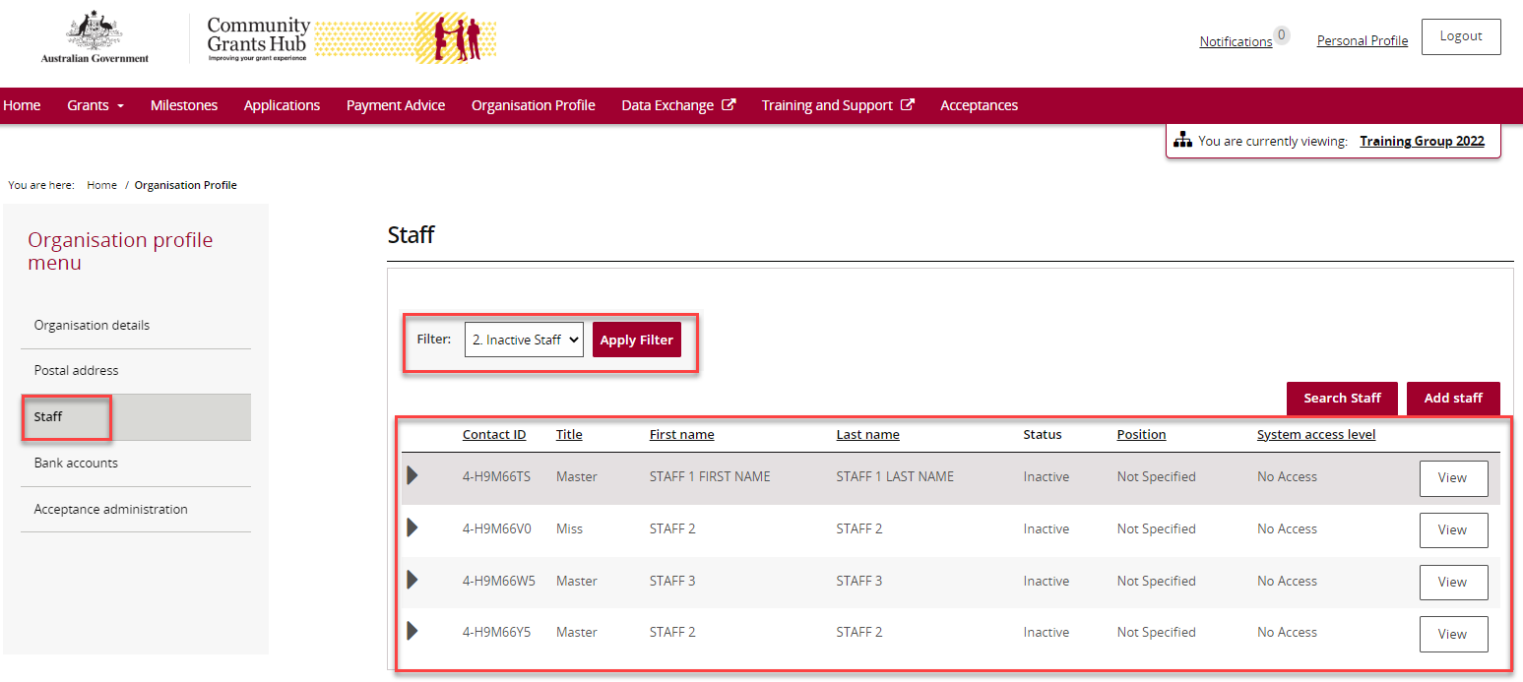

## Need Help?

For further assistance, contact the Grant Recipient Portal Helpdesk:

**Email**: [GRP.Helpdesk@communitygrants.gov.au](mailto:GRP.Helpdesk@communitygrants.gov.au)

**Phone**: 1800 020 283 (Option 5)

**Operating Hours:** Monday to Friday 9:00am – 5:00pm (AEST/AEDT)