# Search and Resend Payment Advice

Grant Recipient Portal Task Card

______________________________________________________________________________

**Portal Access required**: Administrator, Editor or View Only

The Grant Recipient Portal (Portal) enables grant recipients to search and resend their payment advice(s) (also known as a Recipient Created Tax Invoice (RCTI) or Remittance Advice).

This task card describes the process of searching and resending payment advice(s) in the Portal.

## Navigating to Payment Advice

### Step 1

From the Home screen, select the **Payment Advice** tile. Alternatively, select the **Payment Advice** link from the Navigation menu.

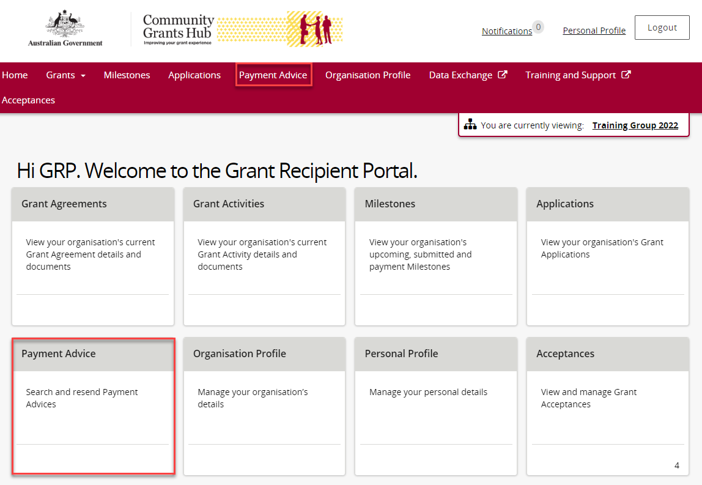

### Step 2

The Payment Advice search screen will display.

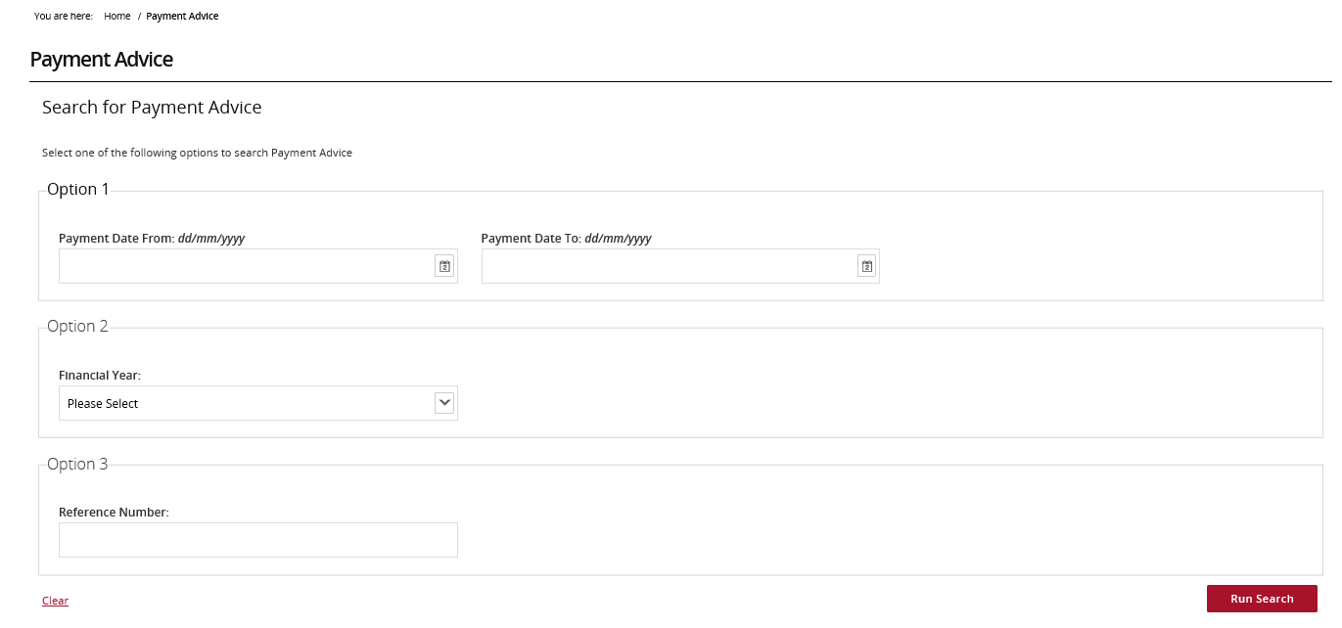

## Search for Payment Advice(s)

### Step 3

Search for a payment using one of the three available options:

* **Option 1 – Payment Date Range –** Allows users to search for a payment using a specific date or date range.
* **Option 2 – Financial Year –** Allows users to search all payments made during a financial year.

**Note:** the financial year is the second year listed in the date range. For example, searching 2022 will return results for the 2021-2022 financial year.

* **Option 3 – Reference Number –** Allows users to search using the payment’s reference number.

**Note:** the reference number can be found on the bank statement and typically starts with 150 or 015.

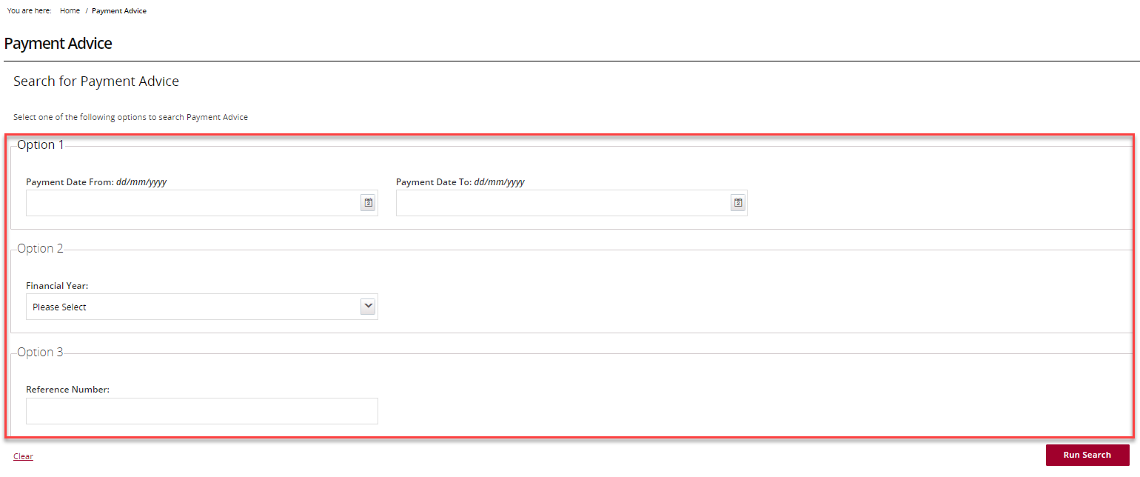

### Step 4

Once the appropriate information has been populated, select the **Run Search** button.

## Screenshot of running a search

### Step 5

The search results will display. Select the **checkbox** next to the Payment Advice(s) thenselect the **Resend Selected** button.

Selecting the **checkbox** next to Payment Date will select all results.

**Note:** Payment Advice(s) cannot be viewed before resending.

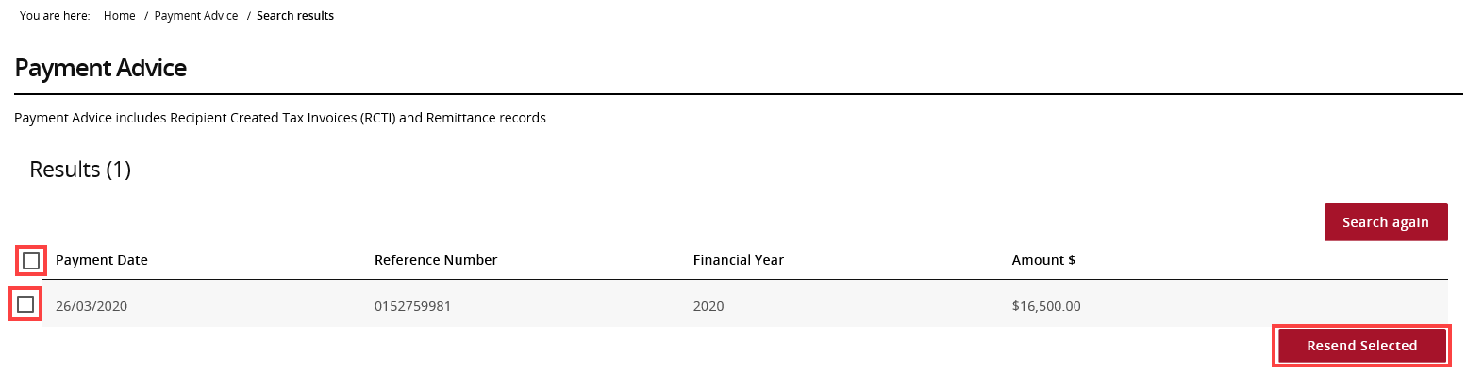

## Email the Payment Advice(s)

### Step 6

After selecting Resend Selected, a dialogue box will display. Enter the appropriate email address/es and select **Resend**.

Copies of the selected Payment Advice(s) will be sent to the nominated email addresses.

**Note:** If the payment advice is not received within 24 hours, please contact the [Grant Recipient Portal Helpdesk](mailto:GRP.Helpdesk@communitygrants.gov.au).

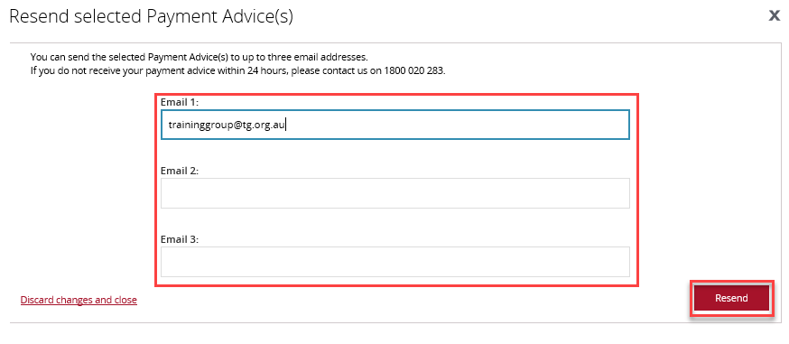

## Need Help?

For further assistance, contact the Grant Recipient Portal Helpdesk:

**Email**: [GRP.Helpdesk@communitygrants.gov.au](mailto:GRP.Helpdesk@communitygrants.gov.au)

**Phone**: 1800 020 283 (Option 5)

**Operating Hours:** Monday to Friday 9:00am – 5:00pm (AEST/AEDT)