# Submit Reports

Grant Recipient Portal Task Card

______________________________________________________________________________

**Portal Access required**: Administrator or Editor

The Grant Recipient Portal (Portal) enables grant recipients to submit some of their reporting milestones including Financial Acquittals, Activity Work Plan (AWP) Reports and Child Safety Statements of Compliance online. Reporting milestones are displayed on both the Milestones and Grant Activities pages in the Portal.

This task card describes the process of submitting a Financial Acquittal, AWP Report and Child Safety Statement of Compliance online through the Portal.

## Navigating to Milestones

### Step 1

From the Home screen, select the **Milestones** tile. Alternatively, select the **Milestones** link in the Navigation menu.

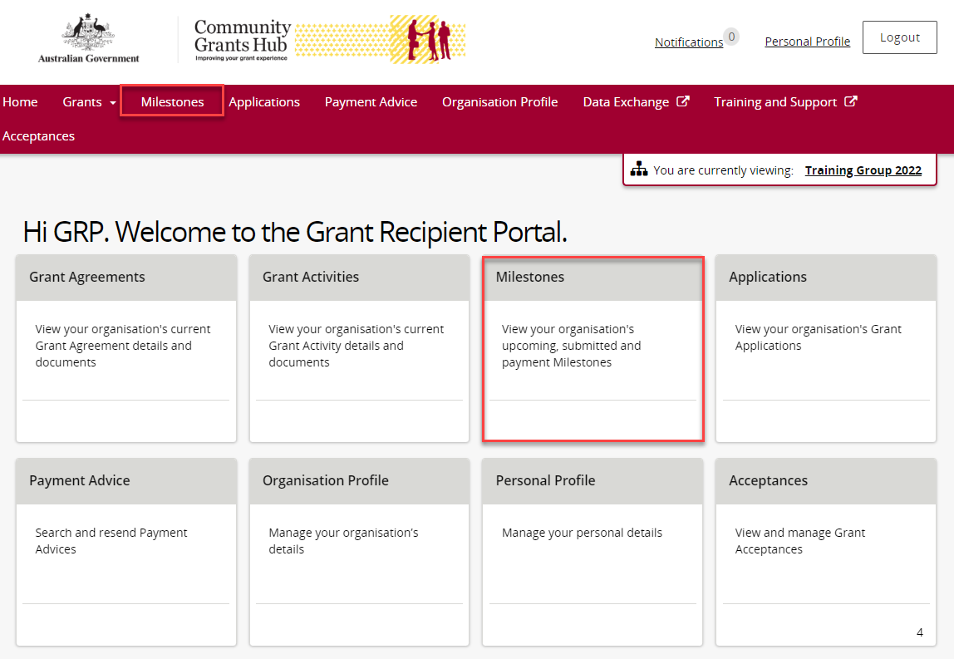

### Step 2

The Milestones screen displays upcoming milestones for the organisation by default.

To display upcoming milestones, use the dropdown menu to select **1. Upcoming Milestones** then select **Apply Filter**.

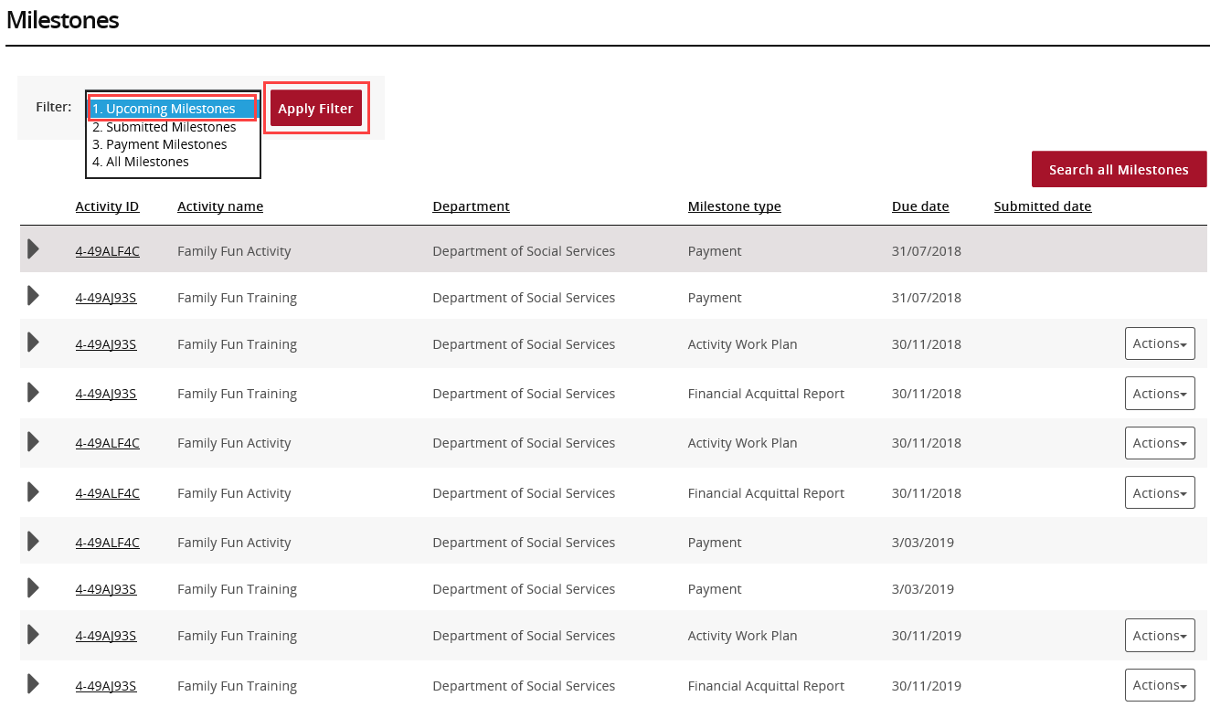

### Step 3

Once the filter has been applied, the 1. Upcoming Milestones will be displayed.

When the correct milestone has been identified, select **Actions** to submit the report.

To submit a Financial Acquittal, proceed to step 9. To submit an AWP Report, proceed to step 21.

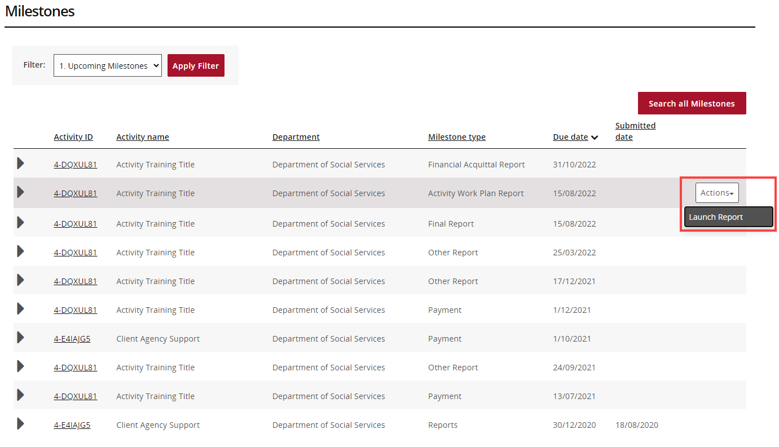

## Navigating to Milestones from Grant Activities

### Step 4

From the Home screen, select the **Grant Activities** tile. Alternatively, select **Grants** in the Navigation menu and select **Grant Activities** from the drop down menu.

## Screenshot of the home page of the portal with grant activities tab and the grant activities tile highlighted.

### Step 5

The Grant Activities screen will display. Select the **expansion arrow** next to an Activity ID to show additional information about the Activity.

Select the **View** button next to the Grant Activity record to open the Activity details.

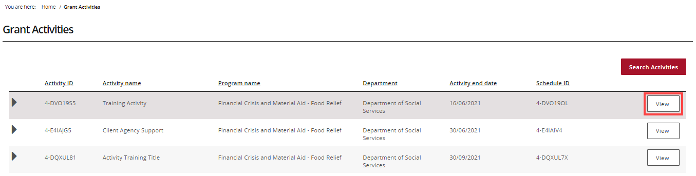

### Step 6

The Activity details screen will display. Select **Milestones** from the Grant Activity menu.

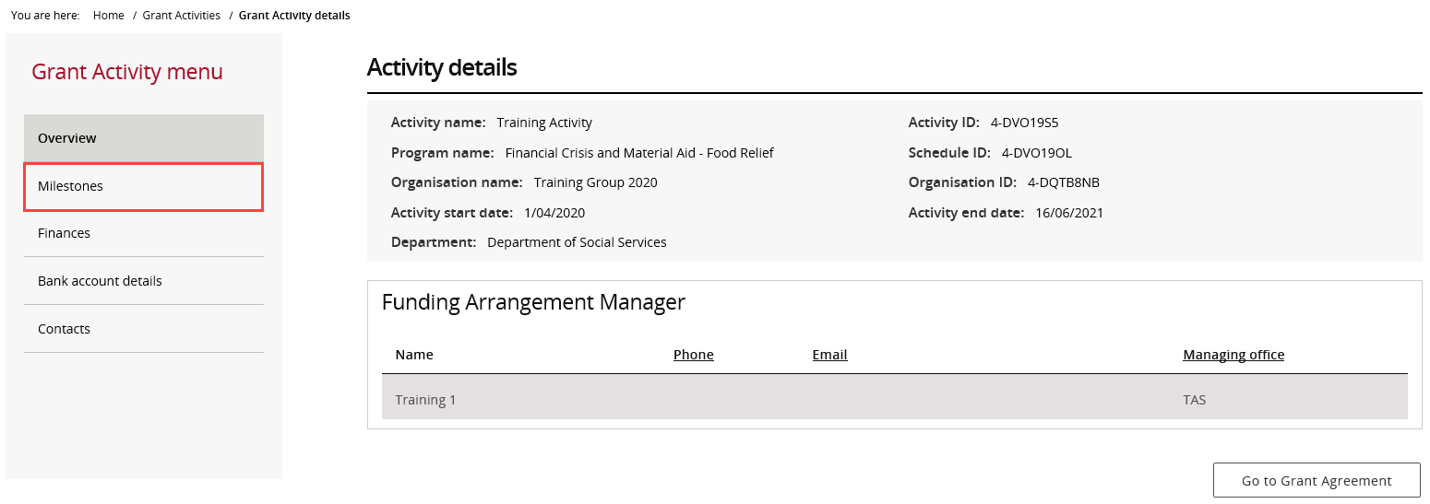

### Step 7

The Milestones screen will display. By default, Filter 1. Upcoming Milestones will be presented.

To change the filter, use the drop down menu and select **Apply Filter** or

To locate a specific Milestone, perform a search by selecting **Search all Milestones**.

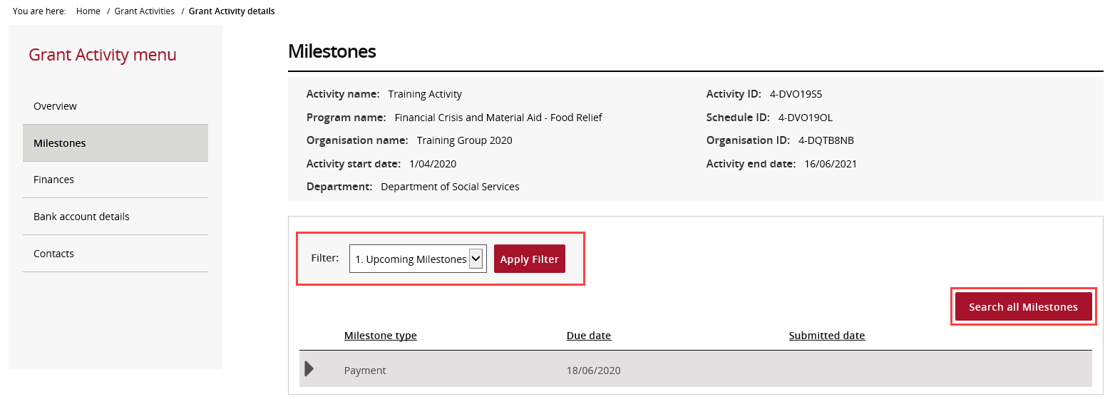

### Step 8

When the correct milestone has been identified, select **Actions** to submit the report.

To submit a Financial Acquittal, proceed to step 9. To submit an AWP Report, proceed to step 21. To submit a Child Safety Statement of Compliance, proceed to step 34.

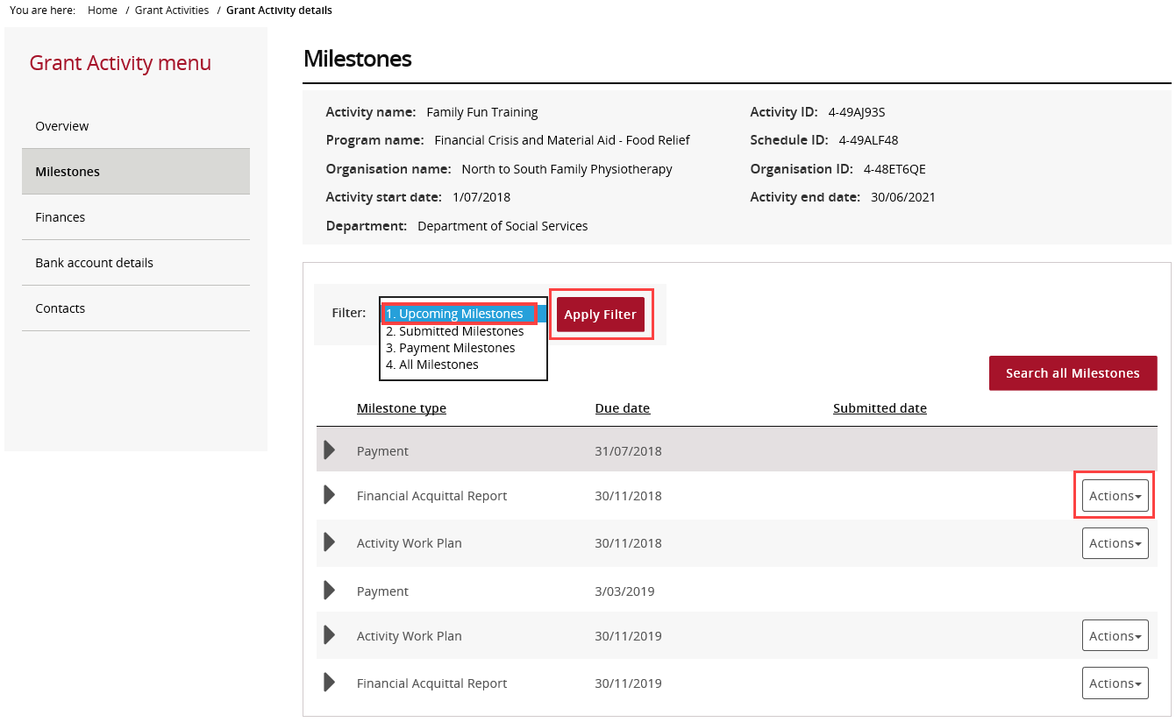

## Submitting a Financial Acquittal

### Step 9

Select the **Actions** button to **Launch Report**.



### Step 10

The Financial Acquittal Report screen will display.

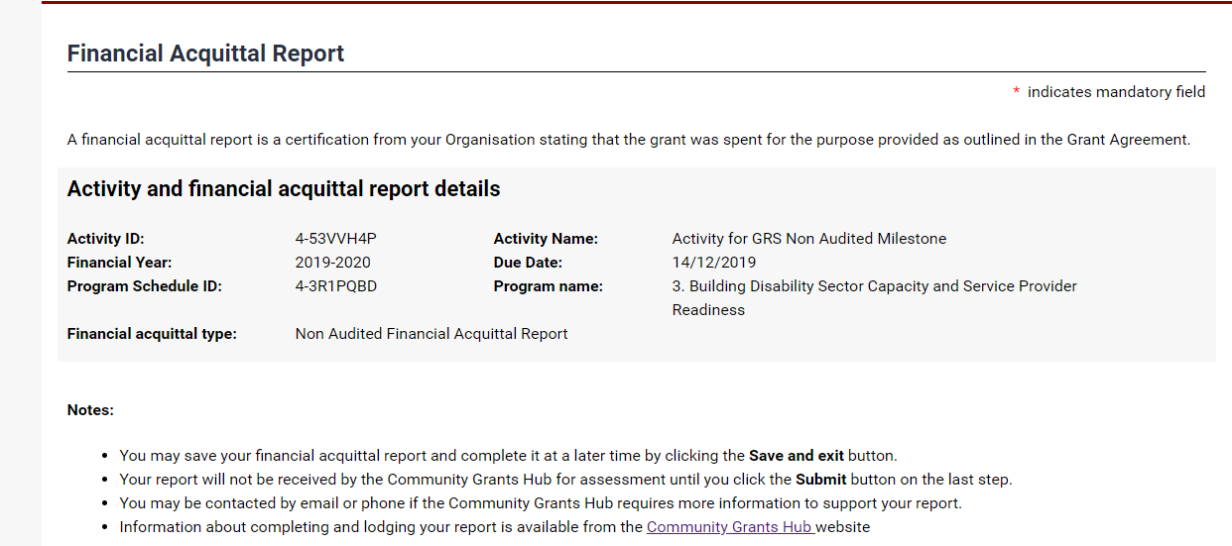

### Step 11

The Activity funding received from the prior financial year will need be declared. The mandatory fields marked with a red asterisk need to be completed.

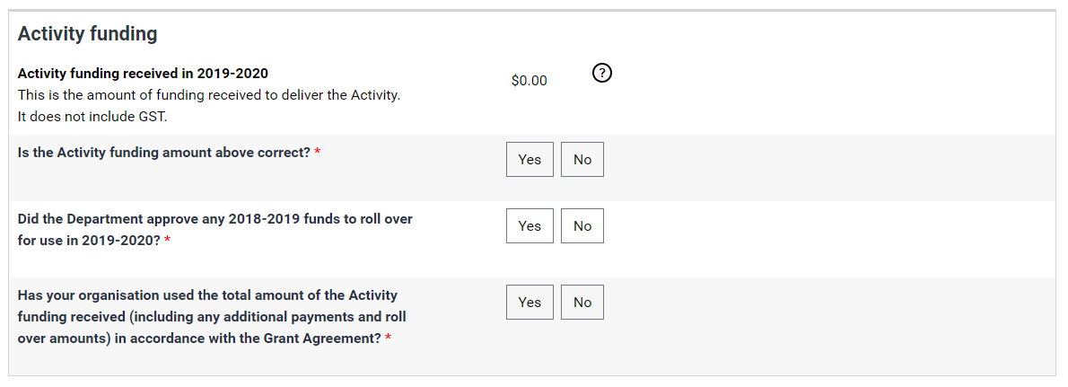

### Step 12

Supporting documents must be provided if the Grant Agreement requires an Audited or Non-audited Financial Acquittal.

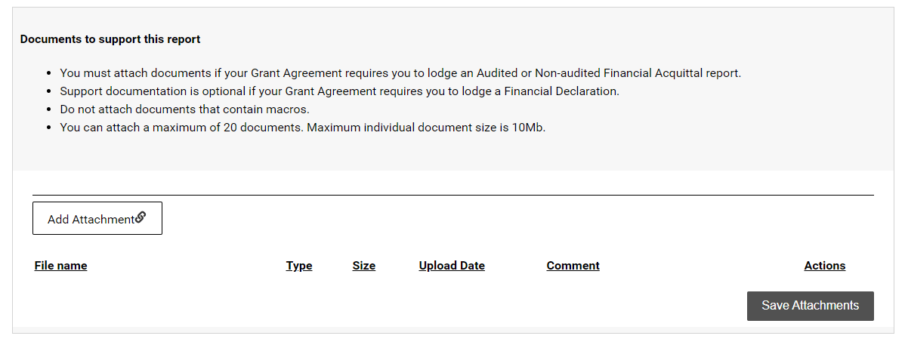

### Step 13

Select **Add Attachment** to choose the appropriate documents to attach.

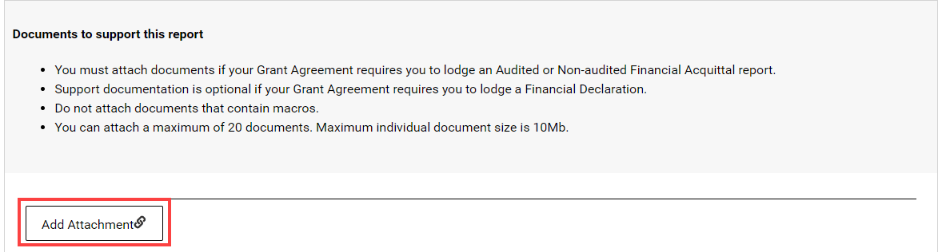

### Step 14

After attaching the documents, you can select the **Actions** drop down menu to **View**, **Remove** or **Edit comment** for each attachment.

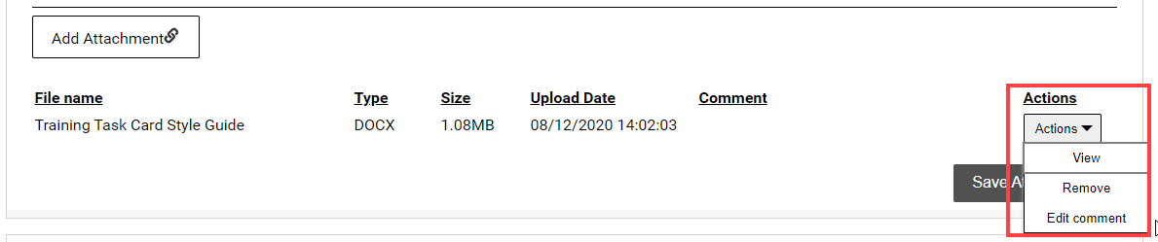

### Step 15

Once all attachments to support the Acquittal have been added, select **Save Attachments.**

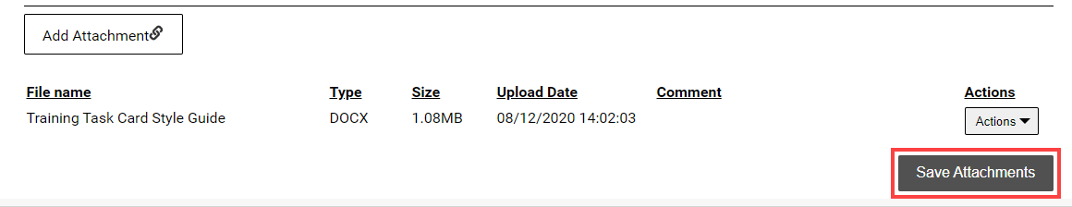

### Step 16

Do not leave this screen while data is being submitted. Once the message disappears, continue to complete the report.

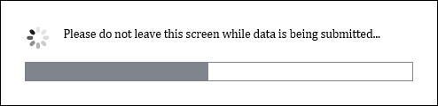

### Step 17

A message will display to advise if the documents were successfully saved.

**Note:** To attach more documents, select **Return to list**.

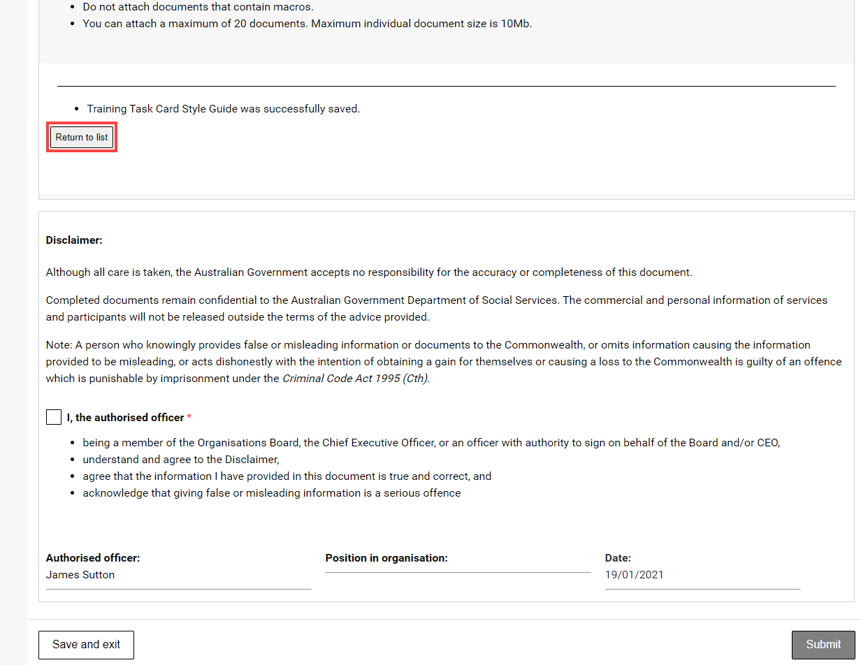

### Step 18

Review the Disclaimer and select the **checkbox** to agree to the Disclaimer then select **Submit**.

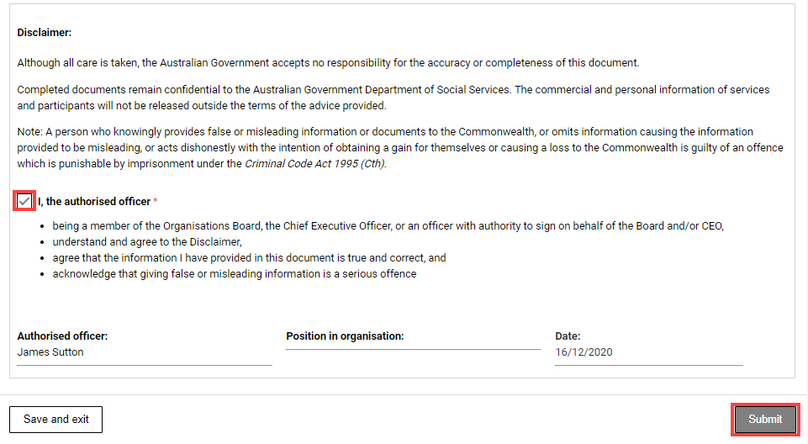

### Step 19

A message will appear advising to stay on this screen until the data has been submitted.

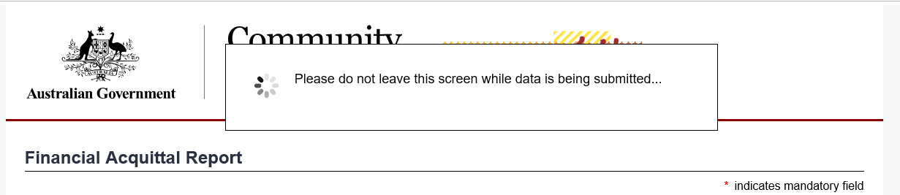

### Step 20

A confirmation page will display. Select **Save and exit** to close the form.

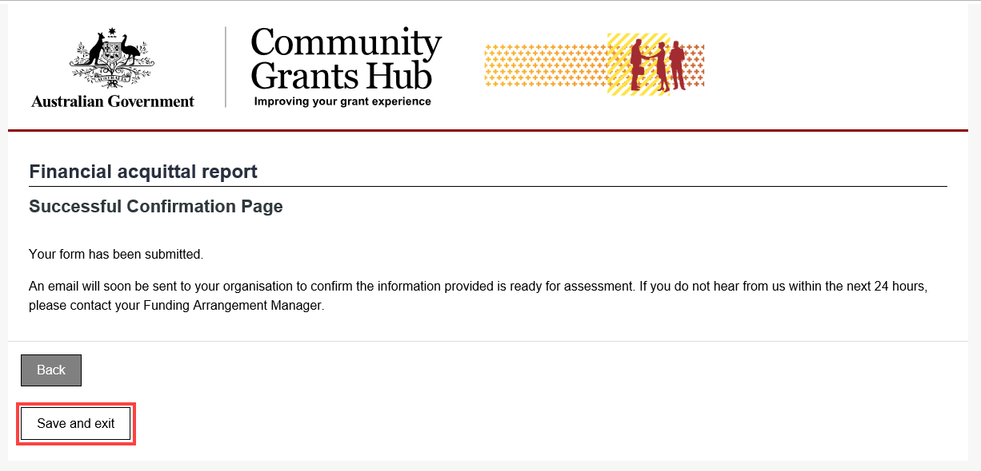

## Submitting an Activity Work Plan Report

### Step 21

Select the **Actions** button to Launch Report.

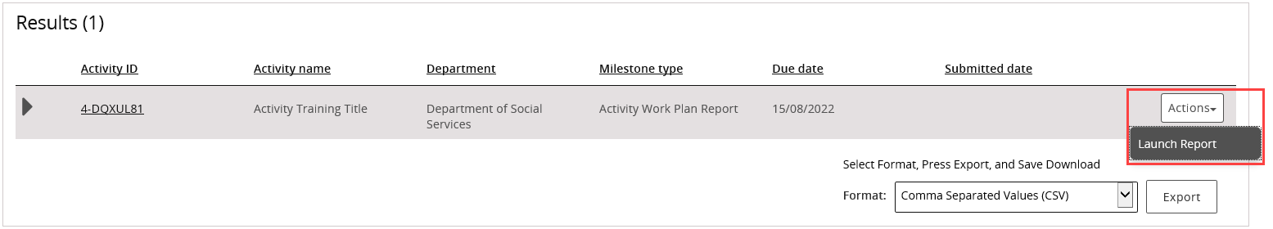

### Step 22

The Upload Report screenwill display. The AWP Report template will need to be completed and saved before attaching it in this view.

If an AWP Report template is required, select the Activity Work Plan (AWP) report templatelink.

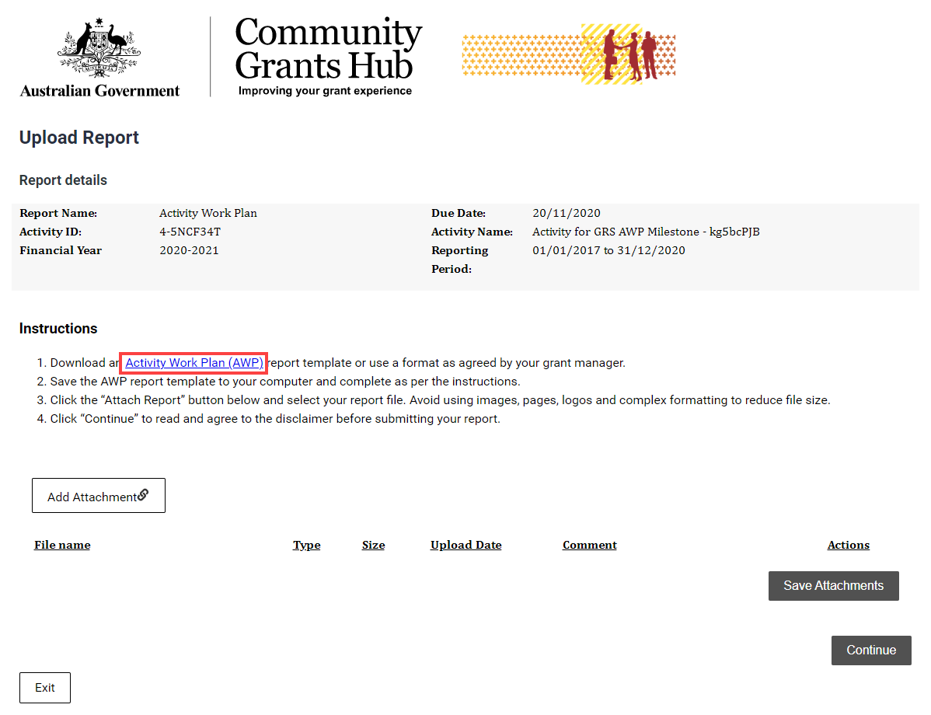

### Step 23

The link will display the Department of Social Services webpage. Select the **Standardised AWP report template** link.

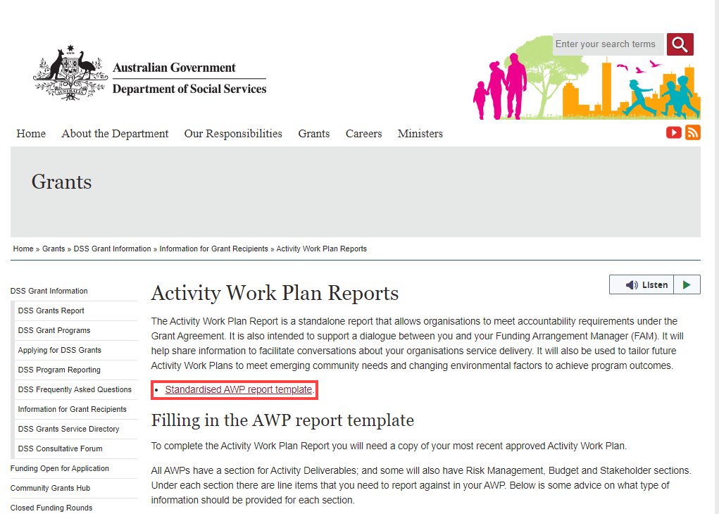

### Step 24

Use the word version for completing the AWP Report and save the document to upload it into the Portal.

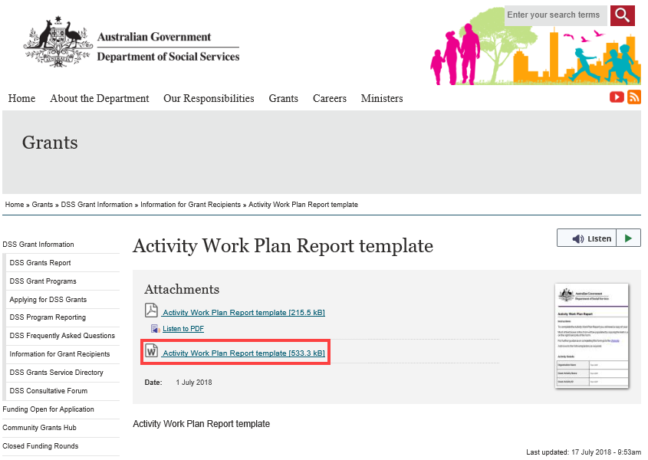

### Step 25

Select **Add attachment** to choose the appropriate documents to attach.

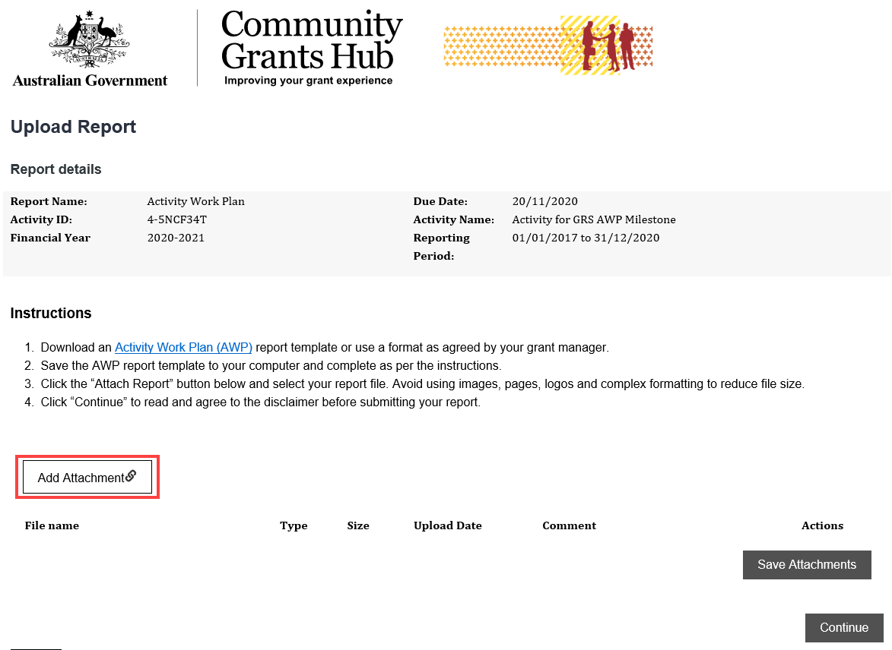

### Step 26

After attaching the documents, you can select the **Actions** drop down menu to **View**, **Remove** or **Edit comment** for each attachment.



### Step 27

Once all attachments to support the AWP Report have been added, select **Save Attachments**.



### Step 28

Do not leave this screen while data is being submitted. Once the message disappears, continue to complete the report.



### Step 29

A message will display to advise if the documents were successfully saved.

**Note:** To attach more documents, select **Return to list.**

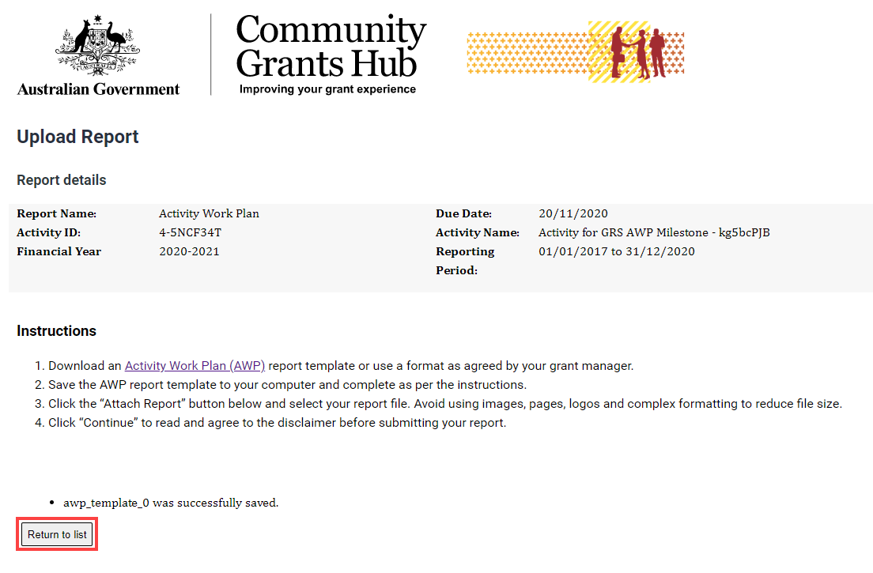

### Step 30

Select **Continue** to go to the next step.

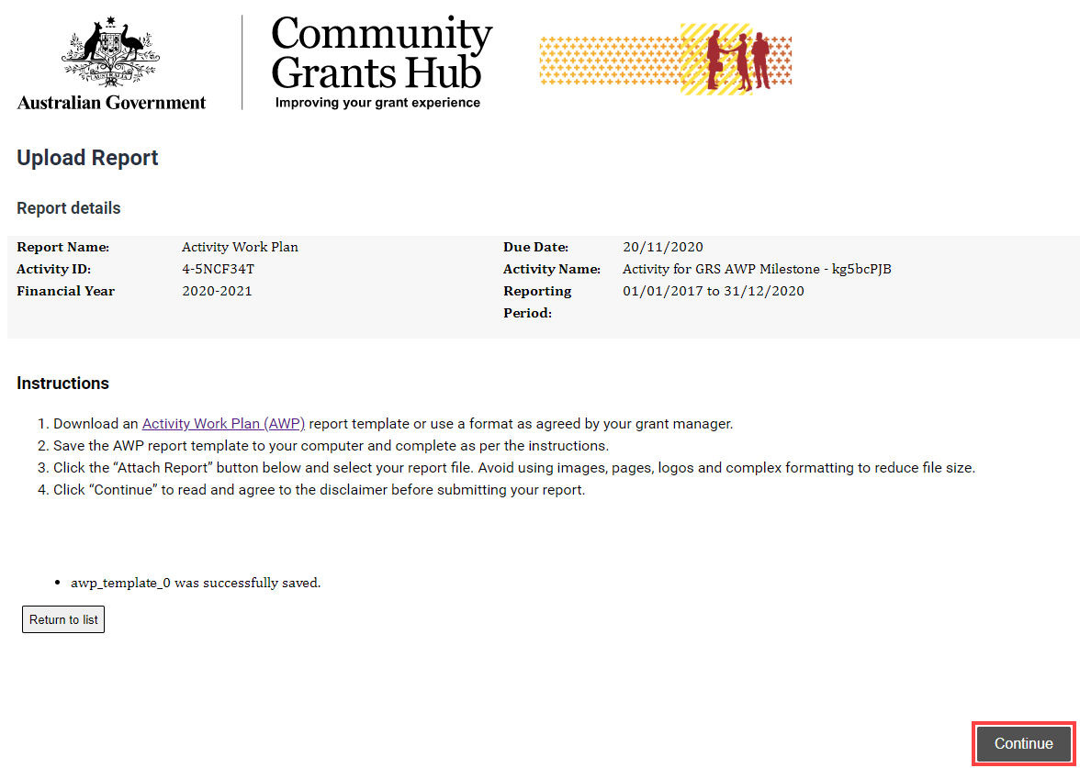

### Step 31

Review the Disclaimer and select the **checkbox** to agree to the Disclaimer then select **Submit**.

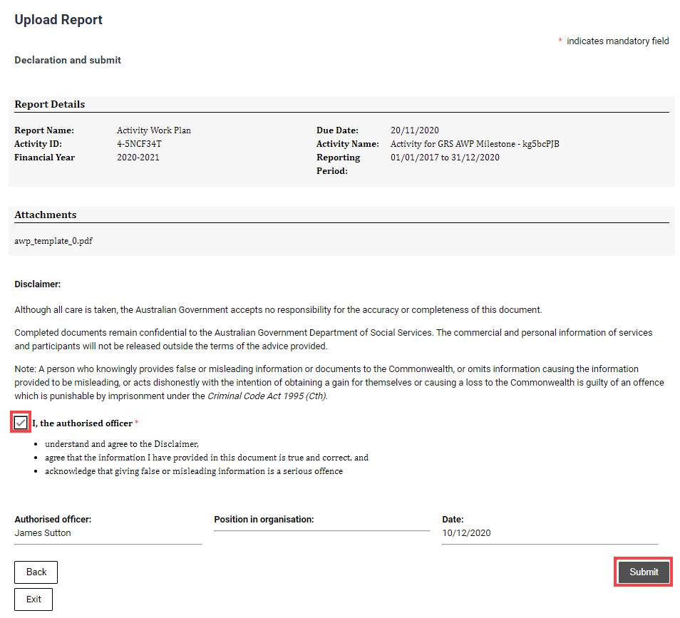

### Step 32

A message will appear advising to stay on this screen until the data has been submitted.

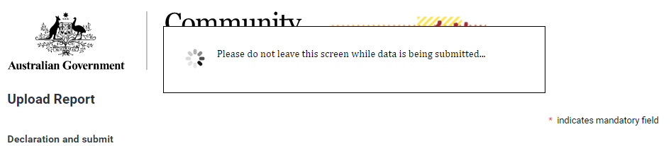

### Step 33

A confirmation page will display. Select **Exit** to close the form.

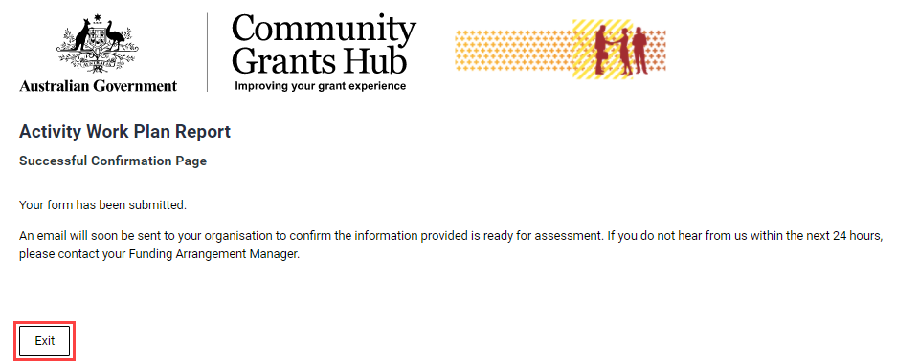

## Submitting a Child Safety Statement of Compliance

### Step 34

Select the **Actions** button to Launch Report.

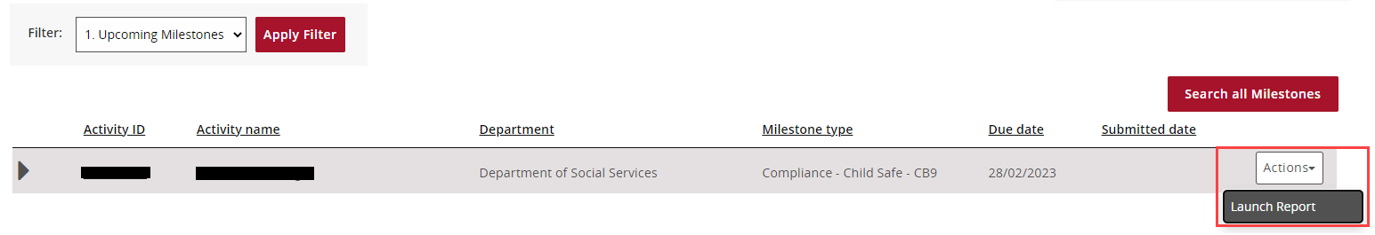

### Step 35

The Instructions Cover Page screenwill display. Select **Next** at the bottom of the page to proceed to the Statement of Compliance.

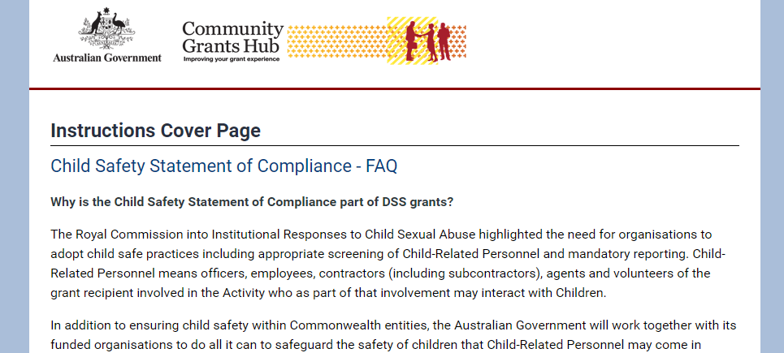

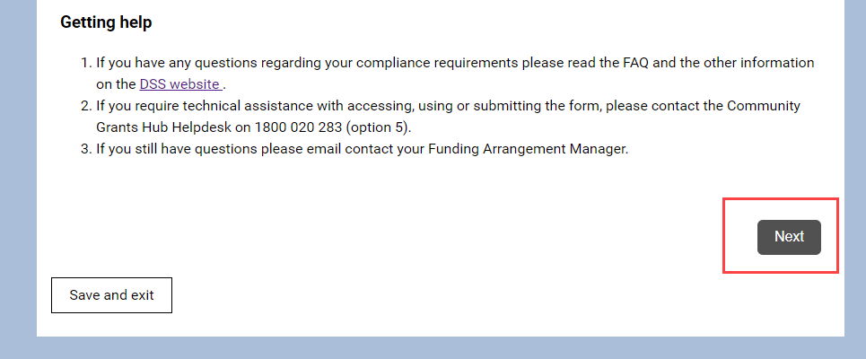

### Step 36

The Statement of Compliance page will load. Details of the grant and the declaration will appear.

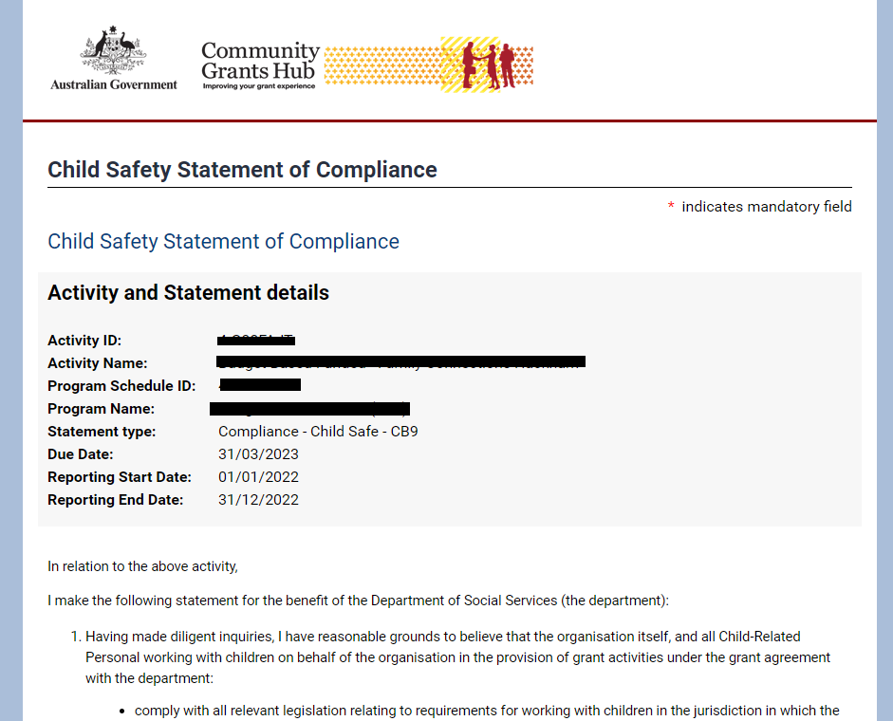

### Step 37

Scroll down to the bottom of the Statement and complete all applicable fields.

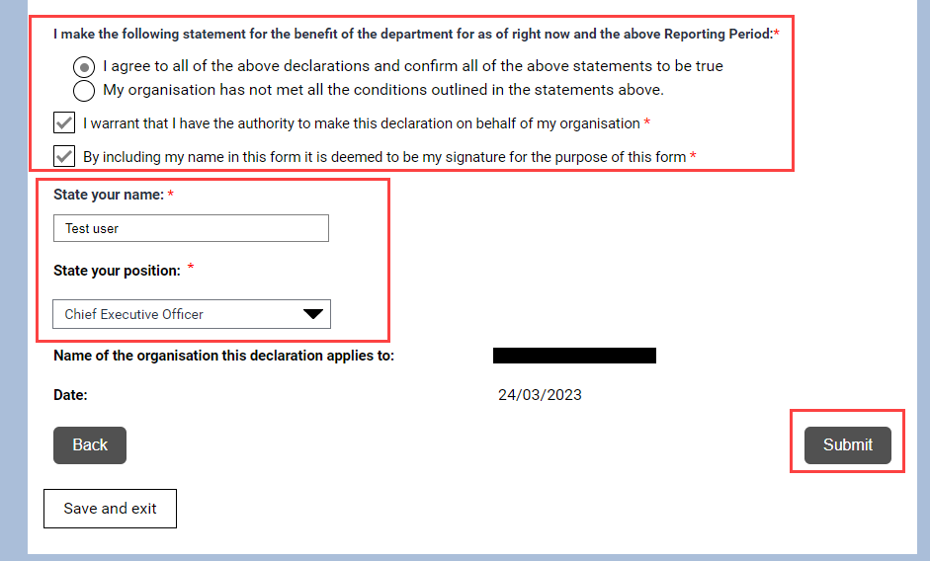

Press **Submit** to complete the Statement of Compliance.

### Step 38

A confirmation page will display. Select **Save and exit** to close the form.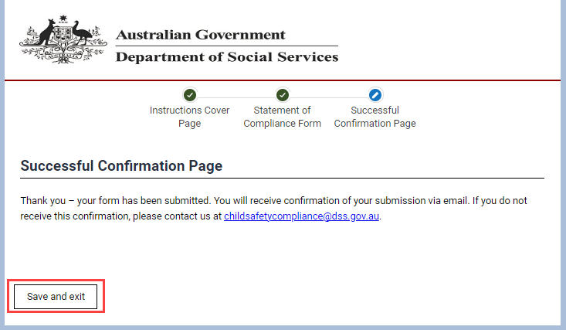

A submission confirmation email will be sent to the Program Schedule primary contact of the grant.

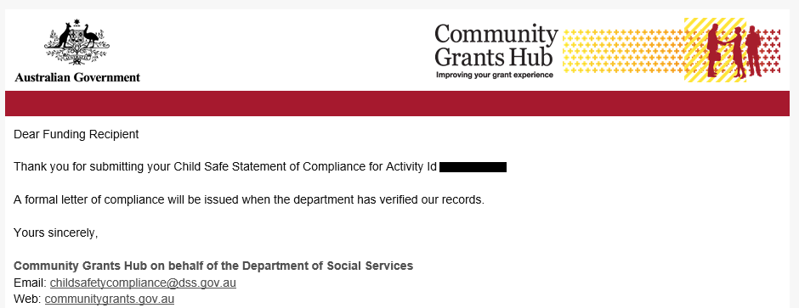

## Need Help?

For further assistance, contact the Grant Recipient Portal Helpdesk:

**Email**: [GRP.Helpdesk@communitygrants.gov.au](mailto:GRP.Helpdesk@communitygrants.gov.au)

**Phone**: 1800 020 283 (Option 5)

**Operating Hours:** Monday to Friday 9:00am – 5:00pm (AEST/AEDT)