# Update your Personal Profile

Grant Recipient Portal Task Card

______________________________________________________________________________

**Portal Access required**: Administrator, Editor or View Only

The Grant Recipient Portal (Portal) enables grant recipients to view and self-manage their Personal Profile information as well as selecting which Organisation information to view (where a user has access to multiple organisations).

This task card describes the process of updating their Personal Profile and selecting an Organisation to view.

## Updating your Personal Profile Information

### Step 1

From the Home screen, select the **Personal Profile** tile. Alternatively, select the **Personal Profile** link in the top right hand corner.

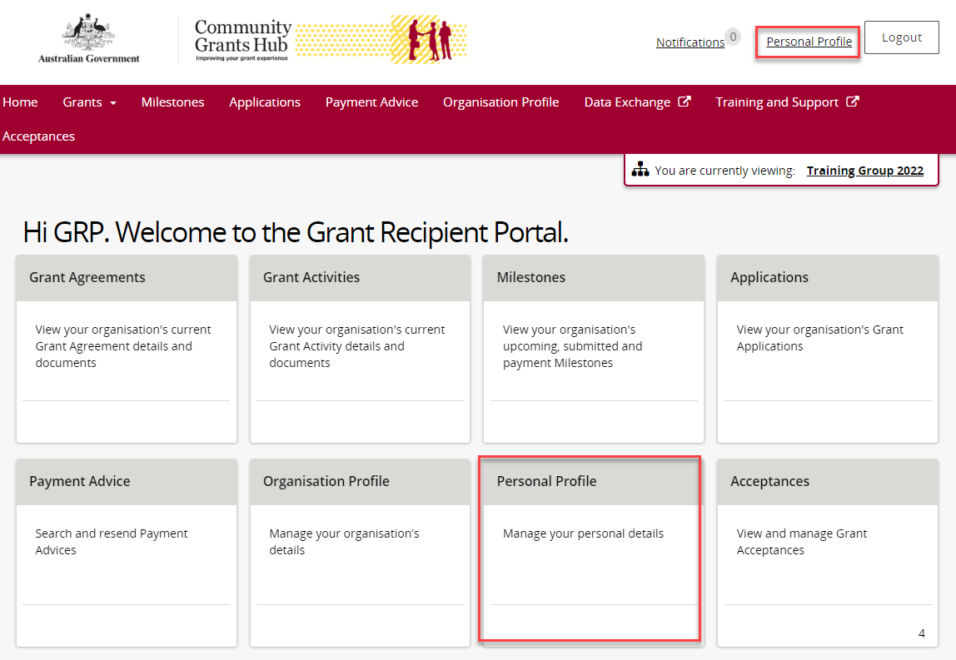

### Step 2

The Personal Profilescreen will display. This screen has two sections:

* Personal Profile
* Organisation selection

The below information related to your Personal Profile can be viewed:

* First Name
* Last Name
* Job Title
* Work Phone
* Mobile
* Email Address
* Preferred method of communications
* Contact Id

The Organisation selection section displays organisations you have access to.

## Screenshot of personal profile screen and the organisation selection area highlighted below.

### Step 3

To update your personal details, select **Update Profile**.

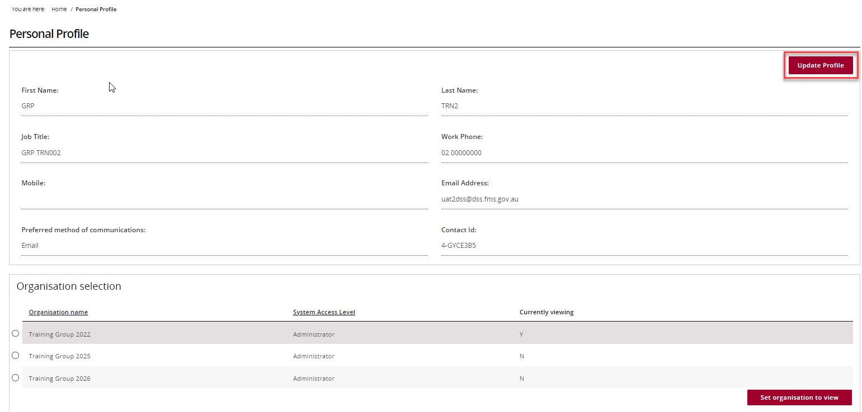

### Step 4

The Update Personal Profile page will display. All mandatory fields marked with an asterisk must be populated at all times.

The following personal details can be changed:

* Job Title
* Preferred method of communications
* Mobile
* Work Phone

Once the changes have been made, select the **Save** button.

**Note:** All other fields are linked to your access and cannot be changed through this page on the Portal. If changes are required to these fields contact the [Grant Recipient Portal Helpdesk](mailto:GRP.Helpdesk@communitygrants.gov.au).

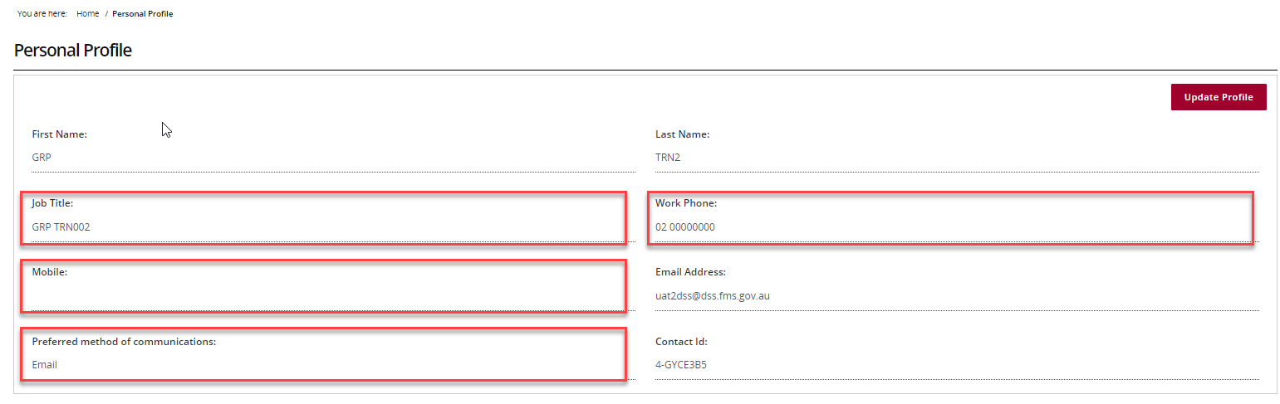

## Updating your Organisation view

### Step 5

In the Personal Profile screen under Organisation selection, will be a list of organisations you have access to.

**Note:** Some users have access to multiple Organisations. To access an organisation with a different ABN, Grant Recipients must have a separate account and access to the ABN in Relationship Authorisation Manager (RAM).

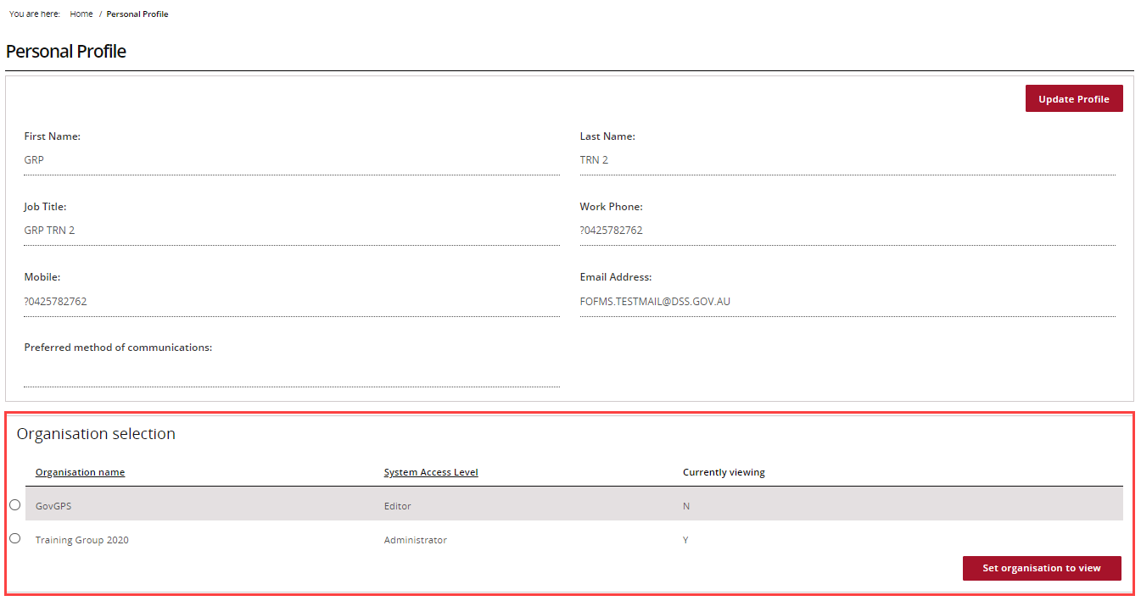

### Step 6

To change the Organisation, select the Organisation and select **Set organisation to view.**

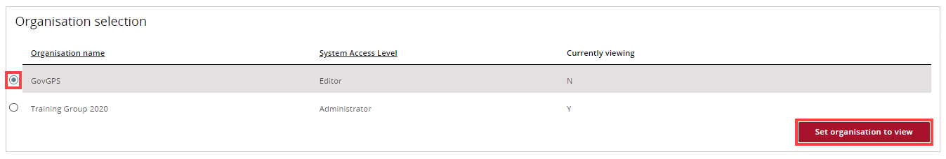

### Step 7

The Organisation you are currently viewing in the Portal will be marked as **‘Y’**.

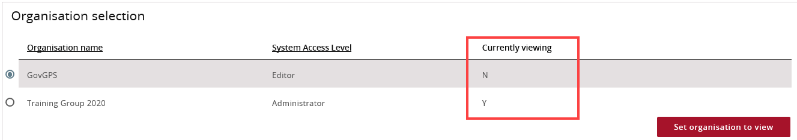

## Need Help?

For further assistance, contact the Grant Recipient Portal Helpdesk:

**Email**: [GRP.Helpdesk@communitygrants.gov.au](mailto:GRP.Helpdesk@communitygrants.gov.au)

**Phone**: 1800 020 283 (Option 5)

**Operating Hours:** Monday to Friday 9:00am – 5:00pm (AEST/AEDT)