# Update Bank Account Information

Grant Recipient Portal Task Card

________________________________________________________________________________________________

**Portal Access required**: Administrator

The Grant Recipient Portal (Portal) enables grant recipients to view, add and request changes to their bank account information.

This task card describes the process of viewing, adding and making changes to bank account details.

## Navigating to bank accounts

### Step 1

From the Home screen, select the **Organisation Profile** tile. Alternatively, select the **Organisation Profile** link from the Navigation menu.

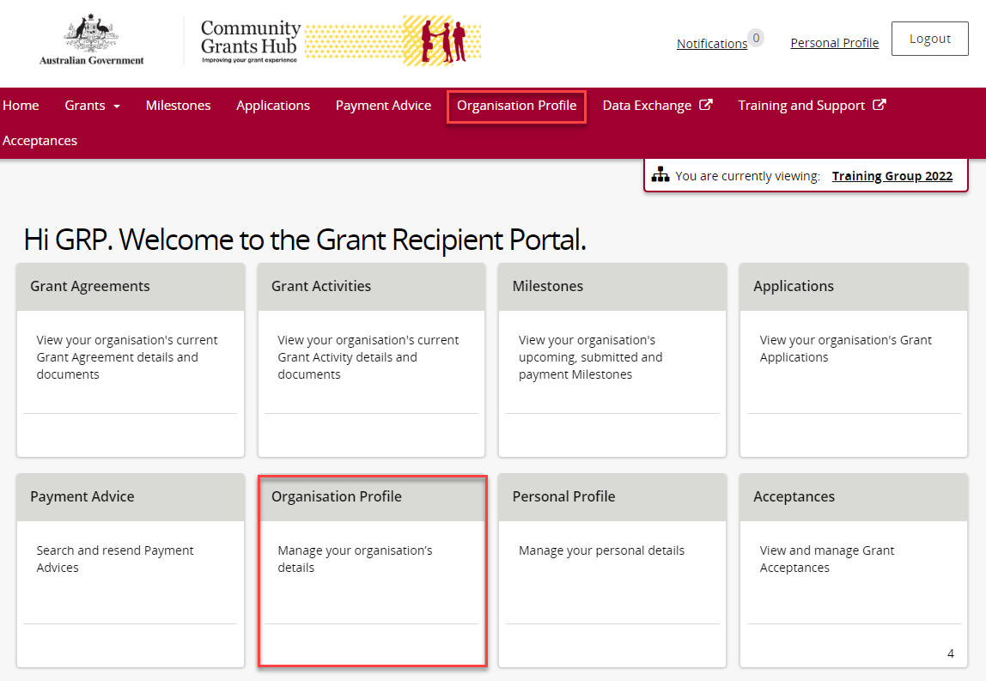

### Step 2

The Organisation Profile screen will display. Select **Bank accounts** from the Organisation profile menu to display a list of the Organisation’s bank accounts. Select **View** to display additional information about a particular bank account.

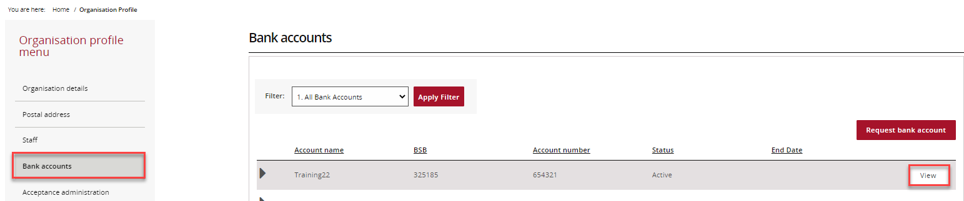

### Step 3

The Bank account details screen will display. This screen also includes details of Grant Activities linked to this bank account.

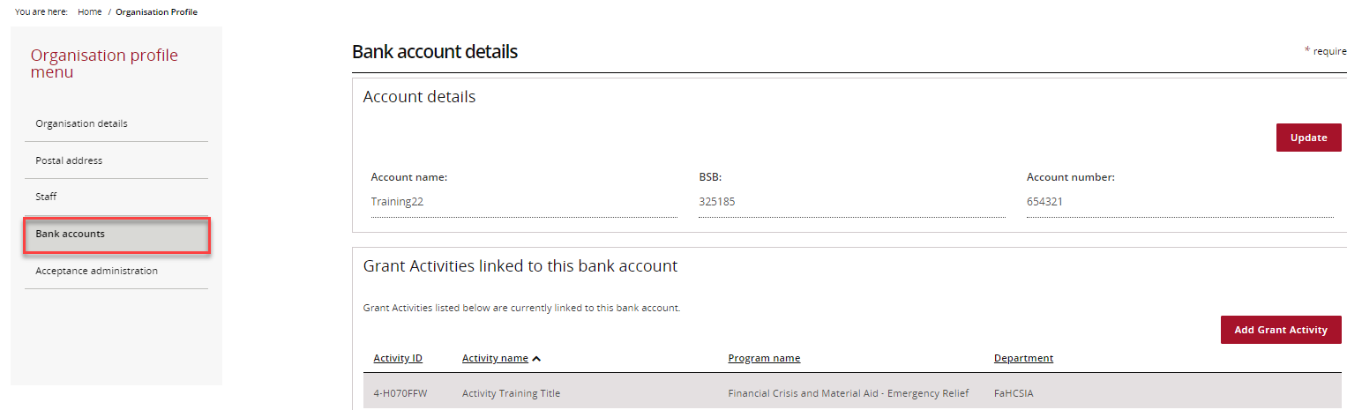

## Updating a bank account name

### Step 4

From the Bank accounts screen, select **View** to display additional information about the bank account.

## This screenshot is of the bank account linked to the grant. The View button is highlighted.

### Step 5

The Bank account details screen will display. To update the Account name select **Update**.

**Note:** The existing BSB and Account number cannot be changed. If a change is required to these fields a new bank account must be requested.

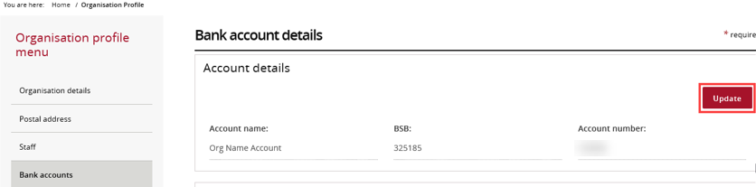

### Step 6

The mandatory fields marked with an asterisk must be populated at all times. Once the Account name has been changed, select **Save and return**.

The screenshot shows the Update bank account screen in the Grant Recipient Portal. The save and return button is highlighted.


## Add bank account to Grant Activities

### Step 7

To view or update Grant Activities linked to an existing bank account, select **View** against the appropriate bank account.

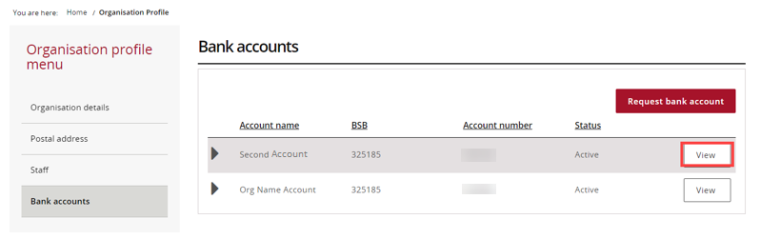

### Step 8

This will display the Grant Activities linked to the chosen bank account, select **Add Grant Activity**.

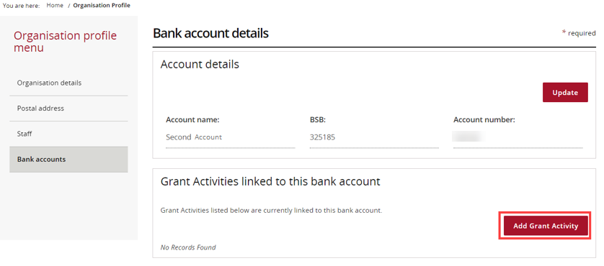

### Step 9

The Link Grant Activities to bank account screen will display.

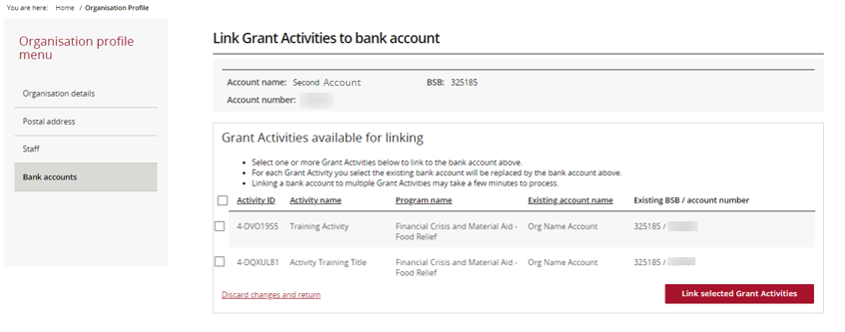

### Step 10

Select the **checkbox** against the appropriate Grant Activities and select **Link selected Grant Activities** to link the bank account.

**Note:** To choose all Grant Activities, select the **checkbox** to the left of Activity ID.

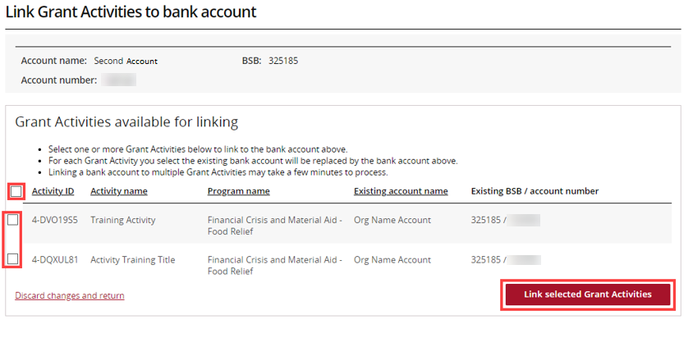

### Step 11

A confirmation page will display. Select **Submit** to finalise the update.

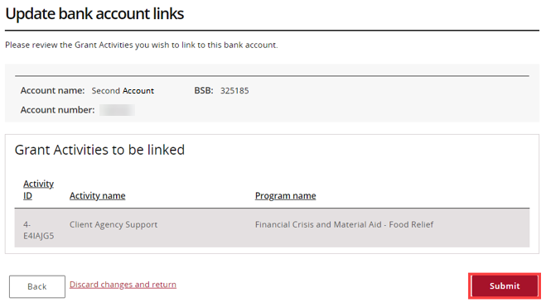

## Add a Bank Account

### Step 12

In the Bank accounts screen select **Request bank account** to add new bank account details.

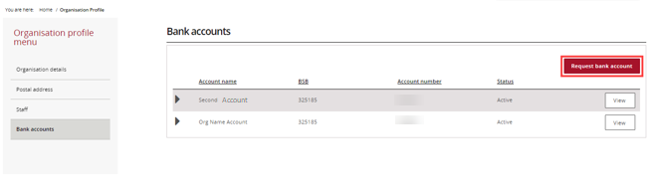

### Step 13

The Request bank account screen will display. Complete the Account name, BSB and Account number and select **Continue**.

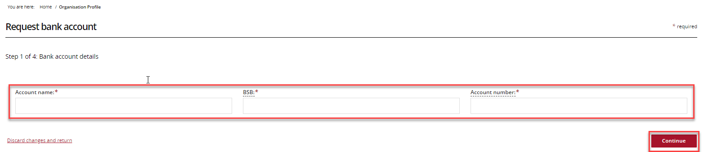

### Step 14

Proof of bank account details will be required. Select **Add file** to attach a file from your computer.

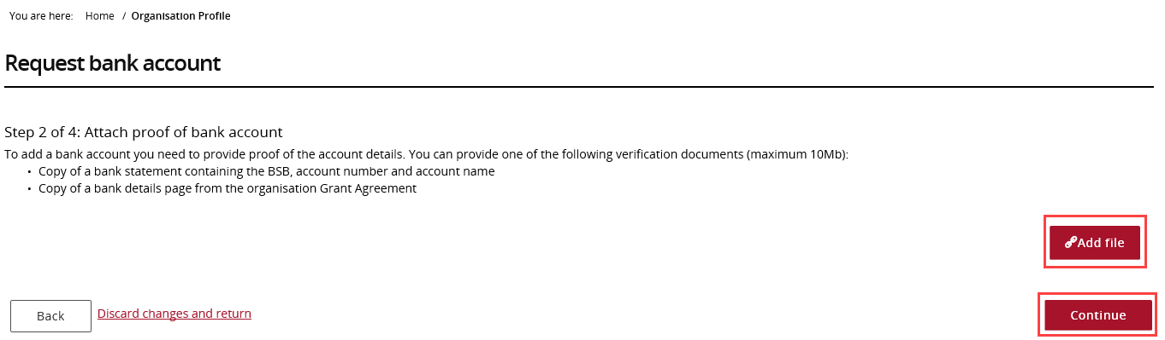

### Step 15

The file will attach. To **View** or **Delete** a file, select **Actions and the required step**.

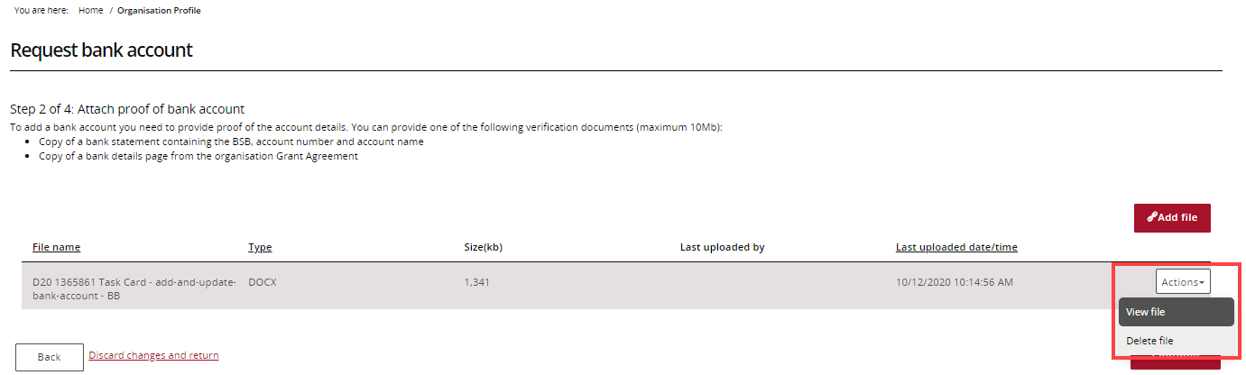

### Step 16

Select **Continue** to proceed to next step.

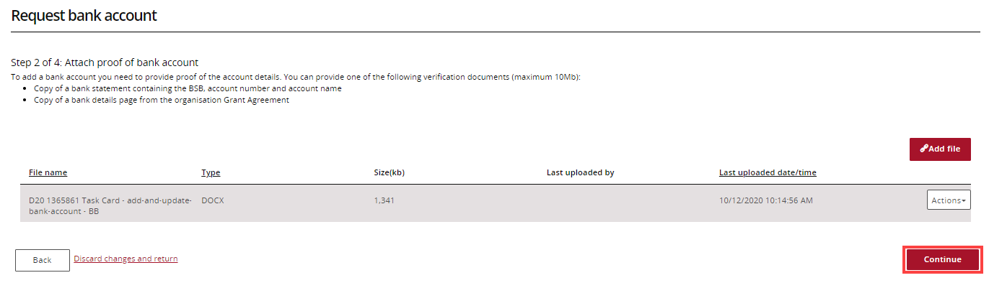

### Step 17

Select the **checkbox** against the Activities that should be linked to the new bank account and select **Continue** to proceed to the next step.

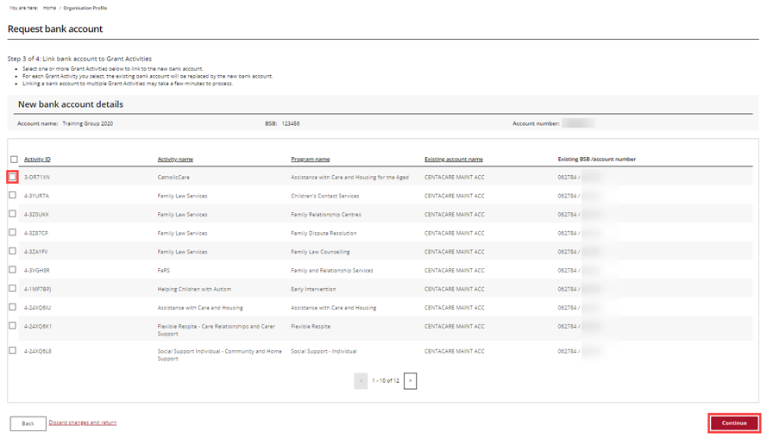

### Step 18

To finalise the new bank account, review the new bank account details and select **Submit**.

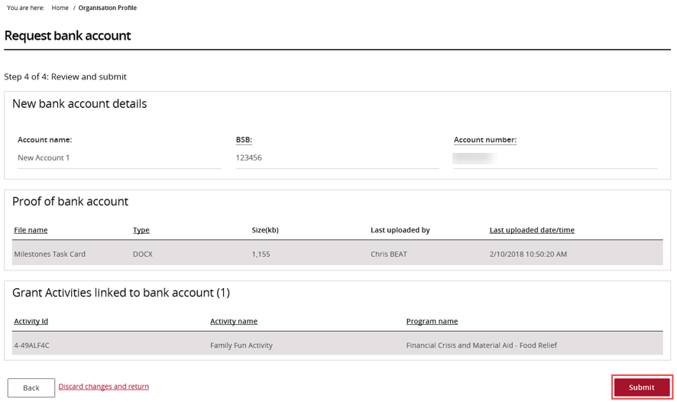

### Step 19

The new bank account details have been submitted to the Community Grants Hub for review and approval. If further information about this change is needed, contact the Funding Arrangement Manager listed on the Grant Agreement.

# Need Help?

For further assistance, contact the Grant Recipient Portal Helpdesk:

**Email**: [GRP.Helpdesk@communitygrants.gov.au](mailto:GRP.Helpdesk@communitygrants.gov.au)

**Phone**: 1800 020 283 (Option 5)

**Operating Hours:** Monday to Friday 9:00am – 5:00pm (AEST/AEDT)