# View Applications

Grant Recipient Portal Task Card

_______________________________________________________________________________

**Portal Access required**: Administrator, Editor or View Only

The Grant Recipient Portal (Portal) enables grant recipients to view a list of their submitted Grant Applications. A Grant Recipient can request a copy of a submitted Grant Application by contacting the Community Grants Hub Hotline on 1800 020 283 or emailing [support@communitygrants.gov.au](mailto:support@communitygrants.gov.au).

This task card describes the process of viewing a list of submitted Grant Applications.

## Viewing Applications

### Step 1

From the Home screen select on the **Applications** tile or select the **Applications** link from the Navigation menu.

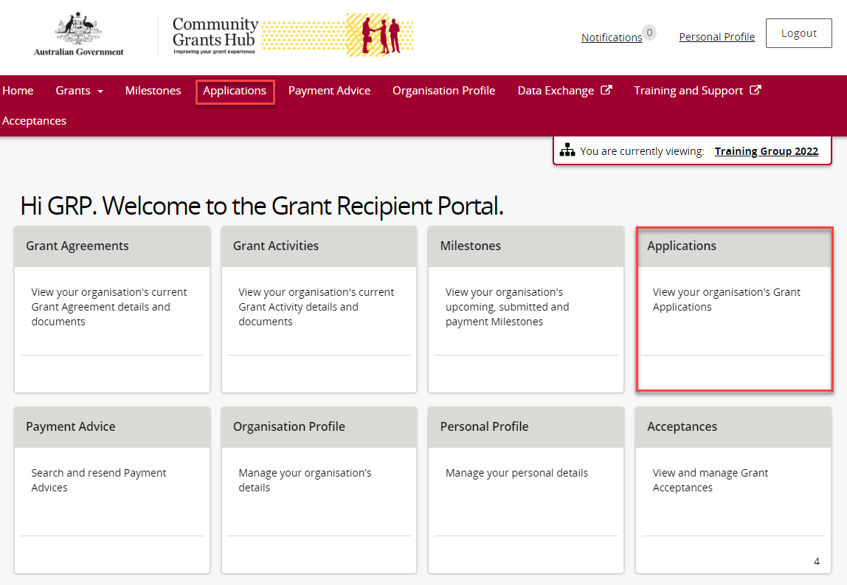

### Step 2

The Applications screen will display showing a list of submitted applications with the following information.

* Application ID
* Funding Round Name
* Department
* Funding Round Category

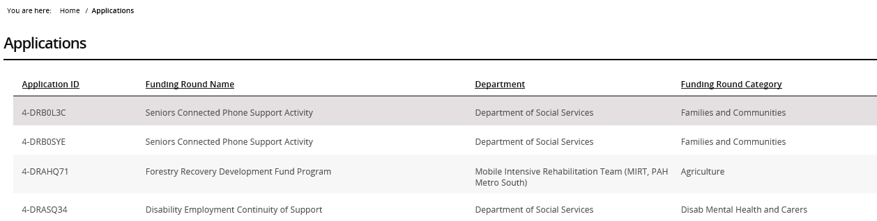

## Need Help?

For further assistance, contact the Grant Recipient Portal Helpdesk:

**Email**: [GRP.Helpdesk@communitygrants.gov.au](mailto:GRP.Helpdesk@communitygrants.gov.au)

**Phone**: 1800 020 283 (Option 5)

**Operating Hours:** Monday to Friday 9:00am – 5:00pm (AEST/AEDT)