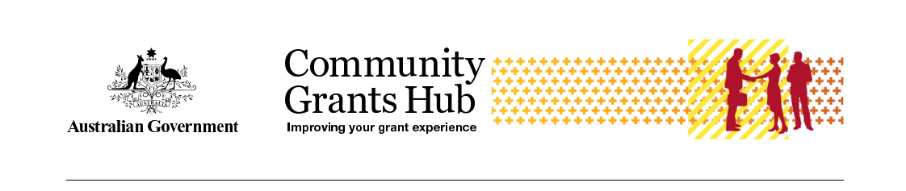

Child Safe Statements of Compliance Process
  - Frequently Asked Questions for Grantees
  - Last updated January 2025

Context
The Royal Commission into Institutional Responses to Child Sexual Abuse highlighted the need for organisations to adopt practices to provide an environment in which children and young people are safe, protected and respected, and where staff have the skills, confidence and knowledge to safeguard children.
In response, the Australian Government introduced the Commonwealth Child Safe Framework (the Framework), a whole-of-government policy that sets minimum standards for creating and embedding a child safe culture and practice in Commonwealth entities.
One part of the Framework is for Commonwealth entities to impose child safe obligations on grantees through grant agreements. The Community Grants Hub includes Child Safe clauses in any grant that, in delivering the activity, may involve interaction with children.
Child Safe clauses articulate the requirements that grantees are to meet, committing them to their child safe obligations and driving better child safe outcomes.

What is a Child Safe Statement of Compliance?
A Child Safe Statement of Compliance confirms your organisation is compliant with the child safe clauses in grant agreements.

When do I need to provide it?
You need to submit this statement to the Community Grants Hub for each calendar year of your grant (from January 1 to December 31). The statement is due by March 31 of the following year.

Do I need to provide a separate statement for each grant?
Yes, you must provide a separate Child Safe Statement of Compliance for each funded activity.

Who should complete the Child Safe Statement of Compliance?
The statement must be completed by the head of your organisation, CEO, or an authorized person in a similar position.

What types of Child Safe Statement of Compliance are there?
There are two types of Child Safe Statements of Compliance – a CB9 clause or a G8A clause.
Your grant agreement will contain the relevant clause.
CB9 – Direct contact is where there is direct access to a child, such as through care, training, counselling, consultation, administering medication, or as an employee or volunteer at the organisation, regardless of the level of employee supervision. For example:
- providing early childhood learning services to children, either face to face or online
- providing telephone counselling services to primary school aged children
- teaching children to abseil at an outdoor mentoring program
- delivering online or face to face music therapy sessions to children with autism.
G8A – Incidental contact happens in connection with, or resulting from, the main purpose of the activity that required the contact. It can be interpreted as contact that is likely to be irregular or unplanned, arising as a chance or minor consequence. For example:
- a plumber fixes a blocked drain at a junior sports club where children are training
- a child or children accompany their parents to an appointment at a consumer law centre.

What are my child safe obligations?
Specific obligations are set out in the Child Safe clauses in your agreement. However, in summary:
- You must comply with all legislation related to the employment (including volunteers) of child-related personnel.
- Child related personnel must have and maintain working with children checks.
- You must make an annual Statement of Compliance against the Child Safe clause.
If you have the CB9 Clause, you will also need to undertake Child safe risk assessment annually, providing child safe training to Staff and implement and monitor the National Principles for Child Safe Organisations.

Are there resources to help me to meet my obligations?
There are a range of resources available to help you understand and meet your child safe obligations.
- The National Office for Child Safety (link is external) has resources and information to assist grantees to implement, develop and meet their child safe obligations.
  - National Principles for Child Safe Organisations (link is external)
- Specific to child safety compliance requirements:
  - Child Safety Risk Management Resources (link is external) includes guides and templates to support grantees risk assessment.
  - Section 3.1 in the Commonwealth Child Safe Framework (link is external) lists relevant State and Territory legislation and policy.
- The Australian Human Rights Commission has:
  - 11 free professional learning units (link is external) on the National Principles
  - An introductory self-assessment tool (link is external) for child safe organisations
- The Australian Institute of Family Studies:
  - Pre-employment screening: Working With Children Checks and Police Checks.

Where do I find the Child Safe clause?
Child Safe clauses can be found in the Supplementary Terms of your grant agreement, or in a Deed of Variation (where the clause was included after signing the initial agreement).

What if I can’t find a Child Safe clause in the agreement?
Child Safe clauses are found in the Supplementary Terms of your grant agreement under the heading ‘Child Safety’. The clause number will be either G8A or CB9. You will also have a compliance milestone listed in your milestone list in the grant agreement.
The Child Safe clause may have been added to your agreement by a variation. If your original agreement was executed before March 2020, the clause and the compliance milestone will be in a variation.
If you still cannot find the Child Safe clause in your agreement documents, you can contact your Funding Arrangement Manager or Hub Managed team for further assistance.

Do Child Safe clauses apply to subcontractors?
Child safe obligations apply to any individuals involved in the delivery of your grant who may have interactions with children.
A subcontractor Decision Tree at Diagram 1 has been developed for grantees to help them understand where subcontractors should adopt the same child safe obligations.
It is your responsibility to ensure subcontractors are compliant with child safe obligations. You will certify this in your annual Statement of Compliance to the department.
If a subcontractor is non-compliant then you will need to state that your organisation is also non-compliant. If this happens, you have the opportunity to explain these circumstances and what steps you are taking to remedy this in the Statement of Compliance form.
Further information on subcontractor arrangements is on the National Office for Child Safety website.

What if I do not work with children?
If you have been sent a Statement of Compliance form to complete, your agreement with the Commonwealth includes a Child Safe clause and associated compliance milestone. You must submit an annual Statement of Compliance to the Hub in line with this agreement. If you are not compliant you have the opportunity to explain that the activity you are delivering for the Hub does not involve interaction with children.
If you demonstrate that it is highly unlikely or there is a very remote chance of contact with children in the delivery of the grant, it may be possible to have the Child Safe clause removed.
You need to consider that while your activity may not provide services directly to children, you may have ‘incidental contact’ with children so will have a Child Safe clause in your agreement.

What if I am not compliant?
In the Statement of Compliance, you will be asked to provide details about why you are not compliant. You should refer to specific clause you are not compliant with and what you are doing to address this. You also need to provide a date for when you will become compliant in your response.
The department will be in contact with you after reviewing your explanation to discuss the situation and next steps.
The Hub takes non-compliance with Child Safe clauses seriously. If you cannot comply, the Hub may apply sanctions, such as:
- requiring the grantee to become compliant by a set date (this must be added to the agreement as a new milestone)
- additional reporting requirements for child safety (that is, new reporting milestones)
- blocked payments
- termination of the agreement
- being ineligible for future grants
- being reported to the relevant authorities.

What if I am compliant only part of the year?
If you were not compliant part of the previous calendar year, you must still declare non-compliance.
In your written response you will need to provide:
- the reasons for non-compliance during part of the year
- the date when you became compliant
- a confirmation that you are still compliant.
If your grant commenced part way through the calendar year, your organisation is only required to confirm your compliance for the period the grant was active (i.e. if you grant started 1 July, you only need to confirm your child safety compliance for the period 1 July to 31 December).

How do I submit my Child Safe Statement of Compliance?
The statement is an electronic template issued by the Community Grants Hub via email. The email will contain instructions on accessing and completing the statement.
Grantees registered with the Grant Recipient Portal will be prompted to access the Statement of Compliance directly from the Portal. If your organisation is registered for the Portal, it is recommended you confirm you have a digital identity and are linked to your organisation so there is no delay in submitting your Statement of Compliance. If you need assistance accessing the Grant Recipient Portal, please visit the Grant Recipient Portal Access page.
Grantees not registered for the Grant Recipient Portal will receive a link and code to access the Statement of Compliance. Grantees should click on the link, copy and paste the access code (provided in the notification email), and enter their organisation ID (listed at the top of the grant agreement) as the password.
If you have multiple activities (with Child Safe clauses), you must submit a statement for each activity.

What if I have not received the Child Safe Statements of Compliance Smart link form?
The Community Grants Hub is currently transitioning grants onto the online Child Safe Compliance process. During this transition, some grantees may still be requested to submit statements for some of their grant activities in hard copy by email to their Funding Agreement Manager.
The submission method for each grant will be clearly specified in the Hub’s correspondence to you.
If you have multiple activities (with Child Safe clauses), you must submit a statement for each activity. This may mean some of your grants can be submitted online via the online form, but other grants may require a manual submission.

What if I fail to submit my Statement of Compliance?
You are required to submit your Statement of Compliance as a requirement of your grant agreement. Failure to submit the Statement of Compliance could result in a breach of the agreement and may impact current funding arrangements and future grant applications.

Who receives the Statement of Compliance reminder emails and notifications?
Both the reminder emails and the notification to submit the Statement of Compliance are issued to the primary contact for the grant provided to the Community Grants Hub (referred to as the program schedule primary contact).

Who needs to sign the Statement of Compliance?
The Statement of Compliance must be completed by the head of the organisation, CEO or an authorised person in an equivalent position.

Is compliance declared for the grant or for the whole organisation?
Child safe measures apply to the grant activity, not your whole organisation. If you have multiple grants you will need to submit a statement for each.
The Community Grants Hub does encourage grantees to implement child safe measure across their organisation. The measures are useful tools for building child safe cultures, creating environments where children are respected and thrive.

Can I get an extension?
No, extensions to submit a statement of compliance will not be granted. If you are unable to submit the statement of compliance by 31 March, please contact your Funding Arrangement Manager or Hub Managed team as soon as possible. If you are non-compliant you must tell the department which measures in the Child safe clause you are non-compliant with and how and when you will become compliant. This advice should be included in the statement in the text box provided.
The Hub expects any non-compliance is addressed rapidly and may ask for evidence of compliance.

What if I cannot access or use the Smart Form (Statement of Compliance)?
The forms are accessed from a link in the notification email.
Grantees registered with the Grant Recipient Portal will be prompted to access the Statement of Compliance directly from the Portal. If you need assistance accessing the Grant Recipient Portal, please visit the Grant Recipient Portal Access page.
Grantees not registered for the Grant Recipient Portal will receive a unique link and code to access the Statement of Compliance. Grantees should click on the link, copy and paste the access code (provided in the notification email), and enter their organisation ID (listed at the top of the grant agreement) as the password.
For technical assistance with accessing, using or submitting the form, please contact the Community Grants Hub Helpdesk on 1800 020 283 (option 5).

What if I received an incorrect Statement of Compliance?
If you receive an email for the wrong Child Safe clause email childsafetycompliance@communitygrants.gov.au noting you have received the wrong form and provide your activity ID and organisation name.

Can I submit my Statement of Compliance manually?
To request a manual lodgement form email childsafetycompliance@communitygrants.gov.au and provide your activity ID, organisation name and the email address we need to send the Statement to.

What if I deleted the Child Safe Compliance email or it was sent to the wrong person?
If you need to request an email to be reissued, please contact childsafetycompliance@communitygrants.gov.au telling us if you’ve deleted the email or if it was sent to the wrong person. In that email provide your activity ID, organisation name and the email address where the Statement of Compliance should be sent.

What if I received an overdue notice but have already submitted my Statement of Compliance?
Overdue notices are triggered automatically. If you have received an overdue notice in error, please contact childsafetycompliance@communitygrants.gov.au so we can investigate your record.

Diagram 1: Subcontractor decision tree
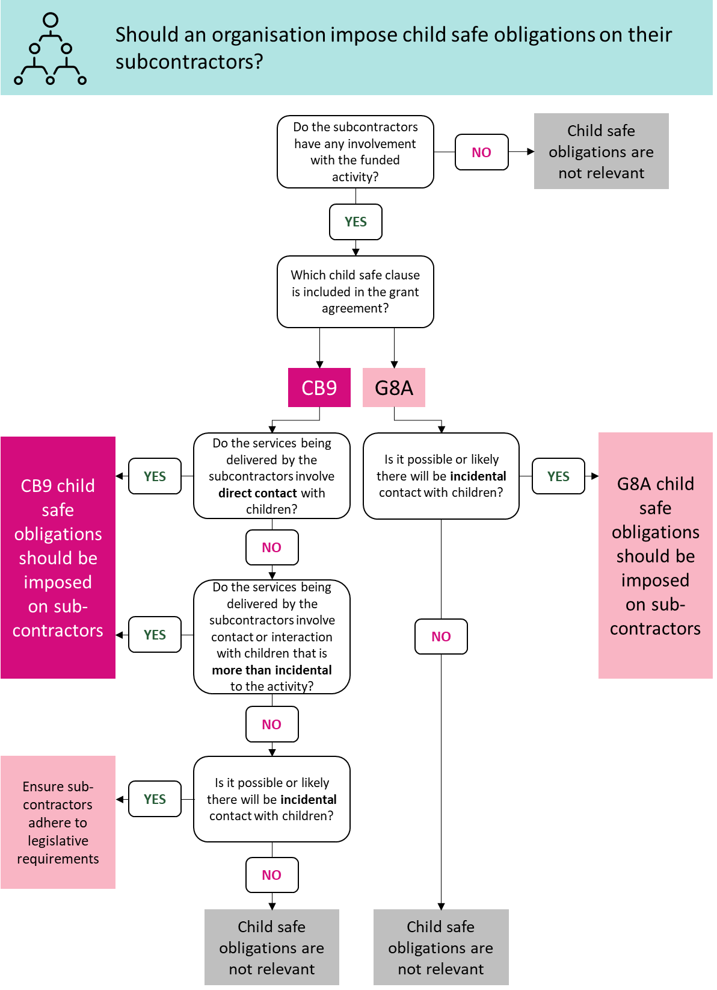
More than incidental to the activity is contact or interaction with children as part of the activity that is more than irregular or unplanned and could occur if grant personnel are likely to be, for example:
- physically touching a child
- building a rapport with a child as an integral and ordinary part of performing the activity or having contact with multiple children.
Long text for decision tree - should an organisation impose child safe obligations on their subcontractors?
Do the subcontractors have any involvement with the funded activity?
No - Child safe obligations are not relevant
Yes - Which child safe clause is included in the grant agreement?
CB9
Do the services being delivered by the subcontractors involve direct contact with children?
Yes - CB9 child safe obligations
No - Do the services being delivered by the subcontractors involve contact or interaction with children that is more than incidental to the activity?
Yes - CB9 child safe obligations should be imposed on subcontractors
No - Is it possible or likely there will be incidental contact with children?
Yes - ensure subcontractors adhere to legislative requirements
No - child safe obligations are not relevant
G8A
Is it possible or likely there will be incidental contact with children?
Yes - G8A child safe obligations should be imposed on subcontractors
No - Child safe obligations are not relevant

Child related personnel means officers, employees, contractors (including subcontractors), agents and volunteers of the Grantee involved with the Activity who as part of that involvement may interact with children.

