Grant Recipient Portal

Quick Start Guide

Prior to gaining access to the Grant Recipient Portal (the Portal), you must set up your Digital ID and link it to your organisation’s ABN in Relationship Authorisation Manager (RAM).

# Step 1 – Setting up your Digital ID

myID is the Australian Government’s Digital ID app which you can download to your smart device. myID allows you to prove who you are when accessing government online services.

Each user of the Portal will need to set up their own myID using a **personal** email address. It should not be a shared or work email address.

Download the **myID app** on your smart phone through Apple Store or Google Play and follow the steps to set up your Digital ID.

More information about setting up myID is available on the [myID website](http://www.myid.gov.au/setup).

# Step 2 – Linking your Digital ID to an ABN using RAM

Relationship Authorisation Manager (RAM) is an authorisation service that allows you to act on behalf of a business online when linked with your Digital ID. How you link depends on your role.

If you are the Principal Authority (generally the CEO or Director), you must link your Digital ID to your organisation’s ABN in RAM. Once linked, you can access online services on behalf of the business and authorise others to do the same.

If you are another user, the Principal Authority or authorisation administrator needs to authorise you to act on behalf of the organisation. When you are authorised, you will receive an email from RAM to link your Digital ID to your organisation.

More information about accepting an authorisation request can be found on the [RAM website.](https://info.authorisationmanager.gov.au/authorised-users-and-administrators)

# Step 3 – Request access to the Portal

To alleviate the need to submit multiple access request forms, it is recommended that the first person to access the Portal within an organisation be the designated Administrator. The Administrator will be able to manage user access for the organisation.

Anyone requesting Administrator access will need to complete a [Grant Recipient Portal Access Form](https://www.communitygrants.gov.au/node/1486) and submit this to the [Portal Helpdesk](mailto:GRP.Helpdesk@communitygrants.gov.au).

An organisation will need only one Administrator; however, multiple Administrators can be set up in the Portal if the organisation desires. Once the Administrator account has been created, the Administrator can create additional Portal users.

Please note: Administrators can only create Portal access for users. All users will still need to set up their Digital ID and be linked to the business in RAM.

Information on how to add users to the Portal can be found in the [Add Organisation Staff task card](https://www.communitygrants.gov.au/adding-staff-portal) found on the Portal website.

# Step 4 – How to sign into the Portal using Digital ID

Once you’ve set up your Digital ID, linked to the ABN in RAM and your Portal user account is created, go to the [Grant Recipient Portal](https://mygrants.communitygrants.gov.au/mygrants) and select **Digital ID** as shown in Figure 1.

*Figure 1 – Select Digital ID*

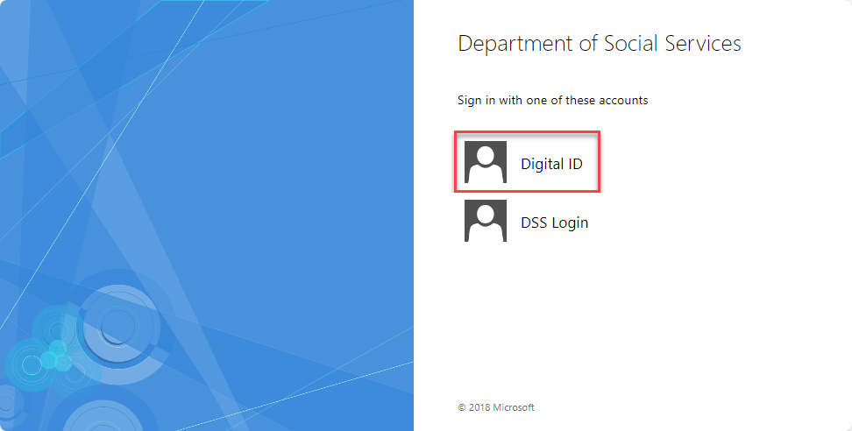

You will then be required to choose myID by clicking **Select** **myID >** as your Digital ID, as shown in Figure 2. You can also select **Remember my choice** to automatically progress to the myID login screen next time.

*Figure 2 – Select myID*

Screen shot of a page which is requires the user to select the myID icon. Users are asked to provide two identity documents to prove who they are.
There is also an option to select the Remember my choice tick box which enables the user to progress quickly through the login screen next time.

The myID login screen will display, as shown in Figure 3. Enter your myID email address. By selecting **Remember me**, next time you will not need to enter your email address and the four-digit code will be pre-filled in your app for you to accept.

*Figure 3 – myID login screen*

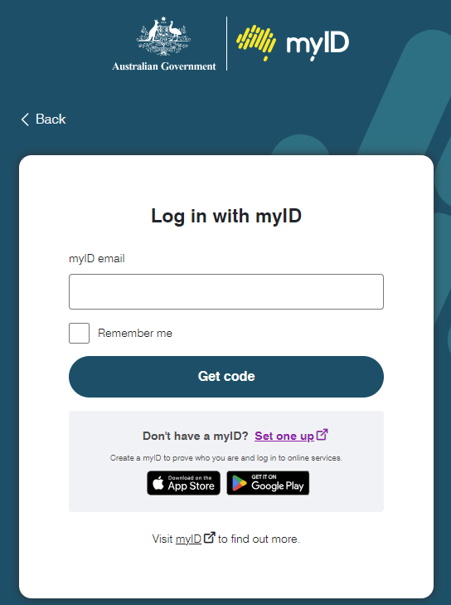

The following screen will display a four-digit code, as shown in Figure 4.

*Figure 4 – Four digit code screen*

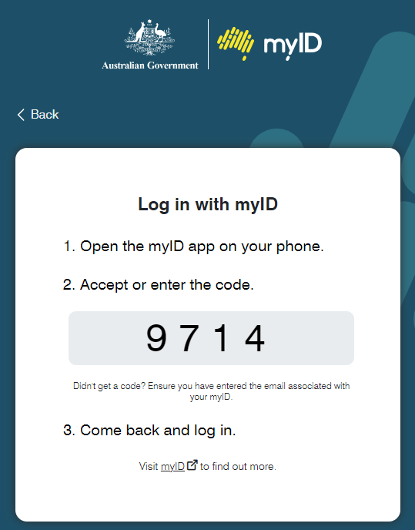

Open the myID app on your smart device. Enter the four-digit code and select **Accept**, as shown in Figure 5.

*Figure 5 – Entering four-digit code in the myID app.*

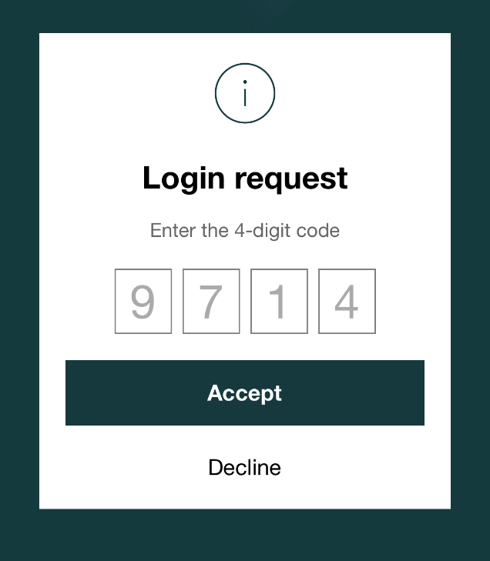

Go back to the [Grant Recipient Portal](https://mygrants.communitygrants.gov.au/mygrants).

When logging into the Portal for the first time using myID, you will need to complete the account activation process. The screen in Figure 6 will display. Enter in the email address that was provided in your Grant Recipient Portal Access Form or added by an Administrator.

*Figure 6 – Account activation*

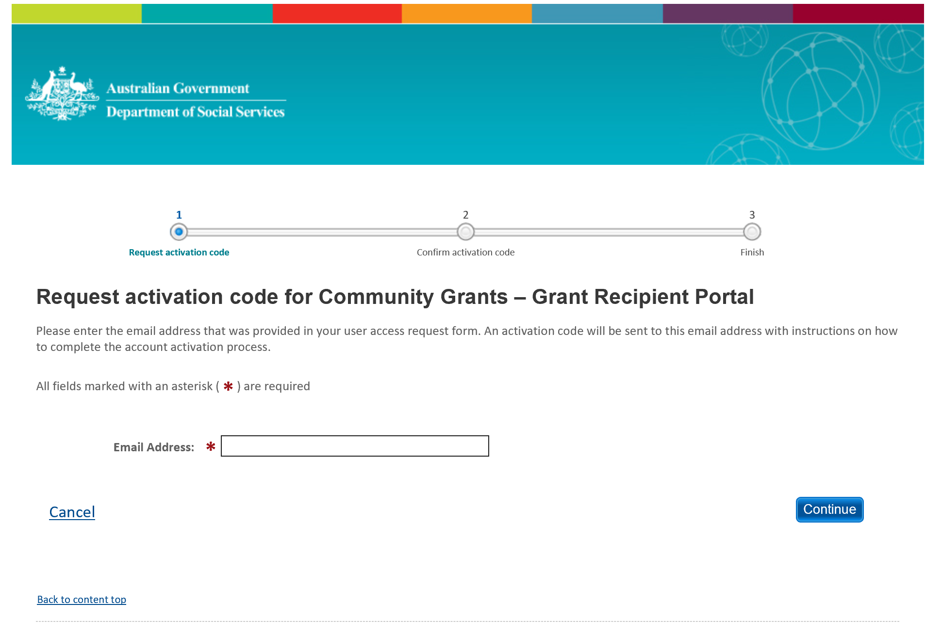

An eight digit activation code will be sent to the email address provided, and the screen shown in Figure 7 will display. Enter the activation code and select **Confirm**.

*Figure 7 – Activation code*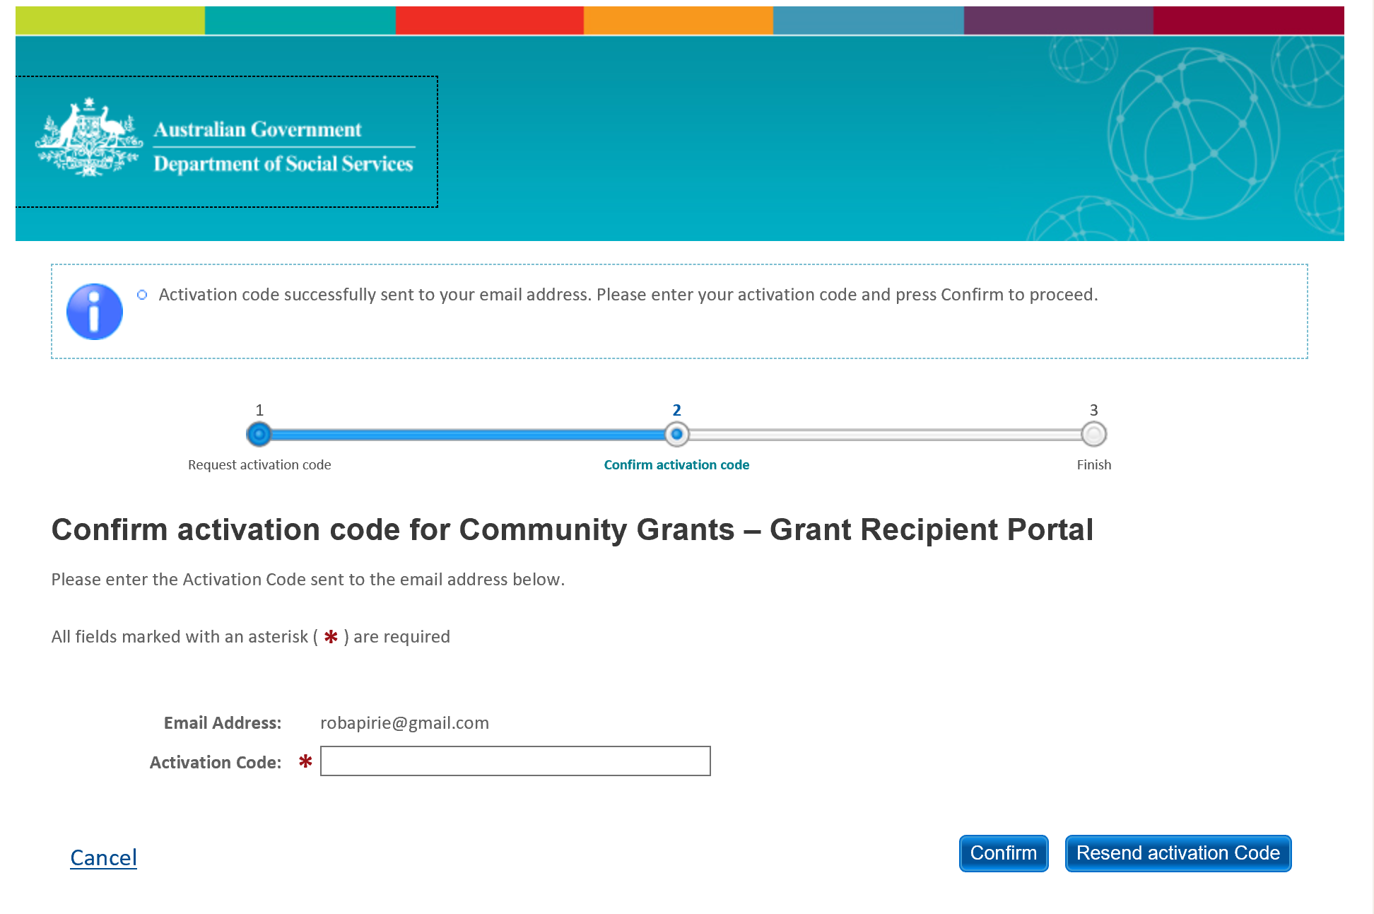

# Step 5 – Login to the Grant Recipient Portal

Once an activation code has been successfully entered, you will be prompted to continue through to the Portal login page. Select **Continue**.

The Welcome screen will display, as shown in Figure 8. Select **I Agree** to accept the terms and conditions and you will be logged into the Portal.

*Figure 8 – Welcome screen*

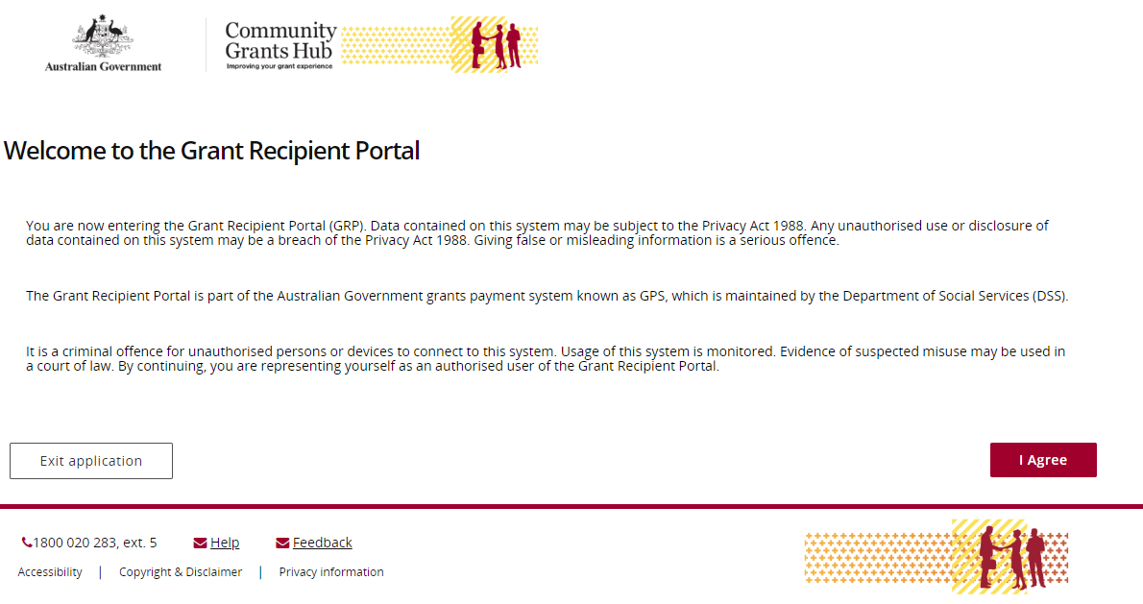

# Need Help?

For further assistance with Digital ID, please see the resources available on the Digital ID and myID websites.

**URL:** https://[www.digitalidsystem.gov.au](http://www.digitalidsystem.gov.au)

**URL:** <https://www.myid.gov.au>

**Phone**: 1300 287 539 (Select Option 2, then option 1 for myID)

**Operating Hours:** Monday to Friday 8.00am – 6.00pm (AEST/AEDT)

If you require assistance with Relationship Authorisation Manager visit the RAM website.

**URL:** <https://info.authorisationmanager.gov.au/help>

For further assistance with the Grant Recipient Portal, please contact the Community Grants Hub:

**Email:** [GRP.helpdesk@communitygrants.gov.au](mailto:GRP.helpdesk@communitygrants.gov.au)

**Phone:** 1800 020 283 (Option 5)

**Operating Hours:** Monday to Friday 9:00am – 5:00pm (AEST/AEDT)