View Milestones
  - Grant Recipient Portal Task Card
Portal Access required: Administrator, Editor or View Only
The Grant Recipient Portal (Portal) enables grant recipients to view their Grant Agreement milestones. The milestones represent actions, deliverables or payments applicable to the Organisation, as detailed in the Grant Agreement.
This task card describes the process of viewing Grant Agreement milestones.

Navigating to Milestones
Step | Action
From the Home screen, select the Milestones tile. Alternatively, select the Milestones link in the Navigation menu.
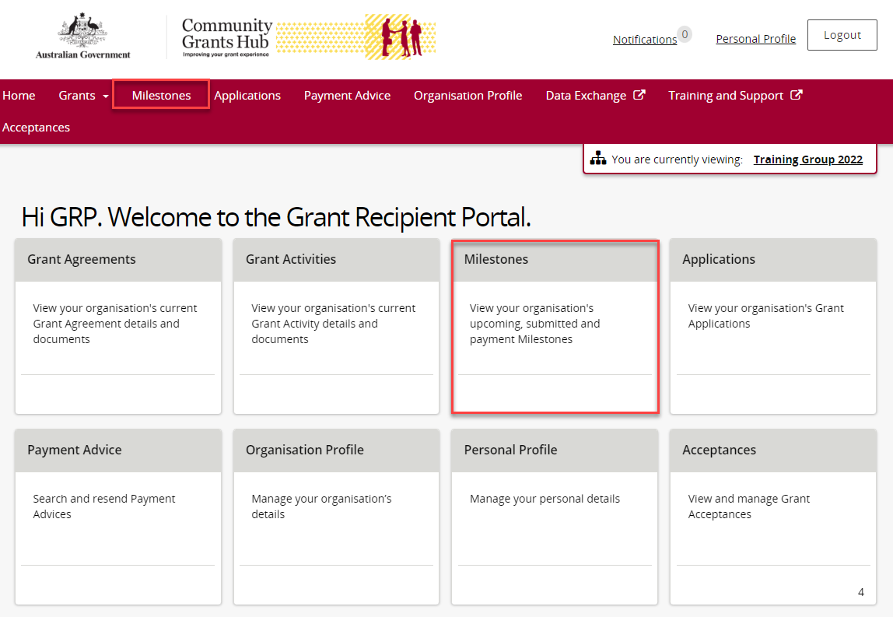
The Milestones screen displays upcoming milestones for the organisation by default.
The Milestones list can be filtered using the drop down menu to choose one of the following:
- Upcoming Milestones
- Submitted Milestones
- Payment Milestones
- All Milestones
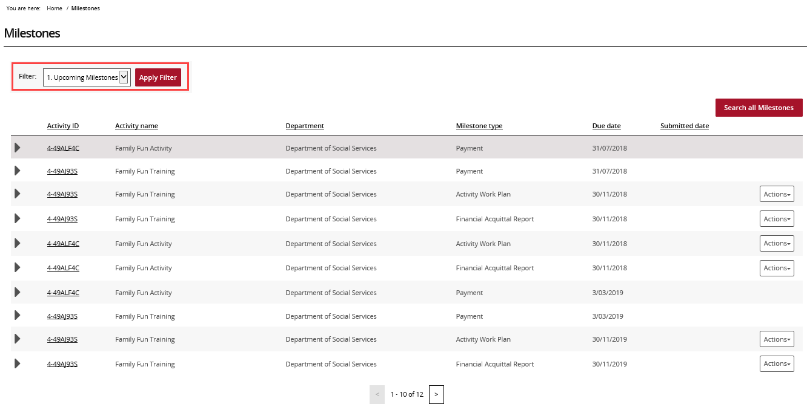
Choose the appropriate option from the drop down menu and select Apply Filter.
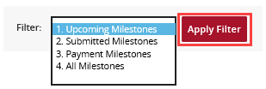
Once the filter has been applied, the applicable Milestones view will display. Select the expansion arrow next to an Activity ID to show additional information about the Milestone.
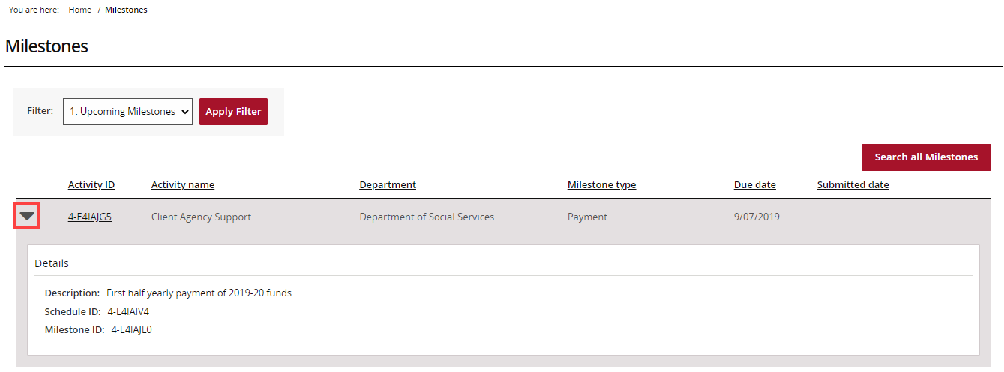
To navigate to the Activity details, select the Activity ID hyperlink.
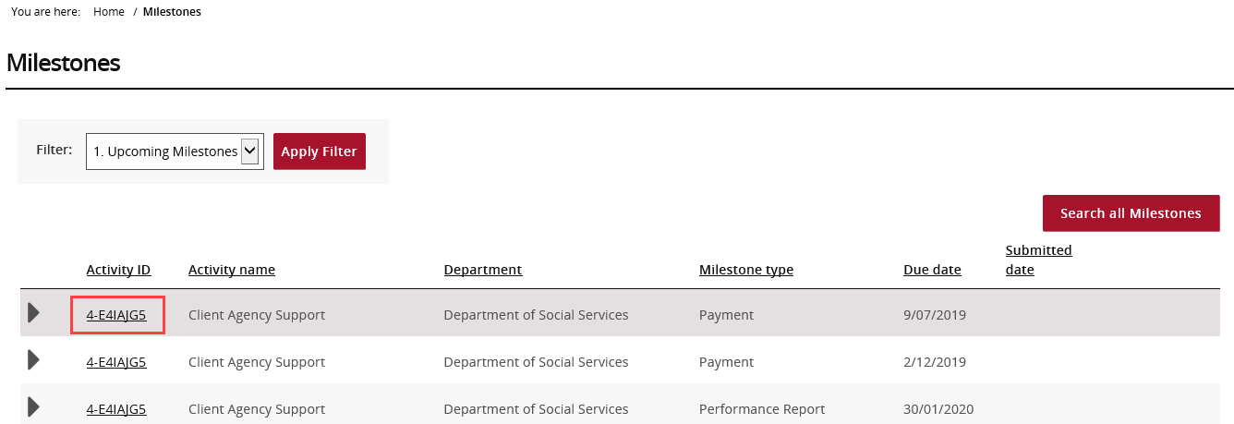

Searching for a Milestone
Step | Action
To locate a specific milestone select Search all Milestones.
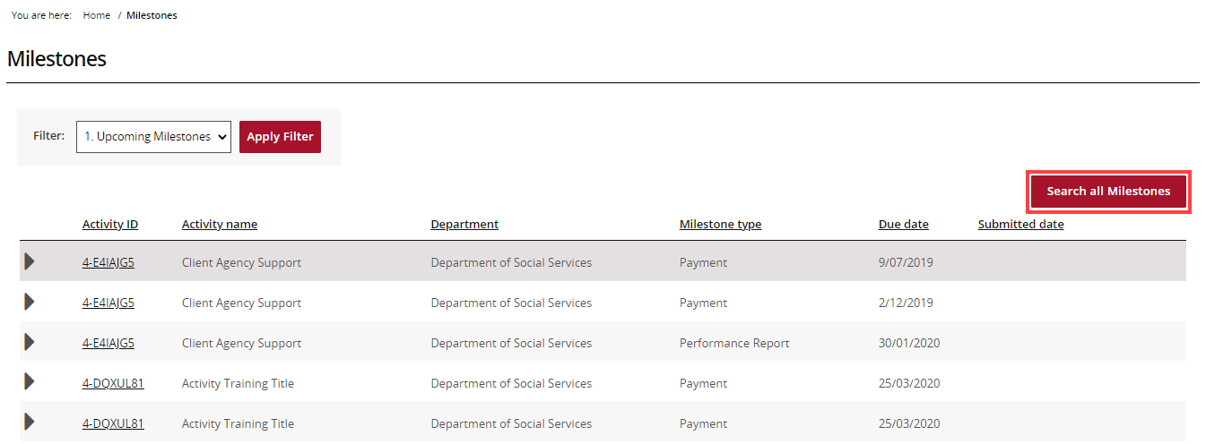
The Search all Milestones screen will display. Enter at least one search criteria and select Run search.
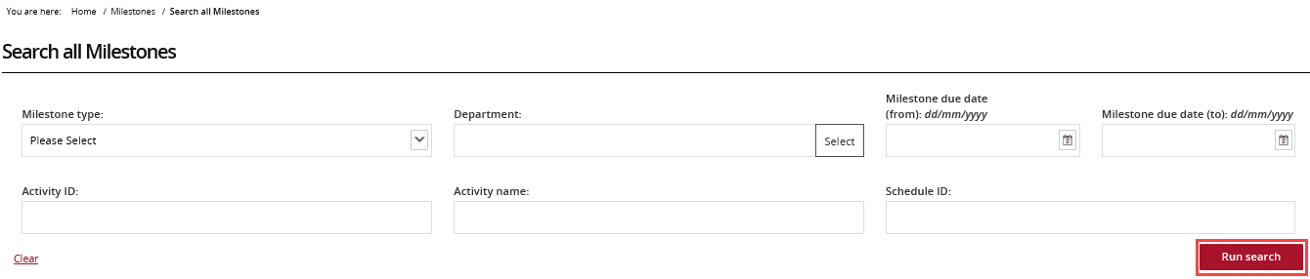
The results will display underneath the search fields. To export the results, choose the Format from the drop down menu followed by Export.
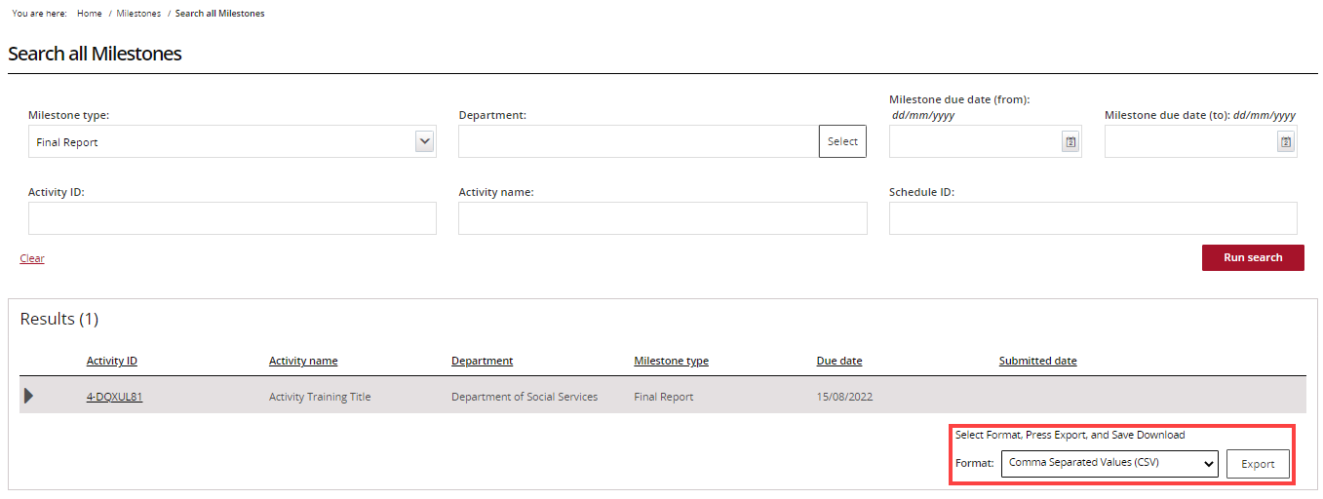
Need Help?
For further assistance, contact the Grant Recipient Portal Helpdesk:
Email: GRP.Helpdesk@communitygrants.gov.au
Phone: 1800 020 283 (Option 5)
Operating Hours: Monday to Friday 9:00am – 5:00pm (AEST/AEDT)

