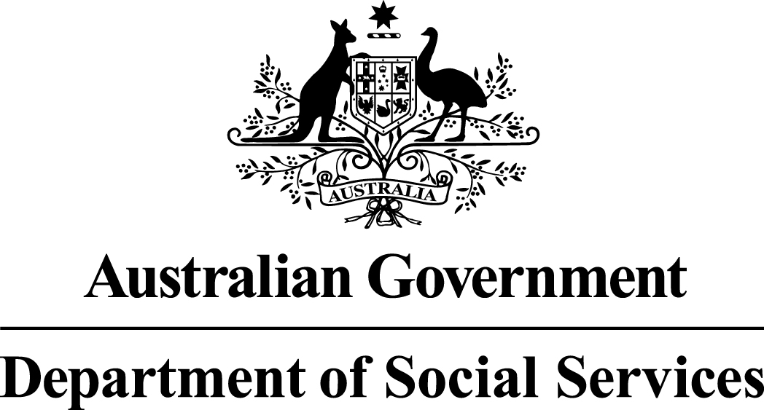

Families and Communities Program

National Plan to Reduce Violence against Women and their Children 2010-2022
Support for Culturally and Linguistically Diverse Fathers
Funding Round Summary

National Initiatives
The Department of Social Services (DSS) provides leadership in Australian Government policy on issues affecting women and children’s safety.
DSS works with state and territory governments as well as portfolios across the Commonwealth through the National Framework for Protecting Australia’s Children 2009-2020 (the National Framework) and the National Plan to Reduce Violence against Women and their Children 2010-2022 (the National Plan) to help support and bring about change for our most vulnerable children, women and families.
The implementation of the National Framework and the National Plan is supported through National Initiatives funding. Funded activities have an emphasis on supporting and improving systems and services for those affected by violence and abuse.
National Initiatives aims to achieve positive outcomes for families, women and their children by funding activities that work across sectors to improve the safety and wellbeing of children, advance gender equality and reduce violence against women and their children.
The sub-activities capture DSS’ business, in line with the Commonwealth Government’s priorities and responsibilities, and aim to contribute to a substantial and sustained reduction in child abuse and neglect and violence against women and their children in Australia over time, and include:
- National Framework for Protecting Australia’s Children 2009-2020;
- National Plan to Reduce Violence against Women and their Children 2010-2022;
- Support for Trafficked People Program; and
- Women’s Safety Package.

National Plan to Reduce Violence against Women and their Children
The National Plan to Reduce Violence against Women and their Children 2010-2022 (the National Plan) is a long-term partnership between the Commonwealth Government and state and territory governments, working with the non-government sector, business and communities, to deliver a significant and sustained reduction in violence against women and their children in Australia.
Under the Third Action Plan 2016-2019 of the National Plan, prevention and early intervention is outlined as a National Priority Area. Action 1.4 seeks to increase men’s involvement in gender equality and reducing violence, including through the use of influencers and role models, with a specific interest in engaging men and fathers from Culturally and Linguistically Diverse (CALD) backgrounds.
The Community Grants Hub, on behalf of DSS, is inviting organisations to apply for funding to deliver the Support for Culturally and Linguistically Diverse Fathers activity.

Selection type
This selection is a restricted process to select one provider to deliver the Support for CALD Fathers activity. A grant may be offered to one organisation as a result of this process.
A restricted (or targeted) selection process is used where there are few providers available due to highly specialised services being required, there are geographical considerations, specific expertise is required or there are time constraints. A restricted round is still competitive, but only opened to a small number of potential grant recipients based on the specialised requirements of the granting activity or project under consideration. Potential grant recipients are invited to apply and are assessed against designated selection criteria.

Available funding for this Activity
$500,000 is available over 2017-18 and 2018-19 to deliver the Support for CALD Fathers activity ($250,000 in 2017-18 and $250,000 in 2018-19).

Closing date and time
Applications must be submitted by 2:00pm AEST Thursday 11 May 2017.
Late applications – information on the late application policy is available on the Community Grants Hub website.

Questions
Questions and answers for this grant round are included in the Application Pack.
If you cannot find an answer to your question relating to this selection process or the Activity, please send your question to support@communitygrants.gov.au.
Responses to questions will be emailed to all invitees, except where the answers are already available in the Application Pack.
Questions will only be answered to explain the Application Form and Program Guidelines and not to advise on how to answer specific selection criteria or about individual Applications during the assessment process. All Applicants will be notified of the outcome of their Application when the selection process is complete.
If you would like help or support in using and/or submitting the Application Form, please call 1800 020 283 or TTY 1800 555 677 or email support@communitygrants.gov.au.
The question and answer period will close at 5:00pm Thursday 4 May 2017. Following this time, only questions relating to using and/or submitting the Application Form will be answered.

Grant objectives
For all children, parents and caregivers are their most important role models. The way parents engage with and look after their children, and how they interact with each other, has a profound impact on children and influences how they themselves behave as parents and develop and maintain intimate relationships.
Disagreements are a normal part of life, and modelling healthy strategies for coping with, and resolving, conflict can benefit children’s attitudes and views about respectful relationships going forward.
The transition to parenthood is a time of increased risk of domestic violence. Research indicates that becoming a father can have a transformational impact on men, particularly in regards to attitudes on gender equality. It is for this reason that strategies aimed at CALD young men and fathers have the potential to foster positive and respectful attitudes and behaviours in future or current relationships. This activity is focussed specifically on CALD young men and fathers as they may need specific support to adapt to different cultural expectations of fathers and families.
The aim of the Support for CALD Fathers activity is to contribute to a reduction in violence against women and their children, by engaging CALD young men and fathers to:
- better understand and appreciate the importance of their (current or future) role as parents and partners; and
- provide them with evidence-based tools, strategies and knowledge to improve their confidence as both parents and partners in order to develop, maintain and role-model healthy and respectful relationships with family members.
This grant provides one-off funding to develop and implement a National strategy targeting young men and fathers from CALD backgrounds in these ways, with a particular focus on engaging them through their interactions with existing service providers.
The strategy must be implemented through Commonwealth, state and territory providers who have contact with CALD young men and fathers across migrant resource hubs as well as other CALD-specific services such as health (including parenting), education, family and relationship (including family law and counselling), care and corrections, men’s behaviour change, and homelessness services. It is expected that the successful applicant will engage with these providers to build their capacity to engage CALD young men and fathers to develop skills and knowledge in these areas. This could include materials for distribution to CALD young men and fathers.

Statement of Requirement
When completing your Application you must provide all information where you are directed to do so. Your application will not be considered if you do not meet these requirements.
The Third Action Plan 2016-2019 of the National Plan seeks to increase men’s involvement in gender equality and reducing violence, including through the use of influencers and role models, with a specific interest in engaging CALD men as fathers. This project reflects that commitment as well as the Plan’s emphasis on primary prevention and driving cultural change from the ground up.
$500,000 (GST exclusive) will be provided to support a project that:
- Develops and implements a national, strength-based strategy which positively engages CALD young men and fathers to better understand the importance of their (current or future) role as parents and partners;
- Provides CALD young men and fathers with evidence-based and culturally relevant tools, strategies and knowledge in order to develop, maintain and role-model healthy and respectful relationships with family members; and
- Supports CALD young men and fathers through their interactions with CALD specific services such as migrant resource hubs as well as health, education, family and relationship, care and corrections, men’s behaviour change, and homelessness service providers at a minimum. This may include active outreach to service providers, to build their capacity to engage CALD young men and fathers in these ways. This could include the development of support materials for distribution to CALD young men and fathers.
In-scope activities for this project include:
- An engagement strategy for
- reaching and working with relevant and CALD-specific services;
- developing culturally relevant material and content for engaging with services; and
- working with services to reach CALD young men and fathers and to distribute relevant content and material.
- resources for CALD fathers delivered through a range of mediums (for example online resources including information resources, social media content, text messages, app content).

- resources for service providers to assist them engage CALD fathers with this messaging, delivered through a range of mediums (for example online resources including information resources, workshops, webinars and other online or face-to-face capacity-building sessions, support materials for on-distribution to men and fathers).
Out-of-scope activities include implementing programs for CALD young men and fathers. These already exist across a range of sectors and the purpose of this activity is to leverage those programs.
The successful applicant must be aware of existing as well as new and emerging work to engage young men and fathers throughout the life of the project, including the Support for New Fathers activity (also supported by DSS). This is to ensure that messaging across projects is aligned and duplication of effort is avoided.
The successful applicant must also work with DSS to confirm the final strategy, and resources must be approved by DSS before dissemination.

Intellectual property
The Commonwealth will retain ownership of any material it provides to the funding recipient (or material which is created) for the purposes of the funding agreement. The Commonwealth will grant the service provider a licence to use the material for the purposes of the funding agreement.
The funding recipient will retain ownership of any material it brings into existence in performing the funding agreement. The funding recipient will grant the Commonwealth a licence to this material (excluding secret and sacred material) for any Commonwealth purpose.

Restrictions

The grants may only be used to deliver:
- resources;
- products;
- research; and
- services outlined in the grant agreement

In addition to the development and delivery of specified products and outcomes, funding may be used for:

- delivery of services which meet the Program Guidelines;
- staff salaries and on-costs for project implementation and ongoing management;
- evaluation and review of the project;
- staff training;
- materials and equipment directly related to the implementation of the project;
- operating expenses directly related to the Activity;
- assets as defined in the Terms and Conditions that can be reasonable attributed to meeting agreement deliverables; and
- travel within Australia directly and specifically related to the project.

Grants are not provided for:
- purchase of land;
- retrospective costs;
- costs incurred in the preparation of a grant application or related documentation;
- major construction/capital works;
- overseas travel; and
- activities for which other Commonwealth, state, territory or local government bodies have primary responsibility.

Value for Money
In assessing the extent to which applications represent value for money, consideration will be given to the information provided at the ‘Achieving value for money’ of the Program Guidelines available on the DSS website or in the Application Pack available on the Community Grants Hub website.

Selection Criteria
The selection criteria are equally weighted.
Criterion 1 – Demonstrate your understanding of the need for the funded Activity in the specified community and/or the specified target group.

Your response must demonstrate an understanding of all of the following:
- the gendered nature of violence against women, its causes, the associated impacts on children and the additional complexities of violence against women that exists within CALD communities;
- knowledge and understanding of the diverse issues facing CALD young men and fathers, and how to support and engage them positively as role models; and
- an understanding of services available to support CALD young men and fathers, and how these could be engaged as part of this strategy.
Criterion 2 – Describe how the implementation of your proposal will achieve the Activity objectives for all stakeholders, including value for money within the Grant funding.

Your response must demonstrate the following:
- a description of the intended strategy, how it will be implemented, and how it contributes to primary prevention and a reduction in violence against women and their children in communities;
- if partnering with other organisations, you must outline the commitment of these organisations to deliver the project;
- how you intend to work with the existing footprint of Commonwealth, state and territory funded organisations to engage CALD young men and fathers; and
- how the work and outcomes of this project will be sustained after the funding period.

Criterion 3 – Demonstrate your organisation’s capacity and your staff capability (experience and qualifications) to deliver the Activity objectives in the specified community and/or specified target group.

Your response must demonstrate the following:
- expertise and cultural competency in designing and/or delivering primary prevention initiatives in CALD communities, or the ability to partner with a relevant organisation with this expertise; and
- expertise in designing and/or delivering initiatives that positively engage CALD young men or fathers in parenting or behaviour change, or ability to partner with a relevant organisation with this expertise.

Attachments
For this round, no attachments are requested. Documents attached to applications will not be assessed.

Feedback for this grant round
A Feedback Summary will be provided in an email to each applicant following the finalisation of the funding round.
The Feedback Summary will provide general round-specific information and will include main strengths and areas of improvement for the applications received in this round.

Multicultural Access and Equity Policy
Australia’s Multicultural Access and Equity Policy: Respecting diversity. Improving responsiveness means that Australian Government agencies make sure that cultural and linguistic diversity is not a barrier for people who need to access government and community services. This means, for example, that appropriate language services should be provided. Grant applicants should consider whether professional translating or interpreting services may be needed to deliver services, projects, activities or events to non-English speakers. If your Application Form states that a budget is required, costs for translating and interpreting services should be included in your budget.

Assessment
The Assessment Team may be comprised of Australian Government officers from each state/territory and national offices. Teams will undertake training so that applications are assessed consistently. The Assessment Team will be bound by the APS Code of Conduct and the departmental Secretary’s Instructions.

Probity and fairness
The selection of funding recipients must be fair, open and demonstrate the highest level of integrity.

The following principles will be applied throughout the selection process:
- fairness and impartiality;
- consistency, accountability and transparency of process;
- security and confidentiality of information;
- identification and resolution of conflicts of interest; and
- compliance with legislative obligations and government policy.

These principles are intended to achieve an equitable, justifiable and sound process.
The Community Grants Hub may engage a Probity Advisor to help meet its obligations to make selection processes defensible and able to stand up to external and internal scrutiny. The Probity Advisor also advises the Community Grants Hub on, and monitors, the procedures used in the selection process to make sure they comply with the published Program Guidelines. The Probity Advisor plays no part in assessing applications.

Program Guidelines
The Program Guidelines provide the starting point for parties considering whether to apply for a grant and is/are the basis for the business relationship between DSS and the grant recipient. Applicants are strongly advised to read the Program Guidelines before completing an Application Form.

How to apply
Once you have completed your Application Form, you must submit it electronically by using the submission section at the end of the form. Following electronic submission, a message with your Submission Reference ID will appear on your screen. An email will be sent to the main email contact provided in the Application Form. A function is also available on the submission page to allow you to send a receipt email to the address of your choosing. Please save this email receipt for future reference and use it in all correspondence about this Application.

If you do not receive a confirmation email or you have difficulties submitting the Application Form, please call the Community Grants Hub Hotline on 1800 020 283 or TTY on 1800 555 677.

Grant Agreement information
The Grant Agreement is a performance-based, legally enforceable agreement between the Commonwealth (represented by DSS) and the successful applicant that sets out the Terms and Conditions governing the grant to be provided.

The type of Grant Agreement entered into will depend on the Activity, the assessed Activity risk level, the length of the Activity and the amount of the grant.

