Murray-Darling Healthy Rivers Program

Mapping Tool User Guide

Version: February 2021

Table of Contents
Mapping Tool User Guide 3
1. Introduction 3
2. An outline of what you need to do 3
3. Launching the mapping tool 4
3.1 Before launching the tool 4
3.2 Launching the mapping tool 4
4. Navigating the mapping tool screen 4
5. Mapping - Uploading an existing map file 6
5.1 Loading Google Earth KML files 6
5.2 Editing a loaded Google Earth KML file polygon 7
6. Mapping - Creating a new or additional site 7
6.1 Search for project location 7
6.2 Adjust map position and zoom 8
6.3 Draw one or more project site areas 9
6.4 Label your site 12
6.5 Save your mapping 12
7. Editing an existing site 13
7.1 Re-positioning the polygon perimeter 13
7.2 Editing a project site title 14
8. Deleting a single project site 14
9. Deleting all project sites 15
10. Downloading your mapping 15
11. How to return to the application form 16
12. Contacts for Help and Information 16

Mapping Tool User Guide

Introduction
As part of submitting your grant application you must include mapping of the location of the project site/s where you propose to carry out on-ground activities. This document contains guidance on how to create the required maps for the Department of Agriculture, Water and the Environment. Note: If your project contains a culturally sensitive site, you may map an area larger than the site (but that still encompasses the site) to prevent its exact location being revealed.
Browser Compatibility
This mapping tool is known to work with the following web browser applications:
- Internet Explorer version 10 and above (Internet Explorer’s Compatibility View is not supported)
- Google Chrome version 36 and above
- Mozilla Firefox version 17 and above
- Safari (Mac users).
If you need to download one of the above browsers for your desktop computer, you can do so at the following sites:
- Internet Explorer
- Google Chrome
- Mozilla Firefox
(Note: Microsoft Edge comes exclusively with Windows 10 and cannot be downloaded or installed separately).
If you experience any issues, please ensure that you are using the latest version of your browser.

An outline of what you need to do
This document provides detailed instructions for mapping of your project site/s. In summary, you will need to:
- check that you are using a compatible web browser and then Launch the mapping tool (Section 3)
- familiarise yourself with the mapping screen, tools and functions (Section 4)
- add or create project sites by:
  - where relevant, uploading an existing project mapping file for your project site/s (Section 5) and/or
  - creating a new site for each proposed area of work by drawing the perimeter of the site/s to create a site polygon (Section 6)
- name each site (Section 6.4)
- save your mapping and download a copy for your records (Section 10)
- return to the application form (Section 11).
These steps are outlined in more detail in the following pages. Please work through these to ensure your project is successfully mapped and saved.

Launching the mapping tool

Before launching the tool
Before accessing the mapping tool, make sure your application form is saved.
Make sure you are working in a web browser that supports the mapping tool (see Section 1).

Launching the mapping tool
The mapping tool can be launched by left clicking with your mouse on the ‘mapping tool’ link in the ‘project site address’ section of your online application form. Once launched, the tool window will open and should look similar to Figure 1 below.
Figure 1: Initial mapping tool screen
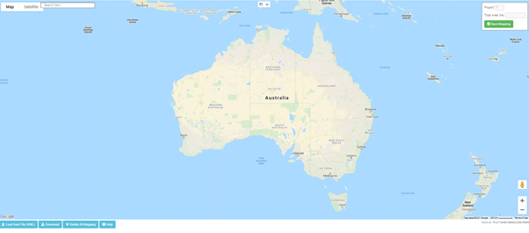
You do not need to compete all mapping in one session. As long as you save your work as you go by using the button at the top right of the mapping tool screen, you can return to the tool at any time, using the URL code provided, prior to submitting your application. For instructions on how to return to the application form, refer to Section 11.

Navigating the mapping tool screen
The mapping tool screen contains several tools and features. These are summarised at Figure 2. Please familiarise yourself with these before proceeding further.

Figure 2: Orientation to mapping tool screen
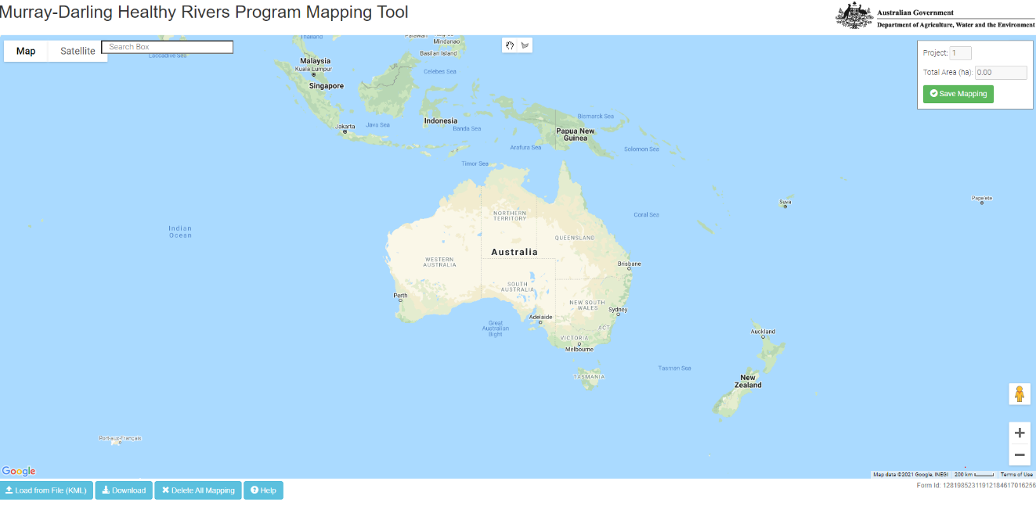
Delete all mapping
Use to clear all mapping and start again
Click to change between Basic Map & Satellite Map View
Search Box
Type an address or place name and select a displayed result to help find a project location
Save Mapping Button – click to regularly save your mapping

Click (-) to zoom out
Upload and download KML mapping file
Help - Click to access this online User Guide
Click hand tool to select map items or to grab and move map position on screen
Click drawing tool to draw a site’s perimeter (this creates a site polygon)
Click (+) to zoom in
Street View icon –
do not use

Mapping - Uploading an existing map file
If you are making a new map of your project site, please go to Section 6.

Loading Google Earth KML files
Google Earth Keyhole Markup Language (KML) is a file format used to store information that can be visualised in an application such as Google Earth. For more information on KML files, please refer here.
If you have an existing KML map file for your project site/s, it must be uploaded before creating any additional sites in the mapping tool. Failure to follow this order will cause the KML file to over-ride and clear all existing mapping you have done using the tool. Once uploaded, modifications to the KML file’s polygon areas can be made in the mapping tool.
Before attempting to use the ‘Load from File (KML)’ function, please note the following:
- This function may require the latest version of your browser (see Section 1 above).
- The function only loads KML files and not KMZ files.
- You can only upload one KML file in total. Further uploads will overwrite previous KML uploads. Experienced Google Earth Pro users with multiple existing KML files, should merge them into a single KML file before uploading. This can be done within Google Earth Pro, which can be downloaded at no cost here.
- Due to web browser limitations, the mapping tool can generally only load a maximum KML file size of about 1.3 MB. If you experience problems in loading large files into the mapping tool, please contact the Community Grants Hub (see details in Section 12).
- If you intend to upload a Google Earth KML file, please make sure the KML file only contains polygons, and not other spatial information (such as points and lines).
To upload a KML file, left click with your mouse on the blue ‘Load from File (KML)’ button in the bottom left of the map screen.
A file system navigation box will appear (Figure 3). Use it to locate your KML file and left click on it. Left click on the ‘Open’ button to upload the KML file into the mapping tool.
Figure 3: Navigating to KML file for upload
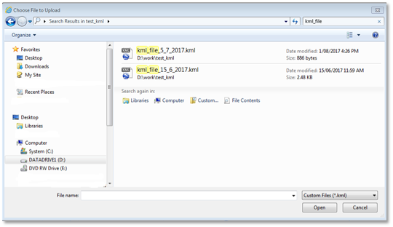
The KML file should upload and display a message stating ‘Successfully loaded kml file.’
To save the mapping, close the successful file load message and left click on the ‘Save Mapping’ button at the top right of your screen to save your map in the tool.
If issues are encountered when loading non-standard KML files, they may be corrected by loading the file into Google Earth Pro and then resaving it. Google Earth Pro is available for download at no cost here.
If the issue persists, please contact the Community Grants Hub (see Section 12).

Editing a loaded Google Earth KML file polygon
Once a KML file has been loaded into the tool, you can edit the site polygon(s) and site title(s). Please refer to Section 7.
If you wish to add additional sites to those uploaded from your KML file, refer to Section 6.

Mapping - Creating a new or additional site

Search for project location
Left click ‘Satellite’ in the top left of the screen (Figure 4) and ensure the ‘Labels’ tick box is selected (note: you can change your map view selection later at any time).

Figure 4: How to change type of map view
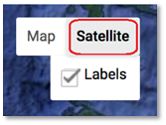
Type the address or name of a town or street location near the project area into the search box in the upper left of the screen (Figure 5).
Figure 5: Example of address results to select from
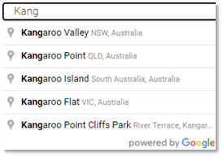
Select the closest location by left clicking on the preferred listed place/location.

Adjust map position and zoom
To zoom into the exact site location, adjust the map position by panning and zooming.
Panning means moving the map image left/right, or up/down on the screen. To pan, select the small hand tool () at the top centre of the mapping screen (Figure 6) with a left mouse click.
Figure 6: Hand Tool icon
Move the hand cursor () to anywhere on the map. Click and hold the left mouse button while moving the mouse to re-position the map so the area of interest is in the centre of the screen. Once positioned, release the mouse button.
To zoom in or zoom out, you can either:
- click on the plus (+) or minus (-) symbols in the lower right of the map (Figure 7), or
- scroll your mouse wheel up/down.

Figure 7: Zoom in/out buttons
By using the pan and zoom functions, zoom in to your project site area as close as you can. This will help you prepare for accurately drawing a perimeter around your project site/s.

Draw one or more project site areas
Left click on the drawing tool icon at the centre top of the mapping tool window (Figure 8).
Figure 8: Drawing tool icon
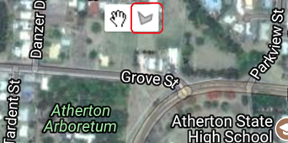
Your mouse cursor will now display as a cross symbol.
Tip: if your cursor is ever stuck as a cross, click on the hand tool to turn it off

Place the cursor cross at the location where you want to start drawing the perimeter/polygon of your site and left click once to make your first point (Figure 9).
Figure 9: Initial step of drawing a site polygon
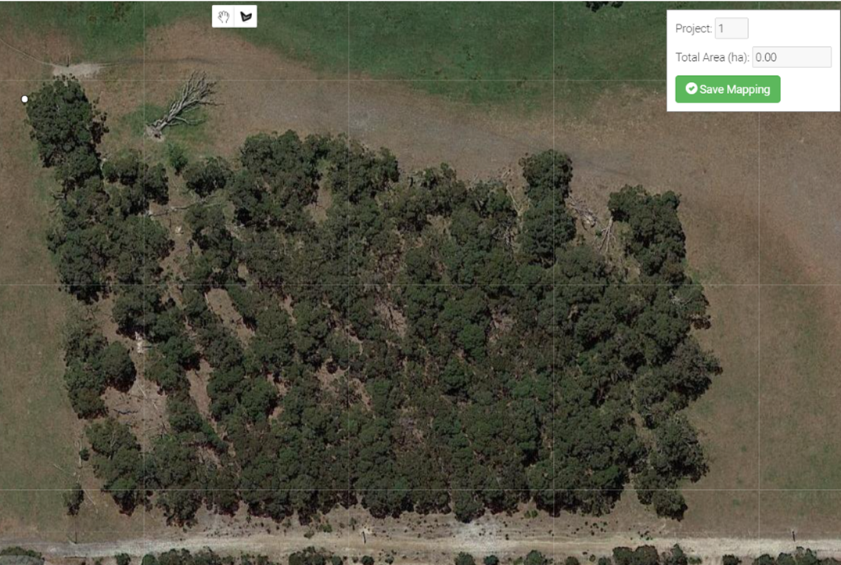

Move your cursor to the next corner of your site’s perimeter (i.e. polygon area) and left click once to create a second point (Figure 10).

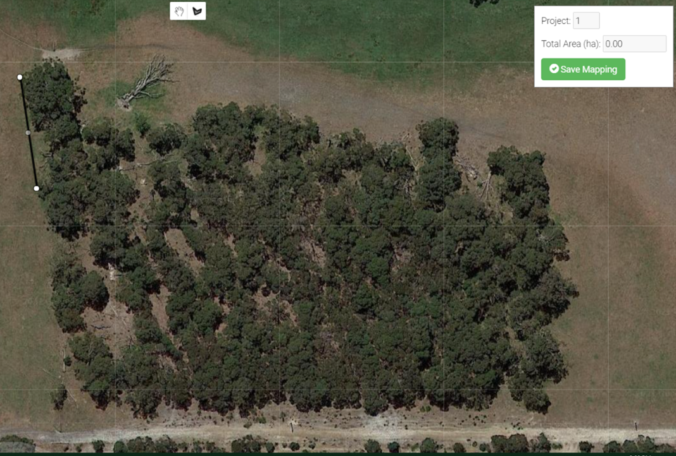
Figure 10: second step of drawing a site polygon

Continue this process of one left click at each point on your site’s perimeter (Figure 11) until you get back to the starting point to create your site’s polygon. If you make an error on the way, don’t worry, keep proceeding until you reach the starting point again. You will have the opportunity later (if needed) to edit the site (Section 7) or to delete the site (Section 8).

Figure 11: Subsequent steps of drawing a site polygon
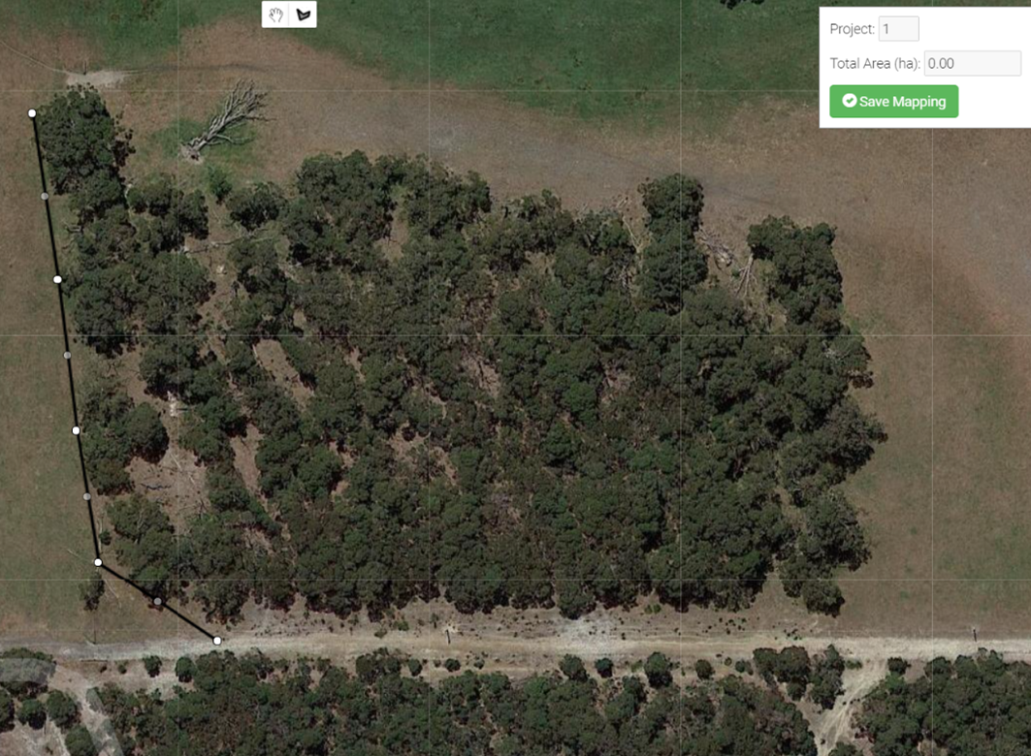

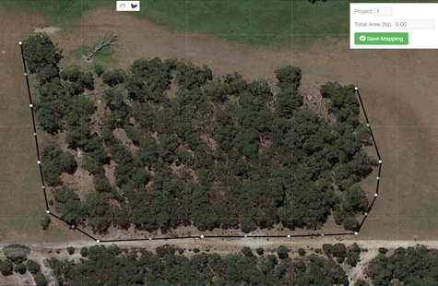
[Tip: Move the map around whilst in draw mode by holding down the left mouse button and drag the mouse until the map is in the desired position. To return to drawing, release the mouse button.]
To finish drawing your polygon, click on the starting point. A pop up window will appear as shown in
Figure 12.

Figure 12: Final step of drawing a site polygon
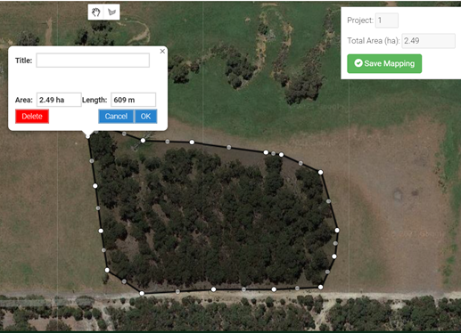
The information window will automatically display the hectare area of the polygon and the length of its perimeter (Figure 12).
To view the total area mapped for all the sites you have mapped so far, refer to the ‘Total Area (ha)’ field at the top right of the map screen (Figure 13).

Figure 13: Total area of all mapped sites

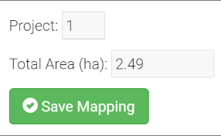

Label your site
To add a site title, left click in the ‘Title’ field and type a name for the site (Figure 14). If you have already clicked on ‘OK’ without labelling your site, go to Section 7.2 to edit your site.
Figure 14: How to label a site with a name
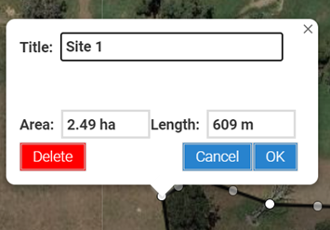

Save your mapping
Incompletely drawn polygons cannot be saved. If a polygon’s information window is still open, left click the ‘OK’ button to close it. Then left click on the ‘Save Mapping’ button at the top right of the screen to save your work.
Once you have clicked ‘Save Mapping’ you will need to copy the URL to return to your mapping later or add to your application (Figure 15).

Figure 15: Saved map URL link
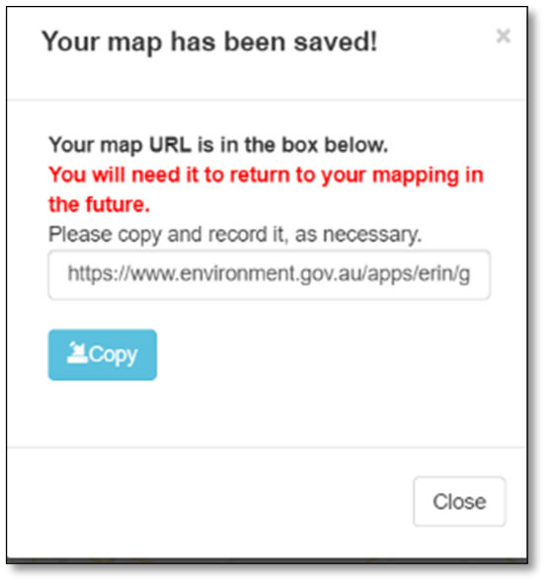
To edit your site polygon or its information further, go to Section 7.
To add an additional project site to your mapping, go to the beginning of Section 6 and repeat the process of creating a site polygon.
If you have finished mapping your site(s) and adding the site title(s) and activities, go to Section 10.

Editing an existing site
Once a site polygon is created (or uploaded from a KML file), it is possible to adjust the polygon further or to adjust the site title. To do this, follow the directions below. Otherwise, progress to Section 10.
The polygon site perimeter has 2 types of dots – white dots and grey dots (Figure 16). The white dots are the primary points and must be positioned first. The grey dots are secondary points and allow finer adjustments by adding more points to the shape’s perimeter. When you make adjustments to the position of grey dots, they may turn white and additional points may appear on the perimeter.

Figure 16: Identifying white and grey dots
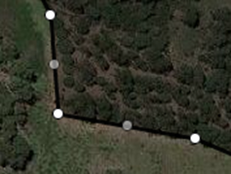
White dots (primary)
Grey dots (secondary)

Re-positioning the polygon perimeter
- Left click on the hand tool at the centre top of your map (Figure 17).
- Left click and hold down the left mouse button over a white dot to take hold of it.

- While holding down the mouse button, move the pointer to the desired position and release the mouse button.
- To undo the last adjustment, click the back symbol (Figure 17) which appears when a point is adjusted.

Figure 17: How to undo a drawing step
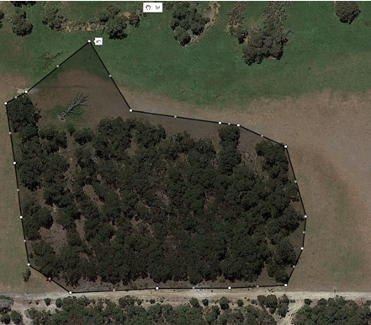
- If necessary, repeat this process to re-position other white dots.
- To fine tune your project area, follow the same process for any grey dots.
- Left click the ‘Save Mapping’ button at the top right of your screen when finished.

Editing a project site title
- Left click on the hand tool at the centre top of your map (Figure 6).
- Place the cursor over the shaded area of a site polygon that you have drawn and left click the mouse.
- The site information window will appear (Error! Reference source not found. 18). The title can be edited as required.
- When the edit has been completed, click ‘OK’ to confirm and close the information window. Alternatively, click ‘Cancel’ if you don’t want to keep any of the changes you have made.

Deleting a single project site
- Left click on the hand tool at the centre top of your map (Figure 6).
- Place the cursor over the shaded area of a site polygon that you have drawn and left click the mouse.
- The site information window will appear (Figure 18). Left click the red ‘Delete’ button to delete the site and its associated information.
- Warning: Clicking the ‘Delete’ button will delete the whole polygon. This action cannot be undone.
Figure 18: How to delete a mapped project site
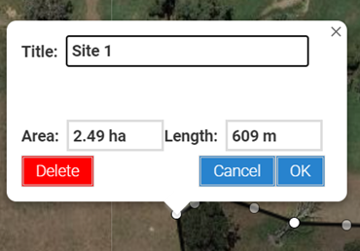

Deleting all project sites
- To delete all site polygons and re-start all mapping, left click on the blue ‘Delete All Mapping’ button in the bottom left of the mapping tool screen (Figure 19). This will delete all polygon areas and their information.
Figure 19: Upload, download, delete and help buttons

Downloading your mapping (for your records)
Once you have completed and saved all your mapping, you have the option to download a file in KML format of your mapping for your records. KML files can be viewed in many mapping applications, such as Google Earth and National Map.

To download your mapping, left click ‘Save Mapping’, then left click on the blue ‘Download’ button (bottom left of screen). You will then be asked where to save the file on your computer.
then

How to return to the application form
You do not have to complete all your mapping in one session. You can use the URL code when you save your map to return and complete your mapping prior to submitting your application.
To ensure all your mapping is saved, always left click on the ‘Save Mapping’ button before leaving the mapping tool.
To close the mapping tool and return to the application form:
- left click on the ‘Save Mapping’ button
- close your browser tab by left clicking on the cross (X) near the top of the browser tab that contains the mapping tool (Figure 20).
Figure 20: How to close a browser tab

DO NOT click on the cross at the top right of the browser window as this will completely close the browser.

- Left click on the centre of the adjacent browser tab containing the application form to view, edit and save your application form.

Contacts for Help and Information
Please contact the Community Grants Hub on:
Phone: 1800 020 283
Email: support@communitygrants.gov.au
Website: www.communitygrants.gov.au/contact

For further information on the program, including supporting documents, visit the Community Grants Hub website.
---------------------------------------

The Department of Agriculture, Water and the Environment has published a standard regarding fine scale mapping of the locations of all on-ground investments that the public are encouraged to adopt. For more information, see here. While you must provide mapping, the standard is flexible around the level of detail required for different activities.

